

CAPSTONE PROJECT REPORT
Report 3 – Software Requirements Specification

Automatic Attendance System Based on Real-Time Location and Face Recognition

INSTRUCTOR: BÙI THỊ LOAN
CLASS: SEP490_G16

Team Members:
- Trần Long Khánh | HE176617
- Nguyễn Đình Dũng | HE176518
- Hà Việt Hiếu | HE176256
- Nguyễn Văn Đạt | HE176009
- Kiều Thị Ngọc Dung | HE171203

Hanoi, June 2025

TABLE OF CONTENTS
TABLE OF CONTENTS 2
LIST OF FIGURES 5
LIST OF TABLES 7
Definitions & Acronyms 11
1. Overview 12
1.1. Product Perspective 12
1.2. System Interfaces 12
1.3. User Interfaces 13
1.3.1. Web Interface 13
1.3.2. Mobile Interface 14
1.4. Hardware Interfaces 15
2. User Requirements 15
2.1. Actors 15
2.2. Use Cases 16
2.2.1. Diagrams 16
2.2.1.1. Admin 16
2.2.1.2. Authorized User 17
2.2.1.3. Student 18
2.2.1.4. Lecturer 19
2.2.2. Use case Descriptions 20
2.3. Business Rules 23
3. Functional Requirements 25
3.1. System Functional Overview 25
3.1.1. Screens Flow 25
3.1.2. Screen Descriptions 26
3.1.3. Screen Authorization 30
3.1.5. Entity Relationship 33
3.1.5.1. Diagram 33
3.1.5.2. Description 34
3.2. System Functional Details 35
3.2.1. Website 35
3.2.1.1 Sign in 35
3.2.1.2. Sign out 37
3.2.1.3 View Dashboard 39
3.2.1.4 View Rooms 44
3.2.1.5 Add Room 46
3.2.1.6 Edit Room 48
3.2.1.7 Delete Room 50
3.2.1.8 View Courses 52
3.2.1.9 Add Course 53
3.2.1.10 Edit Course 56
3.2.1.11 Delete Course 58
3.2.1.12 View Classes 61
3.2.1.13 Edit Class 64
3.2.1.14 Delete Class 67
3.2.1.15 Add Class 69
3.2.1.16 View Class Details 72
3.2.1.17 Assign Lecturer 75
3.2.1.18 View Enrolled Student 77
3.2.1.19 Import Student 79
3.2.1.20 Enroll Student 83
3.2.1.21 View Schedules 86
3.2.1.22 Add Schedule 89
3.2.1.23 Edit Schedule 91
3.2.1.24 Delete Schedule 94
3.2.1.25 View Sessions 97
3.2.1.26 Edit Session 99
3.2.1.27 Delete Session 101
3.2.1.28 View Session Details 103
3.2.1.29 Edit Attendance 105
3.2.1.30 View Users 109
3.2.1.31 Add User 111
3.2.1.32 Import User 113
3.2.1.33 Edit User 116
3.2.1.34 Change User Status 118
3.2.1.35 View User Details 120
3.2.1.36 View Active Devices 122
3.2.1.37 Inactive Device 125
3.2.1.38 View Device Requests 127
3.2.1.39 Edit Device Request 131
3.2.1.40 View Active FaceIDs 134
3.2.1.41 View Attribute Definitions 137
3.2.1.42 Create Attribute Definition 140
3.2.1.43 Update Attribute Definitions 143
3.2.1.44 Delete Attribute Definition 146
3.2.1.45 View Settings 148
3.2.1.46 Create Setting 151
3.2.1.47 Edit Setting 154
3.2.1.48 Delete Setting 157
3.2.2. Mobile 160
3.2.2.1 Sign In 160
3.2.2.2 Sign Out 161
3.2.2.3 View Student Setting 163
3.2.2.4 View Lecturer Setting 166
3.2.2.5 View Profile 169
3.2.2.6 View Device 172
3.2.2.7 Register Device 174
3.2.2.8. View Face ID 176
3.2.2.9. Register Face ID 178
3.2.2.10 Update Face ID 180
3.2.2.11 View Student Home Page 182
3.2.2.12 View Student Schedule 185
3.2.2.13 View Student Calendar 187
3.2.2.14 View Lecturer Home Page 189
3.2.2.15 View Lecturer Schedule 191
3.2.2.16 View Lecturer Calendar 194
3.2.2.17 View Personal Attendance Report 196
3.2.2.18 Join Attendance Session 198
3.2.2.19 View Session Detail 201
3.2.2.20 Verify Face ID Request 204
3.2.2.21 View Lecturer Session Detail 208
3.2.2.22 View Class Attendance Report 211
3.2.2.23 View Session Attendance Report 213
3.2.2.24 Broadcast and Scan Signal 216
3.2.2.25 Create Face ID Request 217
3.2.2.26 Automotive Attendance 222
3.2.2.27 Manual Attendance 223
3.2.2.28 Start Attendance Session 226
3.2.2.29 Backfill Data 230
3.2.2.30 Process Attendance Data 231
3.2.2.31 Store Local Attendance Data 231
4. Non-Functional Requirements 232

LIST OF FIGURES
Figure 1: Context Diagram 11
Figure 2: Web Interface 12
Figure 3: Mobile Interface 13
Figure 4: Use Cases Diagram - Admin 15
Figure 5: Use Cases Diagram - Authorized User 16
Figure 6: Use Cases Diagram – Student 17
Figure 7: Use Cases Diagram – Lecturer 18
Figure 8: AAS Web System Screens Flow Diagram 23
Figure 9: AAS Mobile System Screens Flow Diagram 24
Figure 10: Entity Relationship Diagram 30
Figure 11: Sign in - Sign in form 32
Figure 12: Sign Out - Avatar Dropdown 34
Figure 13: Dashboard 36
Figure 14: Dashboard 36
Figure 15: Dashboard 37
Figure 16: Dashboard 38
Figure 17: Dashboard 39
Figure 18: Dashboard 39
Figure 19: Sign Out - Avatar Dropdown 42
Figure 20: Add room 44
Figure 21: Edit Room 46
Figure 22: Delete Room 48
Figure 23: View Courses 50
Figure 24: Import Users layout 115
Figure 25: Edit User Layout 118
Figure 26 Confirm status change layout 120
Figure 27: User detail layout 122
Figure 30: Manage Active Devices 124
Figure 32: Current Devices Management Layout 125
Figure 34: Requests Devices Layout 130
Figure 35: Pending Device Requests Layout 131
Figure 36: Approve Device Layout 134
Figure 37: Reject Device Layout 134
Figure 38: Current Face ID Management Layout 137
Figure 39: Current Face ID Management Layout 138
Figure 40: Attribute Definitions Layout 140
Figure 41: Definitions Table columns Layout 141
Figure 42: Attribute Definition Details Layout 142
Figure 43: Create Attribute Definition Layout 144
Figure 44: Create Attribute Definition 145
Figure 45: Update Attribute Definition 148
Figure 46: View Settings Layout 153
Figure 47: View Settings Layout 154
Figure 48: Create Settings Layout 156
Figure 49: Update Settings Layout 159
Figure 50: Confirm delete Layout 162
Figure 51: Sign in 164
Figure 52: Sign out layout 166
Figure 53: View Student Setting 168
Figure 54: View Lecturer Setting 171
Figure 55: View Student Profile 174
Figure 56: View Lecture Profile 175
Figure 57: View Device 177
Figure 58: Register Device Layout 179
Figure 59: View Face ID Status Layout 181
Figure 60: Register Face ID layout 183
Figure 61: Update Face ID Layout 185
Figure 62: Homepage layout 187
Figure 63: View Student Schedule Layout 189
Figure 64: View Student Calendar Layout 192
Figure 65: View Lecturer Home Page Layout 193
Figure 66: View Lecturer Schedule Layout 196
Figure 67: View Lecturer Calendar Layout 198
Figure 68: View Lecturer Calendar Layout 200
Figure 69: View Personal Attendance Report Layout 203
Figure 70: View Session Detail Layout 206
Figure 71: Notification Layout 209
Figure 72: Verify Face ID Request Layout 210
Figure 73: View Lecturer Session Detail Layout 213
Figure 74: View Class Attendance Report Layout 215
Figure 75: View Session Attendance Report Layout 218
Figure 76: Schedule Layout 221
Figure 77: Create Face ID Request 222
Figure 78: Create Face ID Request Successfully layout 223
Figure 79: Manual Attendance layout 227
Figure 80: Start Attendance Session layout 230
Figure 81: Confirm start layout 231

LIST OF TABLES
Table 1: Definitions & Acronyms 11
Table 2: Actors Description 15
Table 3: Use Cases Descriptions 21
Table 4: Business Rules 22
Table 5: Actors Description 23
Table 6: Screens Description 28
Table 7: Screen Authorization 30
Table 8: Entity description 32
Table 9: Sign In - Sign in form 33
Table 10: Sign In Specification 34
Table 11: Sign In - Sign in form 35
Table 12: Sign Out Specification 36
Table 13: View Dashboard Layout 37
Table 14: View Dashboard 2 38
Table 15: View Dashboard 3 38
Table 16: View Dashboard 4 39
Table 17: View Dashboard 5 40
Table 18: View Dashboard 6 41
Table 19: View Dashboard Specification 42
Table 20: View Rooms Layout 43
Table 21: View Rooms Specification 44
Table 22: Add room layout 45
Table 23: Add room specification 46
Table 24: Edit room layout 47
Table 25: Edit room specification 48
Table 26: Delete Rooms Layout 49
Table 27: Delete Rooms Specification 50
Table 28: Manage Course (View Course) layout 51
Table 29: Manage Course (View Course) Specification 52
Table 30: Manage Course (Add Course) 53
Table 31: Manage Course (Add Course) 54
Table 32: Manage Course (Edit Course) layout 55
Table 33: Manage Course (Edit Course 2) 56
Table 34: Manage Course (Add Course) Specification 57
Table 35: Manage Course (Delete Course) layout 58
Table 36: Manage Course (Delete Course) Specification 58
Table 37: Manage Course (Delete Course) layout 59
Table 38: Manage Course 60
Table 39: Class Management layout 61
Table 40: Semester layout 61
Table 41: Unassigned Lecturer 62
Table 42: View Class 64
Table 43: Edit Class 64
Table 44: Edit class layout 65
Table 45: Edit class specification 66
Table 46: Edit class specification 68
Table 47: Add new class layout 69
Table 48: Add new classes 69
Table 49: Add new class layout 70
Table 50: Add semester Class Layout 70
Table 51: Add semester Class 70
Table 52: Add semester Class Specification 72
Table 53: View Class detail Layout 72
Table 54: View Class detail layout 73
Table 55: Add new class section (View class detail) Specification 74
Table 56: Add new class section (Assign Lecturer) 75
Table 57: Add new class section (Assign Lecturer) Specification 77
Table 58: Enroll Management (View Enrolled Student) layout 78
Table 59: Enroll Management (Enrolled Student) layout 78
Table 60: View Enrolled Student 80
Table 61: Import Student Layout 80
Table 62: Import Student Layoout 2 81
Table 63: Manage Enrollments (Import Student) Specification 83
Table 64: Enroll Student Layout 84
Table 65: Enroll Student Layout 2 84
Table 66: Manage Enrollments (Enroll Student) Specification 86
Table 67: Manage Schedules (View schedule) layout 87
Table 68: Manage Schedules (View schedule detail) layout 87
Table 69: Manage Schedules (View schedule) layout 89
Table 70: Add schedule Layout 89
Table 71: Add schedule Layout (add schedule) layout 90
Table 72: Add Schedule 91
Table 73: Edit schedule 92
Table 74: Manage Schedule (Add Schedule) 94
Table 75: Manage Schedule (Delete Schedule) layout 95
Table 76: Manage Schedule (Delete Schedule) layout 2 96
Table 77: Manage Schedule (Delete Schedule) 97
Table 78: Manage Sessions (View session) layout 98
Table 79: Manage Sessions (View session) layout 2 98
Table 80: Manage Sessions (View session) 100
Table 81: Manage Sessions (edit session) layout 100
Table 82: Manage Sessions (edit session) specification 102
Table 83: Manage Sessions (delete session) layout 102
Table 84: Manage Sessions (delete session) layout 2 103
Table 85: Manage Sessions (Delete Sessions) 105
Table 86: Manage Session (View Session Detail) 106
Table 87: Manage Session (View Session Detail) Specification 107
Table 88: Manage Session (Edit Attendance) layout 108
Table 89: Manage Session (Edit Attendance) layout 2 108
Table 90: Manage Session (Edit Attendance) Specification 110
Table 91: Manage User (View User) layout 112
Table 92: Manage Users (View Users) Specification 113
Table 93: Manage Users (Add Users) 114
Table 94: Manage Users (Add Users) Specification 116
Table 95: Import User Field Description Table 117
Table 96: Import User Specification 119
Table 97: Edit User Field Description Table 120
Table 98: Manage Users (Edit User) Specification 121
Table 99: Confirm status change Field Description Table 122
Table 100: Manage User (Confirm status change) Specification 123
Table 101: User detail Field Table 124
Table 102: User detail specification 125
Table 103: View Active Devices Field table 126
Table 104: Current Devices Management Field table 127
Table 105: Current Devices Specification 128
Table 106: Inactive Device Field Table 129
Table 107: Inactive Device Field Table 129
Table 108: Sign in Specification 167
Table 109: Sign Out Field Table 168
Table 110: Sign out specification 168
Table 111: View Student Setting Field Table 170
Table 112: View Student Setting Specification 171
Table 113: View Lecturer Setting Field Layout 173
Table 114: View Lecturer Setting Specification 174
Table 115: View Profile Field Table 177
Table 116: View Profile Specification 178
Table 117: View Device Field Table 179
Table 118: View Device Specification 180
Table 119: Register Device Field Table 181
Table 120: Register Device Specification 182
Table 121: View Face ID Field Table 183
Table 122: View Face ID Specification 183
Table 123: Register Face ID Field Table 184
Table 124: Register Face ID Specification 185
Table 125: Update Face ID Field Table 187
Table 126: Update Face ID Specification 187
Table 127: View Student Home Page Field Table 189
Table 128: View Student Home Page Specification 190
Table 129: View Student Schedule Field Table 191
Table 130: View Student Schedule Specification 192
Table 131: View Student Calendar Field Table 193
Table 132: View Student Calendar Specification 194
Table 133: View Lecturer Home Page Field Table 195
Table 134: View Lecturer Home Page Specification 196
Table 135: View Lecturer Schedule Field Table 198
Table 136: View Lecturer Schedule Specification 199
Table 137: View Lecturer Calendar Field Table 200
Table 138: View Lecturer Calendar Specification 201
Table 139: View Personal Attendance Report Field Table 202
Table 140: View Personal Attendance Report Specification 203
Table 141: Join Attendance Session Field Table 205
Table 142: Join Attendance Session Specification 206
Table 143: View Session Detail Field Table 208
Table 144: View Session Detail Specification 209
Table 145: Verify Face ID Request Field Table 212
Table 146: Verify Face ID Request Specification 213
Table 147: View Lecturer Session Detail Field Table 215
Table 148: View Lecturer Session Detail Specification 216
Table 149: View Class Attendance Report Field Table 217
Table 150: View Class Attendance Report Specification 218
Table 151: View Session Attendance Report Field Tale 220
Table 152: View Session Attendance Report Specification 221
Table 153: Broadcast and Scan Signal Specification 221
Table 154: Create Face ID Request Field Table 226
Table 155: Create Face ID Request Specification 226
Table 156: Automotive Attendance Specification 227
Table 157: Manual Attendance Field Table 229
Table 158: Manual Attendance Specification 230
Table 159: Start Attendance Session Field Table 233
Table 160: Start Attendance Session Specification 234
Table 161: Backfill Data Specification 234
Table 162: Process Attendance Data Specification 235
Table 163: Store Local Attendance Data Specification 236

Definitions & Acronyms
No | Acronyms & Abbreviations | Definitions
1 | AAS | The Automatic Attendance System Based on Real-Time Location and Face Recognition
2 | PMP | Project Management Plan
3 | SRS | Software Requirements Specification
4 | SDD | Software Design Description
5 | STD | Software Testing Documentation
6 | SUG | Software User Guides
7 | WBS | Work Breakdown Structure
8 | BR | Business Rule
9 | ERD | Entity Relationship Diagram
10 | GUI/UI | Graphical User Interface
11 | UX | User Experience
12 | JWT | JSON Web Token
13 | HTTPS | Hypertext Transfer Protocol Secure
14 | UC | Use Case
15 | API | Application Program Interface
16 | E | Exception
17 | RP | Release Package
18 | MKT | Marketing Module
19 | AUT | Authentication Module
20 | USR | User Profile Management Module
21 | PRJ | Projects Management Module
22 | SCE | Scenarios Management Module
23 | BOA | Blocks of Action Module
24 | AST | Assets Management Module
25 | LOG | Logs Management Module
26 | SUB | Subscription Management Module
27 | SYS | System Management Module
28 | APS | App Settings Module
29 | CI/CD | Continuous Integration/Continuous Deployment
30 | CRUD | Create Read Update Delete
31 | URL | Uniform Resource Locator
32 | VPS | Virtual Private Server
33 | JSON | JavaScript Object Notation
34 | DOM | Document Oriented Model
35 | CMS | Content Management System
36 | ADB | Android Debug Bridge
Table 1: Definitions & Acronyms

1. Overview

1.1. Product Perspective
The Automatic Attendance System (AAS) is a new, independent software solution developed to enhance and automate the attendance-taking process in educational environments. It operates as a system comprising a mobile application for students and lecturers, and a web-based portal for lecturers and administrators. The system integrates seamlessly with institutional IT infrastructure but does not rely on existing third-party attendance solutions.
AAS leverages Bluetooth Low Energy (BLE) and on-device face recognition to detect student presence and authenticate identity during class sessions. The mobile application plays a dual role: broadcasting BLE signals and performing liveness-verified face recognition. The backend system, hosted on cloud infrastructure, synchronizes attendance data, supports real-time analytics, and enforces business rules such as session schedules, thresholds, and complaint resolution.
This product follows an offline-first architecture, allowing attendance data to be captured and cached locally when internet access is unavailable, with automatic synchronization when the connection is restored. Unlike traditional attendance systems that require fixed hardware (e.g., biometric kiosks, RFID scanners), AAS minimizes deployment and maintenance costs by utilizing students’ personal devices.
The system is modular, extensible, and aligned with “Smart Campus” initiatives, supporting future enhancements such as Android compatibility, advanced biometric spoofing prevention, and integration with learning management systems (LMS).

1.2. System Interfaces
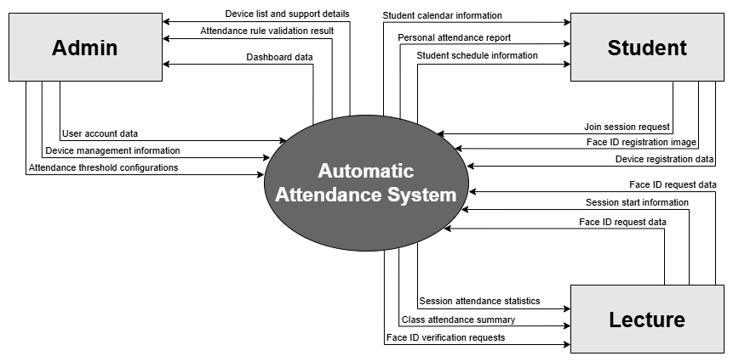
Figure 1: Context Diagram

1.3. User Interfaces

1.3.1. Web Interface
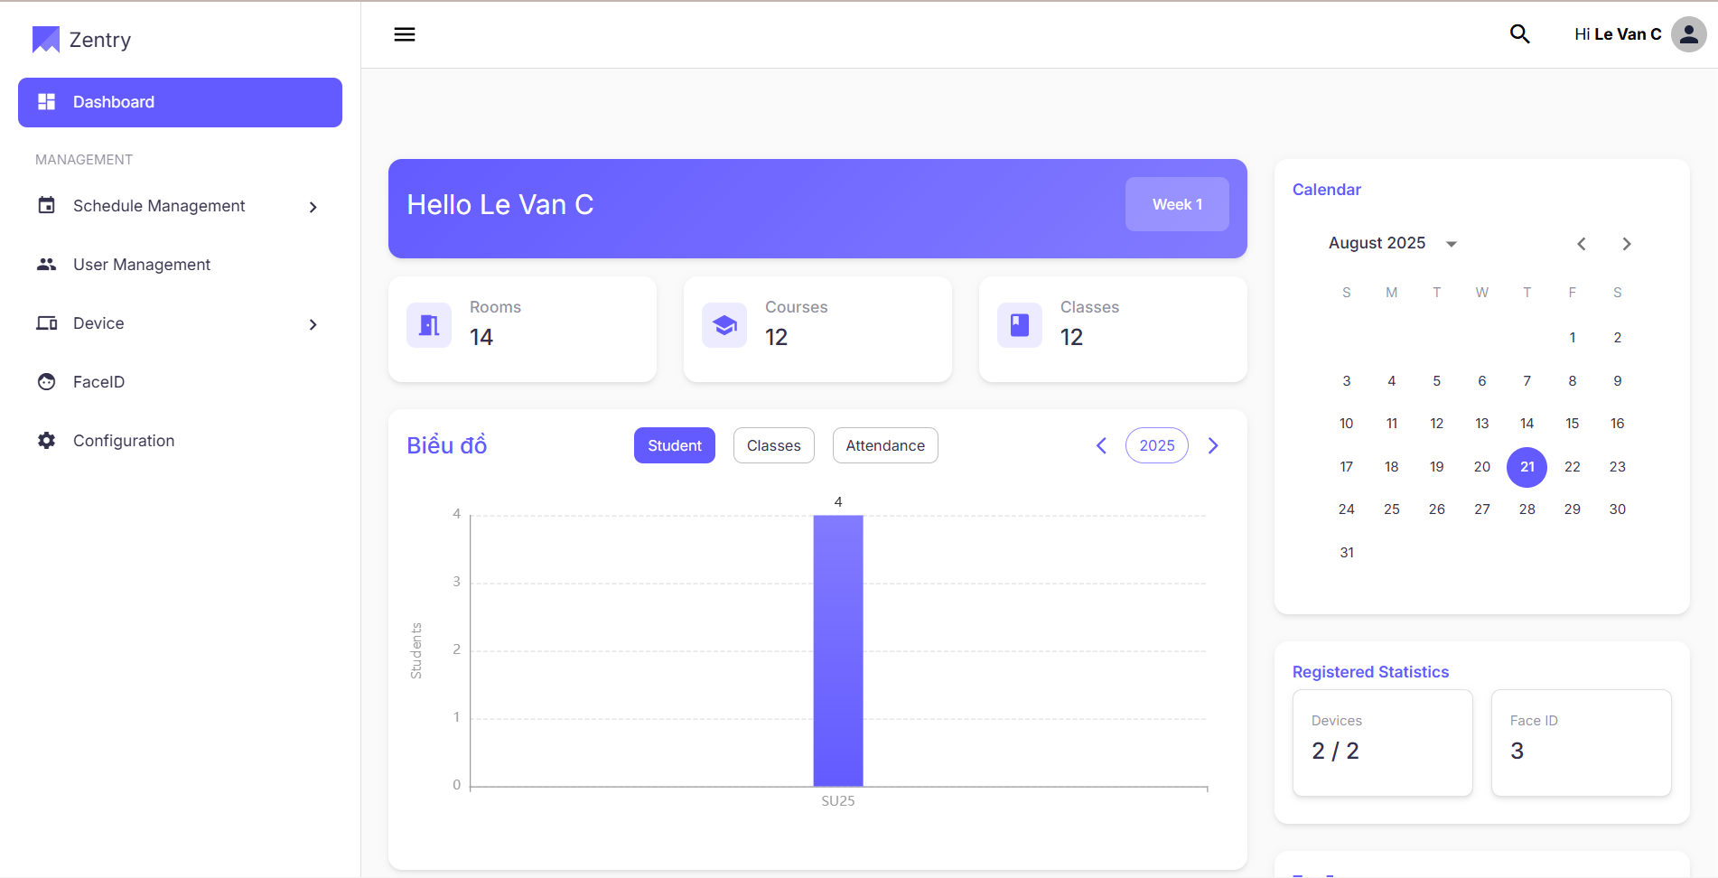
Figure 2: Web Interface
The web interface of the AAS system is designed exclusively for Admin users, allowing them to manage the entire attendance infrastructure.
Key Features:
Dashboard: View attendance trends, system status, and performance metrics.
User Management: Create, update, or remove student and lecturer accounts.
Schedule Management: Import and manage class schedules.
Device Management: Register, update, or delete attendance devices.
Attendance Rules: Configure thresholds and attendance detection rules to ensure accurate attendance tracking.
All admin functions are accessible via the web with secure login and role-based access control.

1.3.2. Mobile Interface
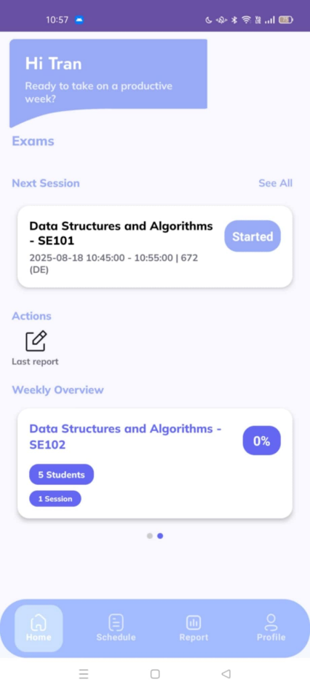
Figure 3: Mobile Interface
The mobile interface of the AAS system is designed to be role-aware and dynamically adjusts its features based on the logged-in user’s role (Student, Lecturer, or Admin). The interface is optimized for Android devices with a clean, grid-based layout and icon-driven navigation.
Key Features (Displayed based on role):
- Attendance Sessions
  - Student: Join sessions using Bluetooth or face recognition.
  - Lecturer: Start and manage attendance sessions.
  - Attendance Reports
- Student: View personal attendance history.
- Lecturer/Admin: View class/session statistics.
- Manage Users
- Admin only: Manage student and lecturer accounts.
- Schedule
- Student: View timetable.
- Lecturer/Admin: Manage or import class schedules.
- Face ID
Register, update, or verify face ID for attendance purposes.
- Settings
Configure preferences, notifications, and attendance options.

1.4. Hardware Interfaces
The system interacts with various hardware to ensure compatibility and functionality across devices and environments.
Mobile Devices:
- Android smartphones and tablets (Android 6.0 or later) with standard hardware configurations, including touchscreen and sensors.
- Internet connectivity for specific external device integration.
Web Browsers:
- Optimized for modern browsers like Chrome, Edge, and Firefox for web-based administration.
API Servers:
Requires servers with Docker capabilities for deployment of the API and backend systems.

2. User Requirements

2.1. Actors
No | Actor | Description
1 | Admin | A system administrator responsible for managing users, devices, schedules, and configuring attendance rules.
2 | Authorized User | A verified user who has signed in and can manage settings, register devices, and receive notifications.
3 | Student | A user who inherits all functions of an Authorized User and can join attendance sessions, view personal attendance.
4 | Lecturer | A user who inherits all functions of an Authorized User and can manage attendance sessions, view teaching schedules.
Table 2: Actors Description

2.2. Use Cases

2.2.1. Diagrams

2.2.1.1. Admin
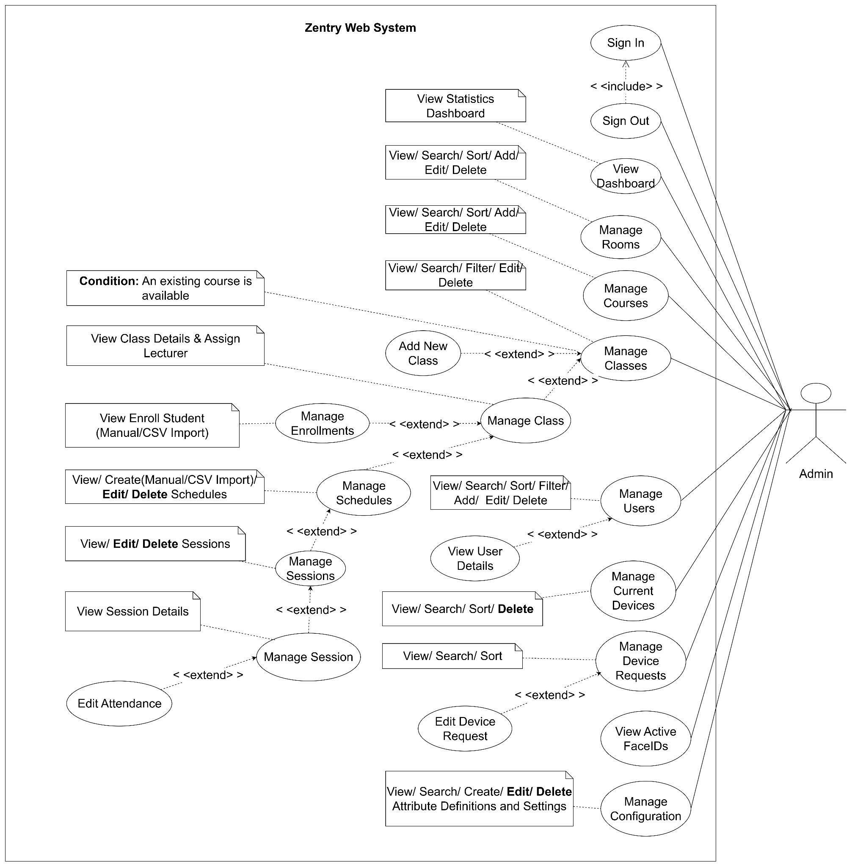
Figure 4: Use Cases Diagram - Admin

2.2.1.2. Authorized User
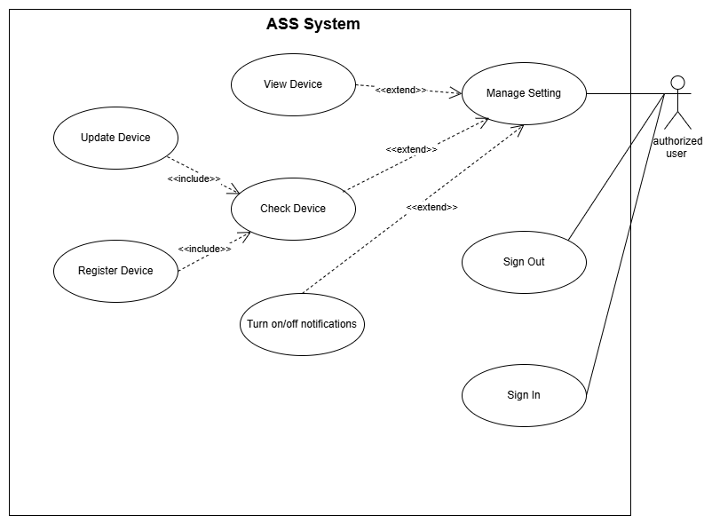
Figure 5: Use Cases Diagram - Authorized User

2.2.1.3. Student
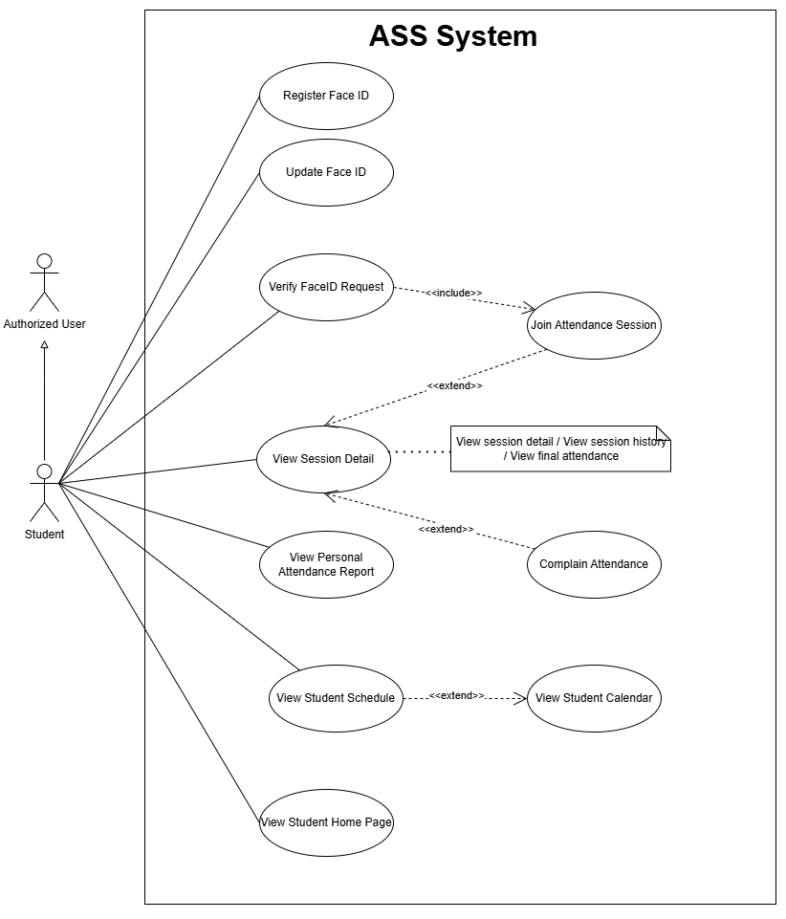
Figure 6: Use Cases Diagram – Student

2.2.1.4. Lecturer
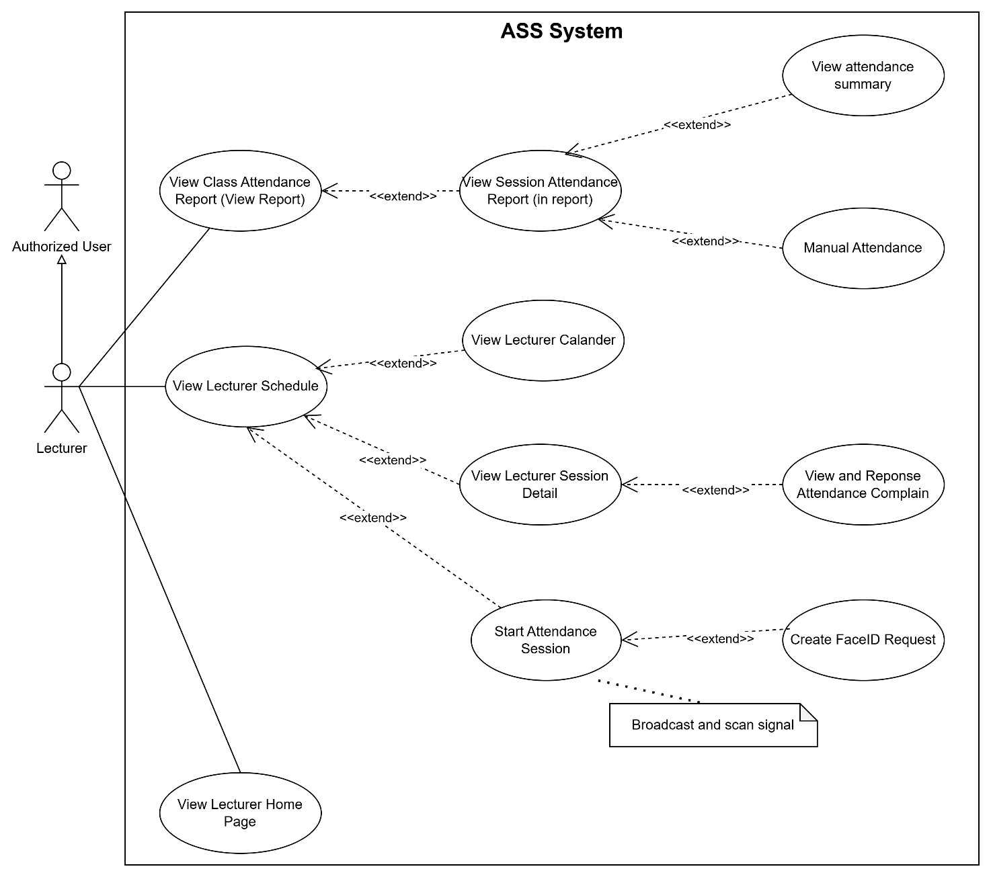
Figure 7: Use Cases Diagram – Lecturer

2.2.2. Use case Descriptions
No | Use Case | Actor | Definitions
UC-01 | Sign In | Student, Lecturer, Admin | Login using registered credentials or linked OAuth account.
UC-02 | Sign Out | Student, Lecturer, Admin | Securely sign out of the application.
UC-03 | View Student Setting | Student | View/manage settings: profile, notifications, device, FaceID, logout.
UC-04 | View Lecture Setting | Lecturer | View/manage settings: profile, notifications, device, logout.
UC-05 | View Profile | Student, Lecturer | Display user profile details.
UC-06 | View Device | Student, Lecturer | View registered devices and update info.
UC-07 | Register Device | Student, Lecturer | Register Bluetooth-capable devices for attendance.
UC-08 | View FaceID | Student, Lecturer | View and manage registered Face ID.
UC-09 | Register Face ID | Student | Register facial data for secure login/attendance.
UC-10 | Update Face ID | Student | Update Face ID if already registered.
UC-11 | View Student Home Page | Student | Display upcoming schedule and announcements.
UC-12 | View Student Schedule | Student | Show student timetable and sessions.
UC-13 | View Student Calendar | Student, Lecturer | View calendar format with classes and session details.
UC-14 | View Personal Attendance Report | Student | View attendance percentage per subject/semester.
UC-15 | Backfill Data | System | Backfill offline data when reconnected.
UC-16 | Join Attendance Session | Student | Join an active roll call session.
UC-17 | View Session Detail | Student | View session info, history, and final attendance.
UC-18 | Verify FaceID Request | Student | Verify identity via Face ID during session.
UC-19 | View Lecturer Home Page | Lecturer | Teaching overview: subjects, student stats, progress.
UC-20 | View Lecturer Schedule | Lecturer | View teaching schedule and access sessions.
UC-21 | View Lecturer Calendar | Lecturer | Calendar of scheduled classes and activities.
UC-22 | View Lecturer Session Detail | Lecturer | Detailed session info: history, total duration, stats.
UC-23 | View Class Attendance Report | Lecturer | View class-level attendance summaries.
UC-24 | View Session Attendance Report | Lecturer | View detailed report of each session.
UC-25 | Broadcast and Scan Signal | Student, Lecturer | Start Bluetooth scan to trigger attendance.
UC-26 | Create FaceID Request | Lecturer | Request Face ID verification during the session.
UC-27 | Automotive Attendance | Lecturer | Auto-take attendance via Bluetooth.
UC-28 | Manual Attendance | Lecturer | Mark attendance manually (within 24h).
UC-29 | Start Attendance Session | Lecturer | Start a new attendance session (manual/auto).
UC-30 | View Dashboard | Admin | Provide an overview of key statistics, schedules, and summary cards, charts, and highlights.
UC-31 | View Rooms | Admin | Admin views all rooms with search, filter, and pagination.
UC-32 | Add Room | Admin | Admin adds a new room (name, building, capacity, status).
UC-33 | Edit Room | Admin | Admin edits an existing room’s details.
UC-34 | Delete Room | Admin | Admin deletes a room (if not referenced or with safe checks).
UC-35 | View Courses | Admin | Admin views all courses with search/filter.
UC-36 | Add Course | Admin | Admin creates a new course (code, name, description, semester).
UC-37 | Edit Course | Admin | Admin updates course information.
UC-38 | Delete Course | Admin | Admin deletes a course (with dependency validation).
UC-39 | View Classes | Admin | Admin views all classes (by course/semester/lecturer).
UC-40 | Edit Class | Admin | Admin edits class info (lecturer, section, schedule links).
UC-41 | Delete Class | Admin | Admin deletes a class (respecting constraints/history).
UC-42 | Add Class | Admin | Admin adds a new class and links it to a course/semester.
UC-43 | View Class Details | Admin | Admin views detailed class info (students, sessions, stats).
UC-44 | Assign Lecturer | Admin | Admin assigns a lecturer to a class (or reassigns).
UC-45 | View Enrolled Student | Admin | Admin views enrolled students of a class.
UC-46 | Import Student | Admin | Admin imports students in bulk (e.g., CSV/Excel).
UC-47 | Enroll Student | Admin | Admin enrolls a student into a class.
UC-48 | View Schedules | Admin | Admin views all schedules (filters by room/class/date).
UC-49 | Add Schedule | Admin | Admin creates a schedule entry (time, room, class).
UC-50 | Edit Schedule | Admin | Admin edits a schedule entry.
UC-51 | Delete Schedule | Admin | Admin deletes a schedule entry.
UC-52 | View Sessions | Admin | Admin views sessions (planned and completed).
UC-53 | Edit Session | Admin | Admin edits a session (time/room/status/notes).
UC-54 | Delete Session | Admin | Admin deletes a session (with audit constraints).
UC-55 | View Session Details | Admin | Admin views session details (attendance list, metrics).
UC-56 | Edit Attendance | Admin | Admin edits attendance records for a session (audited).
UC-57 | View Users | Admin | Admin views users (students/lecturers/admins) with filters.
UC-58 | Add User | Admin | Admin adds a new user account.
UC-59 | Import User | Admin | Admin imports users in bulk (CSV/Excel).
UC-60 | Edit User | Admin | Admin edits user information (name, email, role, etc.).
UC-61 | Change User Status | Admin | Admin changes a user’s status (activate/deactivate/lock).
UC-62 | View User Details | Admin | Admin views detailed user profile and activity.
UC-63 | View Active Devices | Admin | Admin views active devices linked to users.
UC-64 | Inactive Device | Admin | Admin marks a device as inactive/disabled.
UC-65 | View Device Requests | Admin | Admin views incoming device registration requests.
UC-66 | Edit Device Request | Admin | Admin reviews and updates a device request (approve/reject, notes).
UC-67 | View Active FaceIDs | Admin | Admin views active FaceIDs (approved/usable records).
UC-68 | View Attribute Definitions | Admin | Admin views attribute definitions used by the system.
UC-69 | Create Attribute Definition | Admin | Admin creates a new attribute definition.
UC-70 | Update Attribute Definition | Admin | Admin updates an existing attribute definition.
UC-71 | Delete Attribute Definition | Admin | Admin deletes an attribute definition (with validation).
UC-72 | View Settings | Admin | Admin views global/system settings.
UC-73 | Create Setting | Admin | Admin creates a new setting (key/value or structured).
UC-74 | Update Setting | Admin | Admin updates an existing setting.
UC-75 | Delete Setting | Admin | Admin deletes a setting (with safety checks).
UC-76 | Process Attendance Data | System | Validate and store submitted attendance records.
UC-77 | Store Local Attendance Data | System (Mobile) | Temporarily store attendance offline when the device is disconnected.
Table 3: Use Cases Descriptions

2.3. Business Rules
Code | Business Rule | Definitions
BR-01 | User Authentication Required | All users must sign in using valid credentials or OAuth before accessing the system.
BR-02 | Role-Based Access Control | Only authorized roles (Student, Lecturer, Admin) can access specific functions.
BR-03 | Device Registration Required | Only approved devices can be used for attendance and FaceID verification.
BR-04 | FaceID Registration Required | Students must register FaceID before joining FaceID-based attendance.
BR-05 | Attendance Session Timeframe | Joining or broadcasting an attendance session is only allowed within the configured time slots.
BR-06 | Only One Active Attendance Session | Each class can only have one active attendance session at a time.
BR-07 | Manual Attendance Adjustment Deadline | Manual attendance must be completed within 24 hours after the session ends.
BR-08 | Admin Approval for Device Updates | Device update/registration must be approved by Admin before use.
BR-09 | Only Lecturer Can Modify Attendance | Only Lecturers are allowed to modify attendance records. Students and Admins cannot make changes.
BR-10 | Automatic Data Synchronization | Offline attendance data must be automatically synchronized once the connection is restored.
BR-11 | Attendance Threshold Configurable | Admin can define attendance thresholds (e.g., 10%, 20%) for monitoring purposes.
BR-12 | Attendance History Must Be Stored | All attendance session data must be stored for reporting and auditing purposes.
BR-13 | Admin Manages Schedules and Users | Only Admin has CRUD rights over schedules and user accounts.
BR-14 | Attendance Data Backup Required | The system must ensure automatic backup and recovery of attendance data.
BR-15 | Hidden Device Scanning Time | The system automatically scans nearby devices for attendance purposes, but Lecturers and Students are not informed of when the scan occurs to ensure security and prevent cheating.
Table 4: Business Rules

No | Actor | Description
1 | Admin | A system administrator responsible for managing users, devices, schedules,  and configuring attendance rules.
2 | Authorized  User | A verified user who has signed in and can manage settings, register devices,  and receive notifications.
3 | Student | A user who inherits all functions of an Authorized User and can join  attendance sessions, view personal attendance.
4 | Lecturer | A user who inherits all functions of an Authorized User and can manage  attendance sessions, view teaching schedules.
Table 5: Actors Description

3. Functional Requirements

3.1. System Functional Overview

3.1.1. Screens Flow
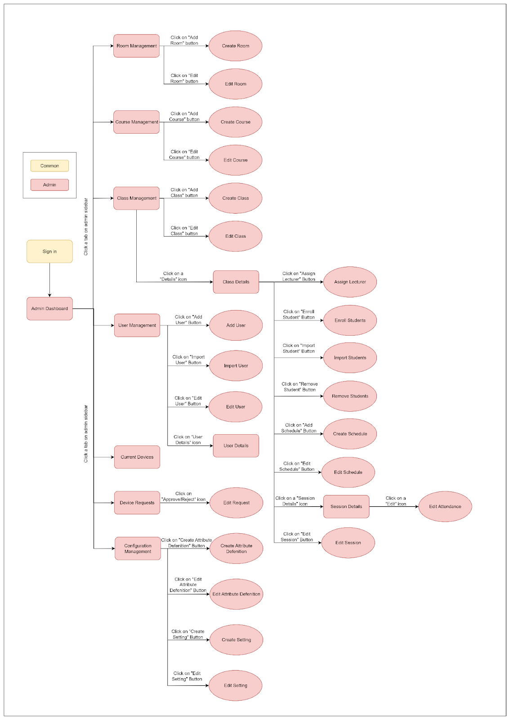
Figure 8: AAS Web System Screens Flow Diagram
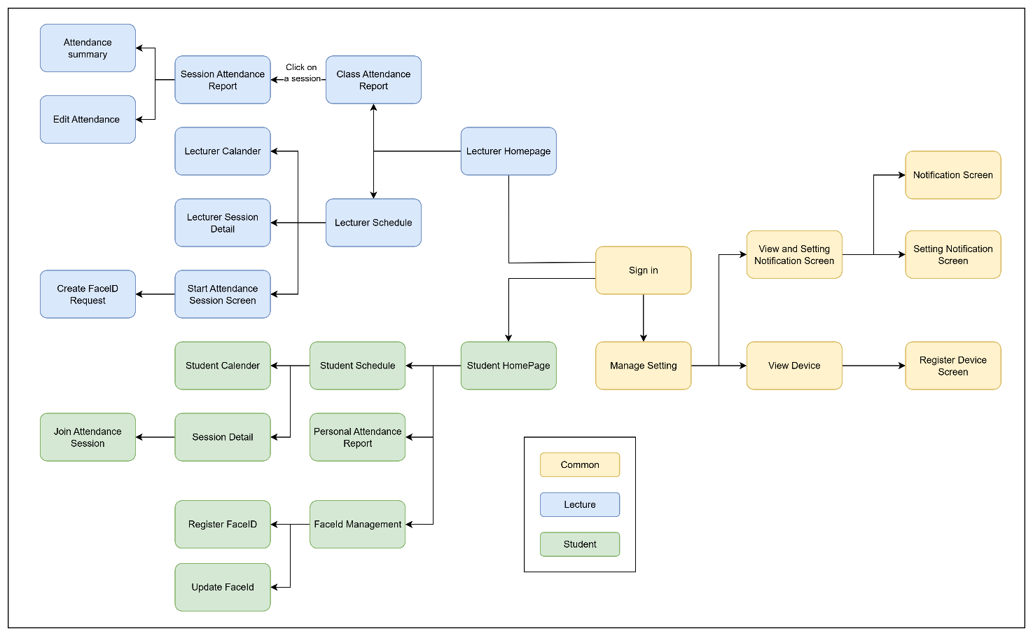
Figure 9: AAS Mobile System Screens Flow Diagram

3.1.2. Screen Descriptions
No | Name | Role | Description
Website Screen
 |  |  | Description
1 | Sign In | Admin | Allows admin to securely log into the system using credentials.
2 | Admin Dashboard | Admin | Displays system overview including statistics of rooms, courses, classes, users, devices, and schedules.
3 | Room Management | Admin | Provides a list of all available rooms with options to view, filter, and manage.
4 | Create Room | Admin | Enables admin to add a new room with details such as name, building, and capacity.
5 | Edit Room | Admin | Allows modification of existing room information.
6 | Course Management | Admin | Provides a list of courses with search and filtering functions.
8 | Create Course | Admin | Enables admin to create a new course by defining code, name, description, and semester.
9 | Edit Course | Admin | Allows editing course information already stored in the system.
10 | Class Management | Admin | Displays list of classes grouped by semester, with options for detail view.
11 | Create Class | Admin | Supports creating new classes linked to specific courses and lecturers.
12 | Edit Class | Admin | Allows updating class details such as section code, semester, or assigned lecturer.
13 | Class Details | Admin | Provides detailed information of a selected class including enrolled students and sessions.
14 | Assign Lecturer | Admin | Enables assigning lecturers to a specific class.
15 | Enroll Students | Admin | Enroll Students – Allows admin to manually enroll students into a class.
16 | Import Students | Admin | Import Students – Supports bulk student enrollment via file import.
17 | Remove Students | Admin | Remove Students – Allows removal of selected students from a class.
18 | Create Schedule | Admin | Create Schedule – Enables creation of session schedules for a class.
19 | Edit Schedule | Admin | Edit Schedule – Provides options to update existing session schedules.
20 | Session Details | Admin | Session Details – Displays details of a specific session including attendance records.
21 | Edit Session | Admin | Edit Session – Allows admin to adjust session details such as date, time, or room.
22 | Edit Attendance | Admin | Edit Attendance – Enables correction or update of student attendance records.
23 | User Management | Admin | User Management – Displays list of system users including Admin, Lecturer, and Student roles.
24 | Add User | Admin | Add User – Allows manual addition of a new user with account details.
25 | Import User | Admin | Import User – Supports bulk creation of users via file upload.
26 | Edit User | Admin | Edit User – Provides functionality to update existing user information.
27 | User Details | Admin | User Details – Displays detailed profile information of a selected user.
28 | Current Devices | Admin | Current Devices – Shows list of devices currently approved and linked to users.
29 | Device Requests | Admin | Device Requests – Lists pending device registration requests awaiting admin approval.
30 | Edit Request | Admin | Edit Request – Allows admin to approve or reject device requests.
31 | Configuration Management | Admin | Configuration Management – Provides system-wide configuration options for attributes and definitions.
32 | Create Attribute | Admin | Create Attribute – Enables creation of new custom attributes in the system.
33 | Edit Attribute | Admin | Edit Attribute – Allows modification of existing attributes.
34 | Create Definition | Admin | Create Definition – Supports creation of definitions for use in system configurations.
35 | Edit Definition | Admin | Edit Definition – Allows editing of definitions already created.
Mobile Screen
01 | Sign in | Common | Login screen for both students and lecturers
02 | Manage Setting | Common | Manage personal preferences and application settings
03 | View and Setting Notification Screen | Common | View the list of notifications and configure preferences
04 | Setting Notification Screen | Common | Configure individual notification types and behaviors
05 | View Device | Common | Display the registered device information
06 | Register Device Screen | Common | Register a new device to the system
07 | Update Device Screen | Common | Edit or update information of an existing device
08 | Student HomePage | Student | Main landing screen after login, showing summary information
09 | Student Calendar | Student | Calendar view of scheduled sessions
10 | Student Schedule | Student | Detailed list view of class schedule
11 | Session Detail | Student | View full details about a selected session
12 | Join Attendance Session | Student | Join and check in to an active session
13 | Personal Attendance Report | Student | View personal attendance history and statistics
14 | FaceID Management | Student | Manage registered FaceID data for attendance
15 | Register FaceID | Student | Register new facial data for the attendance system
16 | Update FaceID | Student | Update existing facial recognition data
17 | Lecturer Homepage | Lecturer | Main dashboard for lecturers after logging in
18 | Lecturer Schedule | Lecturer | View the list of upcoming teaching sessions
19 | Lecturer Calendar | Lecturer | Calendar view of lecturer’s schedule
20 | Lecturer Session Detail | Lecturer | Detailed information about a specific teaching session
21 | Start Attendance Session Screen | Lecturer | Start a new attendance-taking session
22 | Create FaceID Request | Lecturer | Submit request to register FaceID for a student
23 | Manual Attendance | Lecturer | Manually mark attendance for students
24 | Session Attendance Report | Lecturer | View attendance report for a single session
25 | Class Attendance Report | Lecturer | Aggregate attendance report for an entire class
26 | Attendance Summary | Lecturer | Summary of attendance across all sessions
Table 6: Screens Description

3.1.3. Screen Authorization
No | Name | Platform | Admin | Student | Lecturer
1 | Sign in | Web/Mobile | ✔ | ✔ | ✔
2 | Admin Dashboard | Web | ✔ | ✖ | ✖
3 | Room Management | Web | ✔ | ✖ | ✖
4 | Create Room | Web | ✔ | ✖ | ✖
5 | Edit Room | Web | ✔ | ✖ | ✖
6 | Course Management | Web | ✔ | ✖ | ✖
7 | Create Course | Web | ✔ | ✖ | ✖
8 | Edit Course | Web | ✔ | ✖ | ✖
9 | Class Management | Web | ✔ | ✖ | ✖
10 | Create Class | Web | ✔ | ✖ | ✖
11 | Edit Class | Web | ✔ | ✖ | ✖
12 | Class Details | Web | ✔ | ✖ | ✖
13 | Assign Lecturer | Web | ✔ | ✖ | ✖
14 | Enroll Students | Web | ✔ | ✖ | ✖
15 | Import Students | Web | ✔ | ✖ | ✖
16 | Remove Students | Web | ✔ | ✖ | ✖
17 | Create Schedule | Web | ✔ | ✖ | ✖
18 | Edit Schedule | Web | ✔ | ✖ | ✖
19 | Session Details | Web | ✔ | ✖ | ✖
20 | Edit Session | Web | ✔ | ✖ | ✖
21 | Edit Attendance | Web | ✔ | ✖ | ✖
22 | User Management | Web | ✔ | ✖ | ✖
23 | Add User | Web | ✔ | ✖ | ✖
24 | Import User | Web | ✔ | ✖ | ✖
25 | Edit User | Web | ✔ | ✖ | ✖
26 | User Details | Web | ✔ | ✖ | ✖
27 | Current Devices | Web | ✔ | ✖ | ✖
28 | Device Requests | Web | ✔ | ✖ | ✖
29 | Edit Request | Web | ✔ | ✖ | ✖
30 | Configuration Management | Web | ✔ | ✖ | ✖
31 | Create Attribute Definition | Web | ✔ | ✖ | ✖
32 | Edit Attribute Definition | Web | ✔ | ✖ | ✖
33 | Create Setting | Web | ✔ | ✖ | ✖
34 | Edit Setting | Web | ✔ | ✖ | ✖
35 | Manage Setting | Mobile | ✖ | ✔ | ✔
36 | View and Setting Notification | Mobile | ✖ | ✔ | ✔
38 | Setting Notification | Mobile | ✖ | ✔ | ✔
39 | View Device | Mobile | ✖ | ✔ | ✔
40 | Register Device | Mobile | ✖ | ✔ | ✔
41 | Update Device | Mobile | ✖ | ✔ | ✔
42 | Student Homepage | Mobile | ✖ | ✔ | ✖
43 | Student Calendar | Mobile | ✖ | ✔ | ✖
44 | Student Schedule | Mobile | ✖ | ✔ | ✖
45 | Session Detail | Mobile | ✖ | ✔ | ✔
46 | Join Attendance Session | Mobile | ✖ | ✔ | ✖
48 | Personal Attendance Report | Mobile | ✖ | ✔ | ✖
49 | FaceID Management | Mobile | ✖ | ✔ | ✖
50 | Register FaceID | Mobile | ✖ | ✔ | ✖
51 | Update FaceID | Mobile | ✖ | ✔ | ✖
52 | Lecturer Homepage | Mobile | ✖ | ✖ | ✔
53 | Lecturer Schedule | Mobile | ✖ | ✖ | ✔
54 | Lecturer Calendar | Mobile | ✖ | ✖ | ✔
55 | Lecturer Session Detail | Mobile | ✖ | ✖ | ✔
56 | Start Attendance Session | Mobile | ✖ | ✖ | ✔
57 | Create FaceID Request | Mobile | ✖ | ✖ | ✔
59 | Manual Attendance | Mobile | ✖ | ✖ | ✔
60 | Session Attendance Report | Mobile | ✖ | ✖ | ✔
61 | Class Attendance Report | Mobile | ✖ | ✖ | ✔
62 | Attendance Summary | Mobile | ✖ | ✖ | ✔
Table 7: Screen Authorization

3.1.5. Entity Relationship

3.1.5.1. Diagram
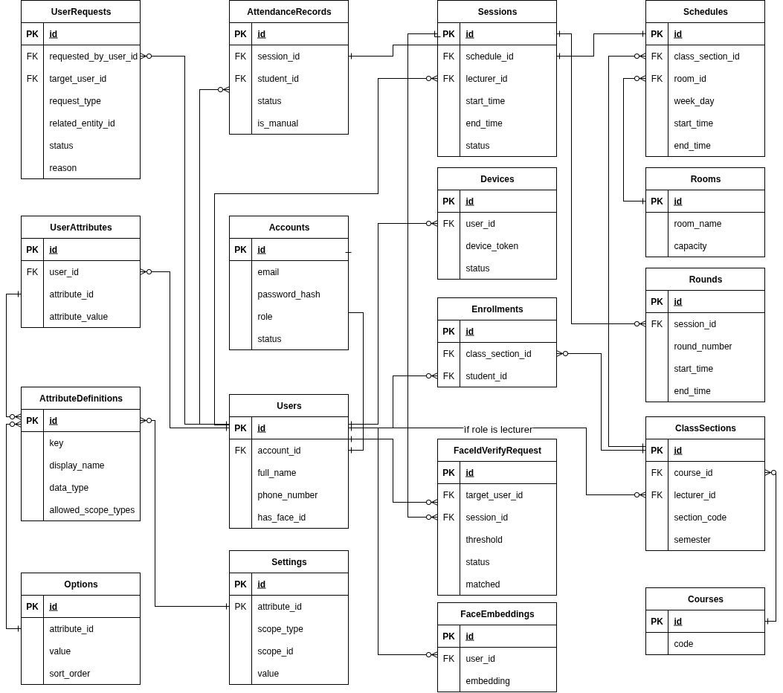
Figure 10.1: SQL Diagram
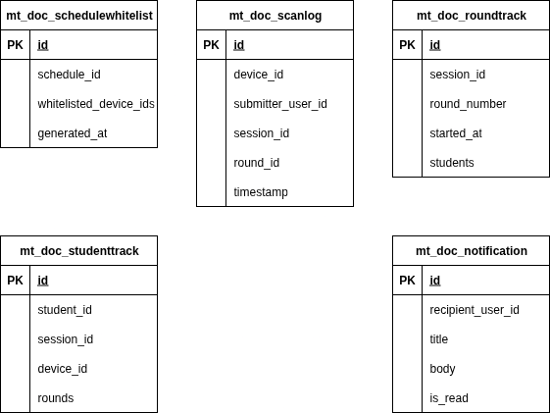
Figure 10.2: NoSQL Diagram

3.1.5.2. Description
No | Name | Description
1 | Users | List of users in the system
2 | Accounts | Login account information for users
3 | UserRequests | Requests created by users
4 | UserAttributes | Custom attributes associated with users
5 | AttributeDefinitions | Definitions of user attribute types
6 | AttendanceRecords | Attendance logs of users in sessions/events
7 | Devices | Devices used for attendance or system management
8 | Sessions | Specific session of a course
9 | Rounds | Attendance rounds within a session
10 | Enrollments | Records of users enrolled in courses
11 | Courses | Information about courses
12 | Schedules | Course schedules
13 | Rooms | Classrooms where sessions are held
14 | Settings | System settings or configuration data
15 | Options | Shared selectable values or configuration options
16 | ClassSections | Course sections with lecturer assignments
17 | FaceIdVerifyRequests | Face recognition verification requests
18 | FaceEmbeddings | Encrypted facial recognition data for user identification
19 | mt_doc_schedulewhitelist | Whitelisted devices for schedule access
20 | mt_doc_scanlog | Device scanning activity logs during sessions
21 | mt_doc_roundtrack | Attendance round progress tracking
22 | mt_doc_studenttrack | Individual student attendance patterns
23 | mt_doc_notification | User notifications and system messages
Table 8: Entity description

3.2. System Functional Details

3.2.1. Website

3.2.1.1 Sign in
a. Screen Layouts
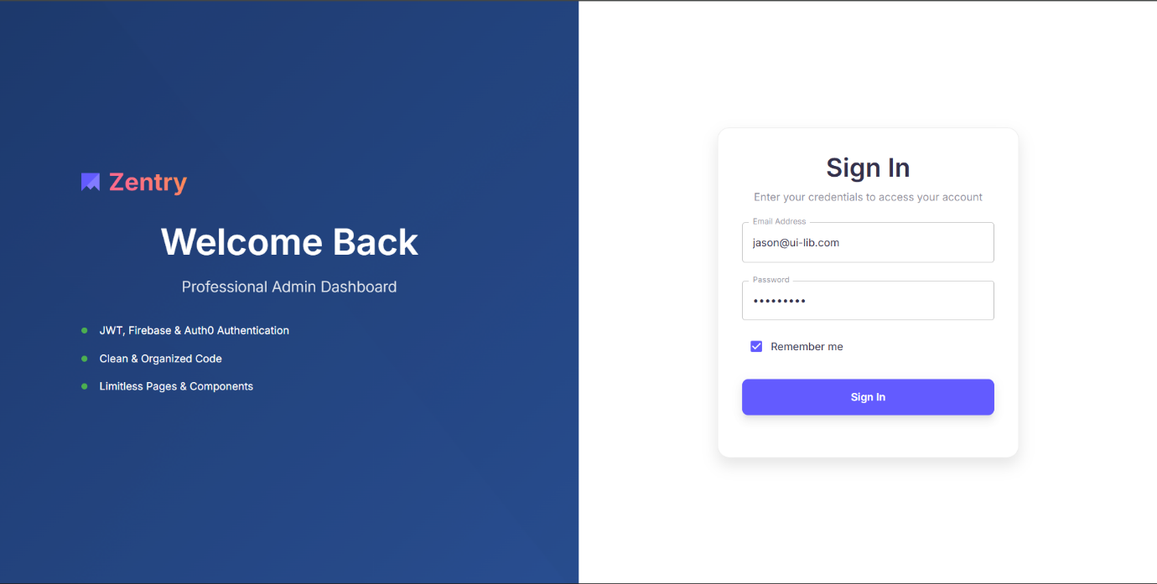
Figure 11: Sign in - Sign in form
No | Field Name | Field Type | Description
1 | Welcome Back | Label | Greeting text on the left panel.
2 | Subtitle Text | Label | Informational bullets (e.g., “Professional Admin Dashboard”).
3 | Sign In | Label | Header text for the form.
4 | Instruction | Label | “Enter your credentials to access your account.”
5 | Email Address | Textbox | User email. Validation: must be a valid email format.
6 | Password | Password | User password. Validation: not empty; min length per BR.
7 | Remember me | Checkbox | Persist session on this device.
8 | Sign In | Button | Submit credentials for verification.
9 | Error message area | Label | Displays errors (invalid credentials, system issues, timeout).
Table 9: Sign In - Sign in form

b. Use Case Specifications
ID and Name | UC01 - Sign in
Created By | DungND | Date Created | 28/06/2025
Primary Actor | Admin | Secondary Actors | System
Trigger | The user opens the website and attempts to log in using username/email and password.
Description | As a user, I want to log in securely so that I can access system features according to my role.
Preconditions | PRE-1. The user has a registered account.  PRE-2. The system is online and operational.
Postconditions | POST- 1. The user is redirected to the corresponding dashboard based on their role.
Normal Flows | Step | By | Step Details
Normal Flows | 1 | User | Open a website
Normal Flows | 2 | User | Enter email and password (optionally check “Remember me”).
Normal Flows | 3 | System | Validate credentials against the user store.
Normal Flows | 4 | System | If valid, identify the user’s role.
Normal Flows | 5 | System | Redirect the user to the corresponding dashboard.
Alternative Flows | Alt Step | Condition | Description
Exceptions | - E1: Invalid credentials → show error message and allow retry.  - E2: System/database error → show “temporarily unavailable”.  - E3: Login request timeout/session expired → prompt user to try again.
Frequency of Use | High
Business Rules | BR-01, BR-02
Other Information | All login attempts are logged for security auditing and monitoring.
Assumptions | Users are pre-registered by Admin or via batch import.  Stable internet connection during login.
Table 10: Sign In Specification

3.2.1.2. Sign out
a. Screen Layouts
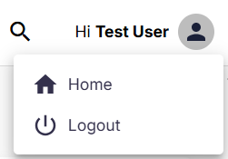
Figure 12: Sign Out - Avatar Dropdown
No | Field Name | Field Type | Description
1 | Avatar Icon | Icon/Button | Displays the user avatar; when clicked, it opens the dropdown menu.
2 | Home Option | Menu Item | Navigation option that redirects the user to the Home page.
3 | Logout Option | Menu Item | Allows the user to sign out from the system.
4 | Dropdown Menu | Container | The component that contains and displays the list of options (Home, Logout).
Table 11: Sign out
b. Use Case Specifications
ID and Name | UC02 - Sign out
Created By | DungND | Date Created | 28/06/2025
Primary Actor |  | Secondary Actors | System
  Admin
Trigger
  The user opens the header user menu and selects Logout.
Description | As a user, I want to securely sign out so that my session is terminated and my account cannot be accessed from this device without signing in again.
Preconditions | PRE-1. The user is authenticated.  PRE-2. The system is online and operational.
Postconditions | POST- 1. Current session and any refresh token are invalidated/revoked server-side.  POST- 2. Client-side auth artifacts (cookies, local storage) are cleared.  POST- 3. User is redirected to the Sign In page.
Normal Flows | Step | By | Step Details
Normal Flows | 1 | User | Clicks User avatar → menu opens.
Normal Flows | 2 | User | Click Logout.
Normal Flows | 3 | User | Clicks Sign out in the dialog.
Normal Flows | 4 | System | Invalidates server session/refresh token; clears client cookies/storage. (Logs the event.)
Normal Flows | 5 | System | Redirects to Sign In and shows optional toast “Signed out.”
Alternative Flows | Alt Step | Condition | Description
Alternative Flows | A1 | Session already expired | System clears local artifacts and redirects to Sign In with notice “Session expired.”
Exceptions | - E1: Server error while invalidating session → show error “Sign-out failed, please try again”; user stays signed in.  - E2: Network error → show warning; allow retry. If the user chooses Force sign out, clear local artifacts and redirect (best-effort log).  - E3: Client storage cannot be cleared → show instruction to refresh/close browser and try again.
Frequency of Use | High
Business Rules
  BR-01, BR-02
Other Information | - Use secure, HttpOnly cookies for session/refresh tokens where applicable.  - Set cache headers to prevent back-button access to protected pages after sign-out.
Assumptions | - The application uses cookies/session or JWT with refresh tokens; both are revoked on sign-out.  - “Remember me” also clears any persistent refresh token on sign-out.
Table 12: Sign Out Specification

3.2.1.3 View Dashboard
a. Screen Layouts
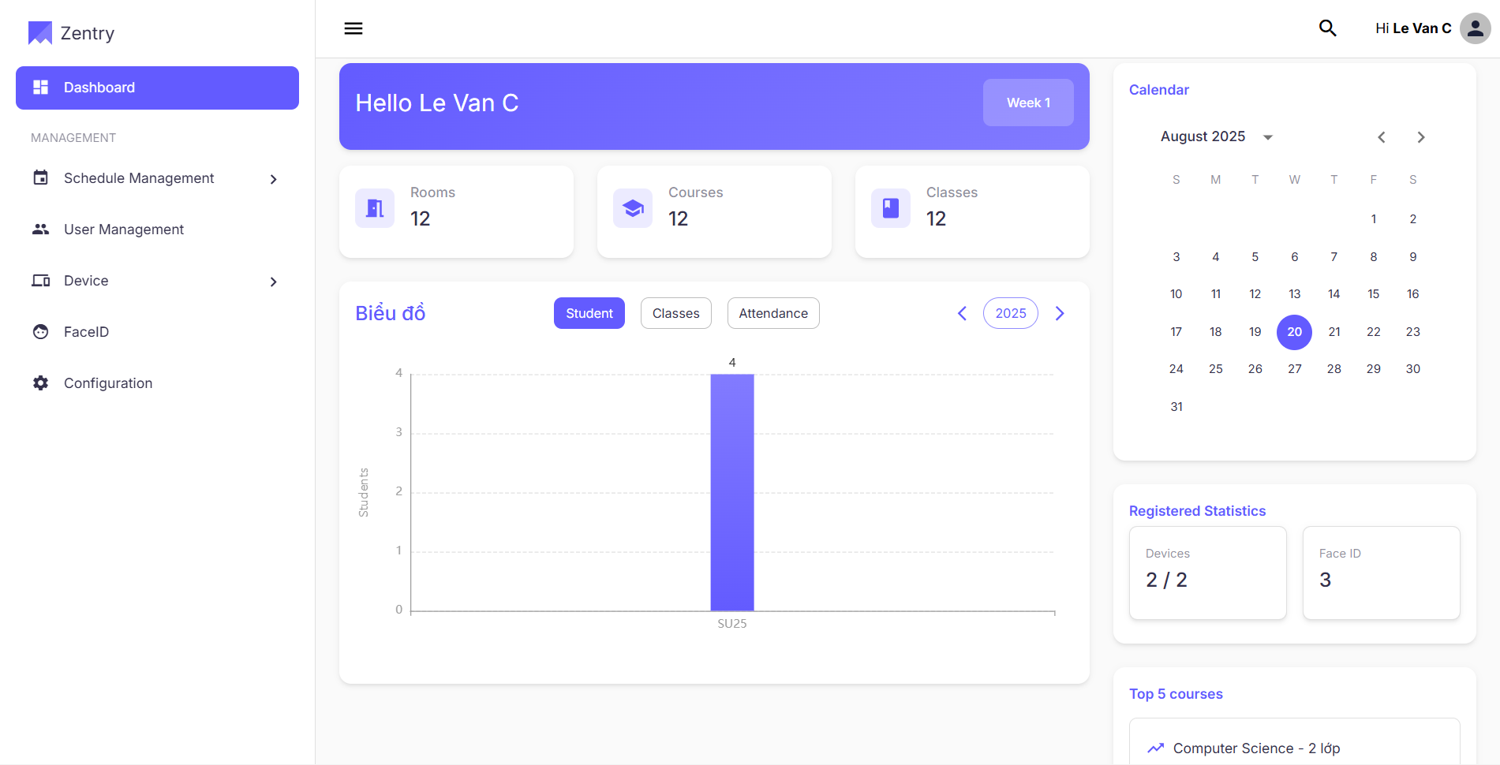
Figure 13: Dashboard
No | Field Name | Field Type | Description
1 | Page Title (“Hello <User>”) | Label | Personalized greeting header.
2 | Week Selector | Panel | Shows current week (e.g., “Week 11”); optional quick jump.
3 | Summary Cards Area | Panel | Hosts Rooms, Courses, Classes cards.
4 | Performance Chart | Panel | Hosts Chart widget + tabs + year navigation.
5 | Calendar | Panel | Monthly calendar widget.
6 | Registered Statistics | Panel | Devices / Face ID counters.
7 | Top 5 Courses | Panel | Ranked course activity list.
Table 13: View Dashboard Layout
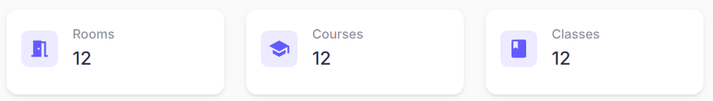
Figure 14: Dashboard
No | Field Name | Field Type | Description
1 | Rooms | Card | Displays total rooms in the system.
2 | Courses | Card | Displays total available courses.
3 | Classes | Card | Displays total scheduled classes.
Table 14: View Dashboard 2
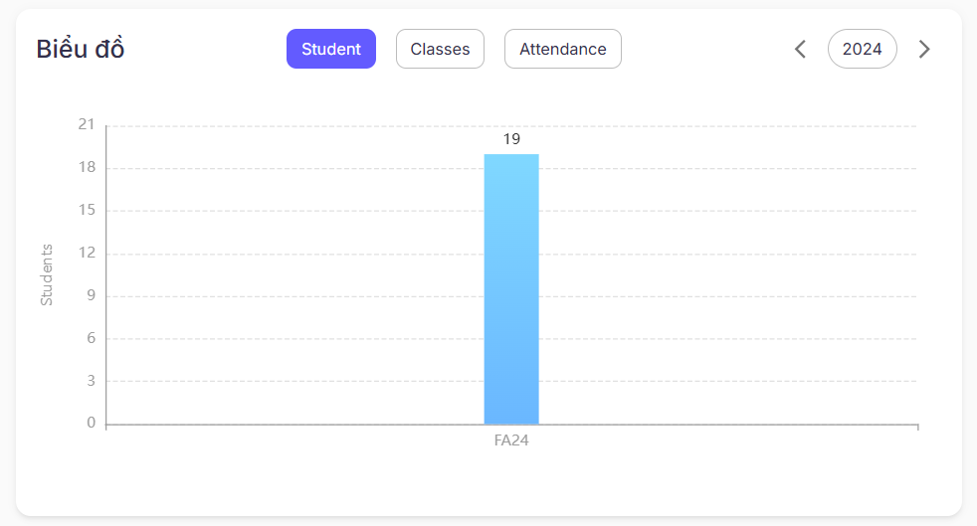
Figure 15: Dashboard
No | Field Name | Field Type | Description
1 | Title (“Chart”) | Label | Section title.
2 | Tab: Student | Tab | Shows student statistics over time.
3 | Tab: Classes | Tab | Shows class statistics over time.
4 | Tab: Attendance | Tab | Shows attendance trend/volume.
5 | Year Selector | Button/Label | Displays selected year (e.g., “2025”).
6 | Prev Year | Icon Button | Navigate to the previous year.
7 | Next Year | Icon Button | Navigate to next year.
8 | Chart Canvas | Chart | Renders series for the selected tab & year (with value labels).
9 | Empty/No-data State | Label | Message shown when there is no data for selection.
Table 15: View Dashboard 3
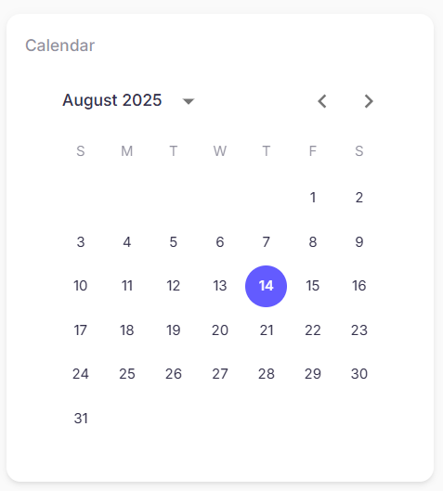
Figure 16: Dashboard
No | Field Name | Field Type | Description
1 | Month Caption | Label | Current month & year (e.g., “August 2025”).
2 | Month Dropdown | Dropdown | Select month/year.
3 | Prev Month | Icon Button | Navigate to the previous month.
4 | Next Month | Icon Button | Navigate to next month.
5 | Day Grid | Calendar | Shows month days; today highlighted.
6 | Day Badge/Events (optional) | Badge | Indicates scheduled classes/events for that day.
Table 16: View Dashboard 4
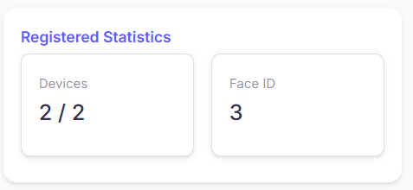
Figure 17: Dashboard
No | Field Name | Field Type | Description
1 | Devices | Stat Card | Total number of registered devices.
2 | Face ID | Stat Card | Total number of registered Face IDs.
Table 17: View Dashboard 5
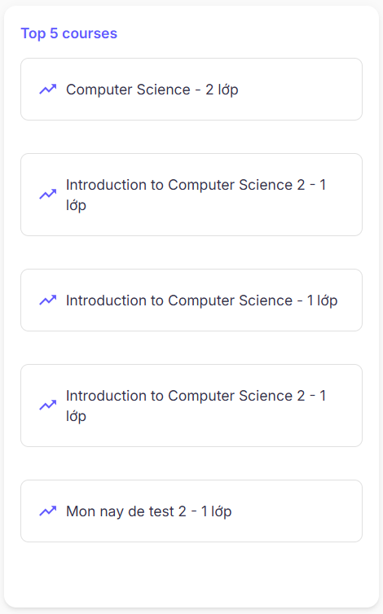
Figure 18: Dashboard
No | Field Name | Field Type | Description
1 | Section Title | Label | “Top 5 courses”.
2 | Course Item | List Item | “<Course name> – <n> classes”; ordered by activity desc.
3 | Empty/No-data State | Label | Message if ranking unavailable.
Table 18: View Dashboard 6
b. Use Case Specifications
ID and Name | UC30 – View Dashboard
Created By | DungND | Date Created | 28/06/2025
Primary Actor | Admin | Secondary Actors | System
Trigger | The user lands on Dashboard after signing in or navigates to Dashboard from the side menu.
Description | The Dashboard provides an overview of key statistics, upcoming schedules, and quick navigation to important modules. It displays summary cards, a calendar, performance charts, registered statistics, and the top 5 most active courses.
Preconditions | PRE-1. The user is authenticated.  PRE-2. User role is authorized to view dashboard data  PRE-3. Relevant data exists (rooms/courses/classes, devices, Face IDs) or graceful empty states are supported.
Postconditions | POST- 1. No data is modified; users may navigate to detailed modules from dashboard widgets.
Normal Flows | Step | By | Step Details
Normal Flows | 1 | User | View Summary Cards (Rooms, Courses, Classes). Each card shows a total and links to its module.
Normal Flows | 2 | User | View Chart section.
Normal Flows | 2.1 | User | Switch chart tabs (Student / Classes / Attendance).
Normal Flows | 2.2 | System | Render data trends for selected category & year.
Normal Flows | 2.3 | User | Navigate years with left/right arrows.
Normal Flows | 3 | User | Check Calendar for the current month; today is highlighted. Use arrows to change month.
Normal Flows | 4 | User | Review Registered Statistics (Devices, Face ID totals).
Normal Flows | 5 | User | View Top 5 Courses ranked by activity (#classes). Click an item to open its course page (if enabled).
Alternative Flows | Alt Step | Condition | Description
Alternative Flows | A1 | Partial API failure | Affected widget shows error + Retry action; other widgets still load.
Exceptions | - E1: Backend unavailable → display toast/banner and per-widget error states; allow manual Retry.  - E2: Data inconsistency (e.g., counts mismatch) → log and show safe fallback (0 or “—”).  - E3: Network timeout → show retry option; preserve user selections (tab/year).
Frequency of Use | High
Business Rules
  BR-01, BR-02
Other Information | - Metrics are read-only aggregates; the refresh strategy may be configurable (auto refresh interval / manual Refresh).  - Accessibility: keyboard navigation for tabs and calendar; ARIA roles on chart/controls.
Assumptions | - Data services expose efficient aggregate endpoints for counts and chart series.  - Timezone and locale are derived from the user profile or the browser.  - If caching is enabled, metrics are eventually consistent within an acceptable delay.
Table 19: View Dashboard Specification

3.2.1.4 View Rooms
a. Screen Layouts
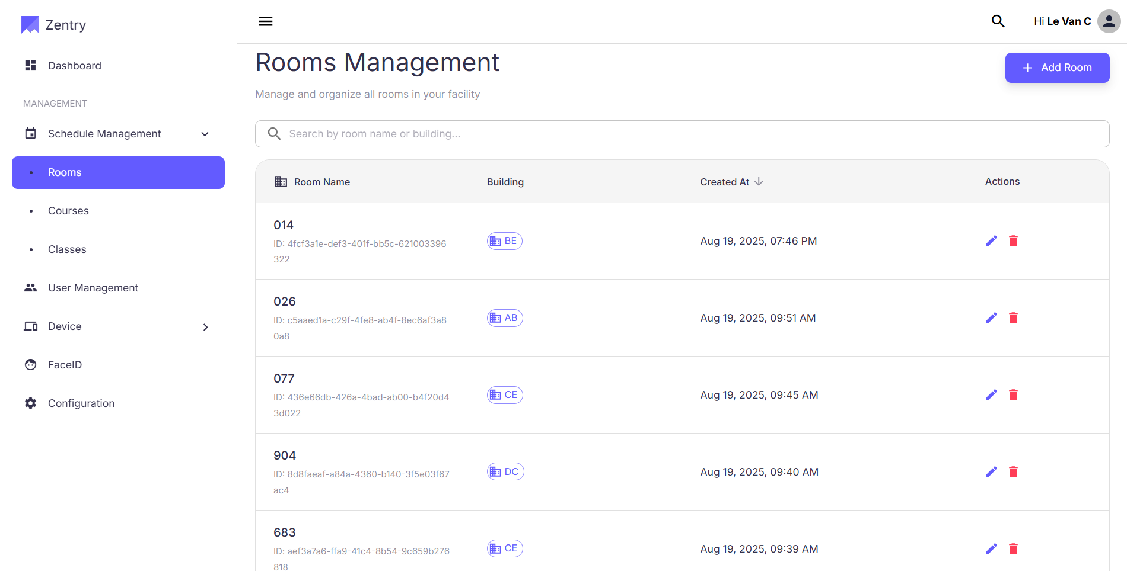
Figure 19: View room layout
No | Field Name | Field Type | Description
1 | Search Box | Textbox | Allows users to search rooms by name or building.
2 | Add Room Btn | Button | Opens a form to add a new room.
3 | Room Name | Text Label | Displays the room name and unique ID.
4 | Building | Badge/Label | Shows the building code of the room.
5 | Created At | Label | Shows the date and time the room was created.
6 | Edit Room Btn | Icon Button | Allows users to edit the details of a specific room.
7 | Delete Room Btn | Icon Button | Allows users to delete a room from the system.
8 | Pagination | Navigation | Navigates through pages if the number of rooms exceeds one page.
Table 20: View Rooms Layout
b. Use Case Specifications
ID and Name | UC33 – Manage Rooms (View Rooms)
Created By | DungND | Date Created | 28/06/2025
Primary Actor | Admin | Secondary Actors | System
Trigger | The user opens the Rooms Management Page (either by entering a URL or navigating Schedule Management → Rooms)
Description | As a user, I want to view all rooms within the facility so that I can easily identify available spaces, check their details, and manage attendance or scheduling effectively.
Preconditions | PRE-1. The user is authenticated and authorized (Admin or Staff role).  PRE-2. The system is online and operational.
Postconditions | POST- 1. The user can successfully view all rooms.  POST- 2. The user can add, edit, or delete room records as needed.
Normal Flows | Step | By | Step Details
Normal Flows | 1 | User | Navigate to the Rooms Management page
Normal Flows |  | System | Display all existing rooms with its name, code, building code, capacity and creation time
Normal Flows | 2 | User | Search for a room by its name or building code using the search bar
Normal Flows | 3 | System | Display all satisfying rooms according to the search
Normal Flows | 4 | User | Customize the pagination view by changing page size, navigate among pages
Normal Flows | 5 | System | Display the rooms according to the specified pagination
Alternative Flows | Alt Step | Condition | Description
Alternative Flows | A1 | No rooms available | Show empty state text (e.g., “No rooms available”) and keep other widgets functional
Exceptions | - E1: Backend unavailable → display toast/banner and error states; allow manual Retry.  - E2: Data inconsistency (e.g., counts mismatch) → log and show safe fallback (0 or “—”).  - E3: Network timeout → show retry option; preserve user selections (search/pagination).
Frequency of Use | High
Business Rules | BR-01, BR-02
Other Information | - Supports server-side pagination and sorting by Created At/Name.  - Times are displayed in the user’s locale/time zone.  - Table remembers last search/sort on return navigation.
Assumptions | - Building codes exist and are preconfigured.  - Room IDs are immutable.  - Network/database are stable during listing.
Table 21: View Rooms Specification

3.2.1.5 Add Room
a. Screen Layouts
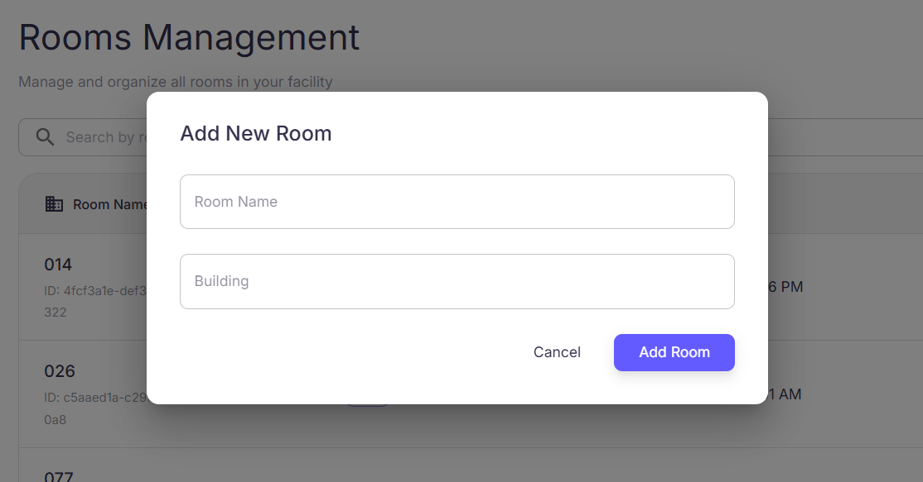
Figure 20: Add room
No | Field Name | Field Type | Description
1 | Title | Label | Displays: “Add New Room”
2 | Room Name | Text Input | User enters the name of the room (e.g., “Meeting Room A”, “Lab 201”)
3 | Building | Text Input | User specifies the building where the room is located
4 | Cancel | Button | Closes the popup without saving changes
5 | Add Room | Button | Saves the room details and closes the popup (if room added successfully)
Table 22: Add room layout
b. Use Case Specifications
ID and Name | UC32 – Manage Rooms (Add Rooms)
Created By | DungND | Date Created | 28/06/2025
Primary Actor | Admin | Secondary Actors | System
Trigger | The user opens the Rooms Management Page (either by entering a URL or navigating Schedule Management → Rooms)
Description | As a user, I want to add a new room with its name, building, and capacity so that the room can be properly managed and scheduled in the system.
Preconditions | PRE-1. The user is authenticated and authorized (Admin or Staff role).  PRE-2. The system is online and operational.
Postconditions | POST- 1. The new room is added and visible in the room list.
Normal Flows | Step | By | Step Details
Normal Flows | 1 | User | Click on button “Add Room”
Normal Flows | 2 | System | Display the “Add New Room” popup.
Normal Flows | 3 | User | Enter room name, building.
Normal Flows | 4 | User | Click “Add Room”
Normal Flows | 5 | System | Validates the inputs.
Normal Flows | 6 | System | Saves the new room and updates the room list.
Normal Flows | 7 | System | Displays a success message.
Alternative Flows | Alt Step | Condition | Description
Alternative Flows | A1 | Invalid Input | Show an error message and prompt the user to correct.
Alternative Flows | A2 | Cancel | Popup closes without saving
Exceptions | - E1: Backend unavailable → display toast/banner and error states; allow manual Retry  - E2: Validation errors → highlight fields with error messages and prevent saving.  - E3: Network timeout → show retry option; preserve user selections (search/pagination).
Frequency of Use | Medium
Business Rules
  BR-01, BR-02
Other Information | - All “add room” activities are logged for auditing.  - Supports both client-side and server-side validation.
Assumptions | - Building lists are already available in the system.  - Room IDs are immutable once created.  - Network/database are stable during the creation process.
Table 23: Add room specification

3.2.1.6 Edit Room
a. Screen Layouts
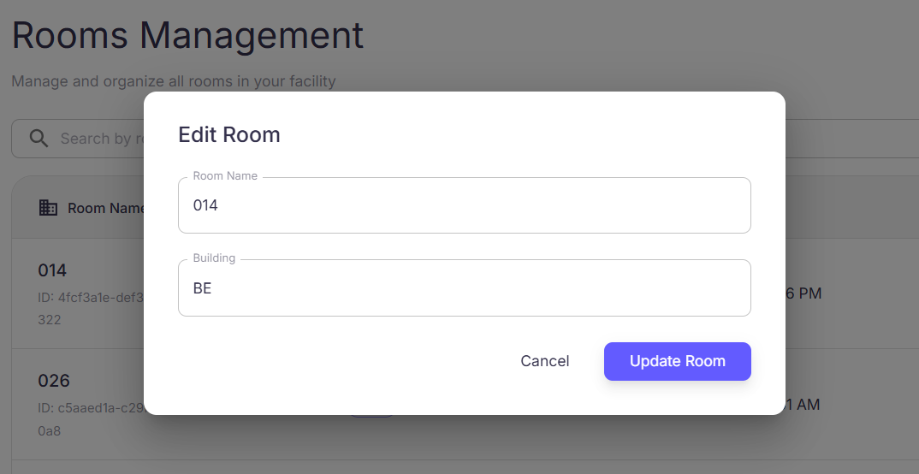
Figure 21: Edit Room
No | Field Name | Field Type | Description
1 | Room Name | Text Field | The name of the room (e.g., “AL101”). Required.
2 | Building | Dropdown | Select the building where the room is located.
3 | Save Button | Button | Saves the changes and updates the room details.
4 | Cancel Button | Button | Cancels the edit and returns to the Rooms Management Page without saving.
Table 24: Edit room layout
b. Use Case Specifications
ID and Name | UC33 – Manage Rooms (Edit Rooms)
Created By | DungND | Date Created | 28/06/2025
Primary Actor | Admin | Secondary Actors | System
Trigger | The user selects a room from the “Rooms Management” page and clicks on the edit button.
Description | As a user, I want to edit the details of an existing room so that I can keep room information up to date and accurate for scheduling and attendance management.
Preconditions | PRE-1. The user is authenticated and authorized (Admin).  PRE-2. The system is online and operational.  PRE-3. The room to be edited already exists in the system.
Postconditions | POST-1. Room details are updated in the database.  POST-2. Updated details are immediately reflected in the room listing.
Normal Flows | Step | By | Step Details
Normal Flows | 1 | User | Clicks on the Edit button for a specific room.
Normal Flows | 2 | System | Displays the Edit Room Form pre-filled with current room details.
Normal Flows | 3 | User | Updates one or more fields and clicks Save.
Normal Flows | 4 | System | Validates inputs (required fields, unique constraints, numeric fields).
Normal Flows | 5 | System | Saves updated details into the database.
Normal Flows | 6 | System | Displays confirmation message and returns to the Rooms Management Page with updated details.
Alternative Flows | Alt Step | Condition | Description
Alternative Flows | A1 | Cancel | Discard changes and returns to Rooms Management Page.
Exceptions | - E1: Backend unavailable → display toast/banner and error states; allow manual Retry  - E2: Validation errors → highlight fields with error messages and prevent saving.  - E3: Network timeout → show retry option; preserve user selections (search/pagination).
Frequency of Use | Medium
Business Rules | BR-01, BR-02
Other Information | - All edits are logged with timestamp and user ID for auditing.  - Supports inline editing in future versions.  - Admin can edit multiple rooms in succession.
Assumptions | - Admin has correct privileges to edit room details.  - The system always loads the latest version of the room before editing.  - Network/database stability is assumed during save operation.
Table 25: Edit room specification

3.2.1.7 Delete Room
a. Screen Layouts
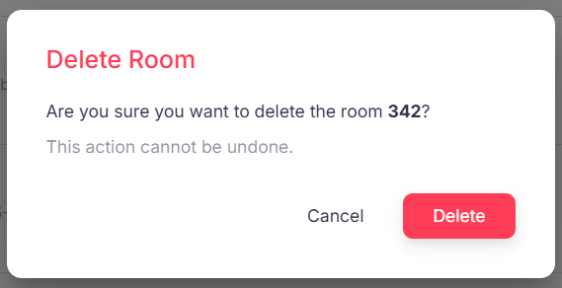
Figure 22: Delete Room
No | Field Name | Field Type | Description
1 | Delete Room | Heading | The title of the confirmation dialog.
3 | Confirmation Message | Text Label | Asks the user to confirm the deletion of the room
4 | Warning Message | Text Label | A warning that the action is irreversible
5 | Delete Button | Button | Confirms the action and deletes the room.
6 | Cancel Button | Button | Allows the user to cancel the action and close the dialog.
Table 26: Delete Room Layout
b. Use Case Specifications
ID and Name | UC34 – Manage Rooms (Delete Rooms)
Created By | DungND | Date Created | 28/06/2025
Primary Actor | Admin | Secondary Actors | System
Trigger | The user selects a room from the “Rooms Management” page and clicks on the delete button.
Description | As a user, I want to delete a room from the system to remove outdated or incorrect room information.
Preconditions | PRE-1. The user is authenticated and authorized (Admin).  PRE-2. The system is online and operational.  PRE-3. The room to be deleted already exists in the system.
Postconditions | POST-1: The room is removed from the database.  POST-2: The room is no longer visible in the room listing.
Normal Flows | Step | By | Step Details
Normal Flows | 1 | User | Click on the Delete button for a specific room.
Normal Flows | 2 | System | Display a confirmation dialog with the room ID.
Normal Flows | 3 | User | Click the Delete button within the dialog.
Normal Flows | 4 | System | Remove the room from the database.
Normal Flows | 5 | System | Display a confirmation message and return to the Rooms Management page.
Alternative Flows | Alt Step | Condition | Description
Alternative Flows | A1 | Cancel | The system discards the action and closes the dialog, returning to the Rooms Management page without making any changes.
Exceptions | - E1: Backend unavailable → display toast/banner and error states; allow manual Retry  - E2: Room cannot be deleted (e.g., currently has upcoming bookings) → System shows a warning message and prevents the deletion.  - E3: Network timeout → show retry option; preserve user selections (search/pagination).
Frequency of Use | Low
Business Rules | BR-01, BR-02
Other Information | - All deletions are logged with a timestamp and user ID for auditing.  - Only Admin can delete rooms.
Assumptions | - The system always verifies if the room can be deleted before proceeding.  - Network/database stability is assumed during the delete operation.
Table 27: Delete Rooms Specification

3.2.1.8 View Courses
a. Screen Layouts
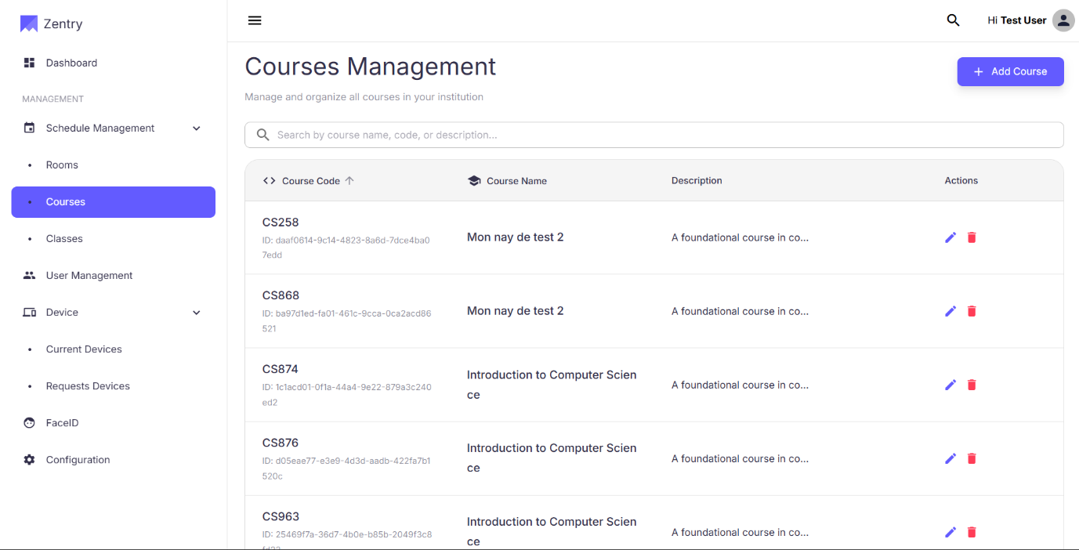
Figure 23: View Courses
No | Field Name | Field Type | Description
1 | Search Box | Textbox | Allows users to search courses by course code, name, or description.
2 | Add Course | Button | Opens a form to add a new course.
3 | Course Code | Text | The unique code for each course.
4 | Course Name | Text | The name of each course.
5 | Description | Text | A brief description of the course.
6 | Actions | Button | Buttons for editing or deleting a course.
7 | Edit Course | Icon Button | Allows the user to edit a specific course.
8 | Delete Course | Icon Button | Allows the user to delete a specific course.
Table 28: Manage Course (View Course) layout
b. Use Case Specifications
ID and Name | UC35 – Manage Course (View Course)
Created By | DungND | Date Created | 28/06/2025
Primary Actor |  | Secondary Actors | System
  Admin
Trigger | The user navigate to the Course Management page
Description | As a user, I want to view a list of all courses in the system so that I can manage and organize courses in the institution.
Preconditions | PRE-1. The user has a registered account.  PRE-2. The system is online and operational.
Postconditions | POST-1: The system displays the list of courses.  POST-2: The user can interact with the displayed list (e.g., search, sort, add, edit, or delete).
Normal Flows | Step | By | Step Details
Normal Flows | 1 | User | Navigate to the Course Management page
Normal Flows |  | System | Display all existing courses with its name, code, and description
Normal Flows | 2 | User | Search for a course by its name, code or description using the search bar
Normal Flows | 3 | System | Display all satisfying courses according to the search
Normal Flows | 4 | User | Customize the pagination view by changing page size, navigate among pages
Normal Flows | 5 | System | Display the courses according to the specified pagination
Alternative Flows | Alt Step | Condition | Description
Alternative Flows | A1 | No courses available | Show empty state text (e.g., “No courses available”) and keep other widgets functional
Exceptions | - E1: Backend unavailable → display toast/banner and error states; allow manual Retry.  - E2: Data inconsistency (e.g., counts mismatch) → log and show safe fallback (0 or “—”).  - E3: Network timeout → show retry option; preserve user selections (search/pagination).
Frequency of Use | High
Business Rules | BR-01, BR-02
Other Information | - The list should be paginated if the number of courses is large.  - The system should support search functionality across multiple fields (course code, name, description).
Assumptions | - The system's API for retrieving courses is fast and reliable.  - The user is logged in and has the necessary permissions to view the course list.
Table 29: Manage Course (View Course) Specification

3.2.1.9 Add Course
a. Screen Layouts
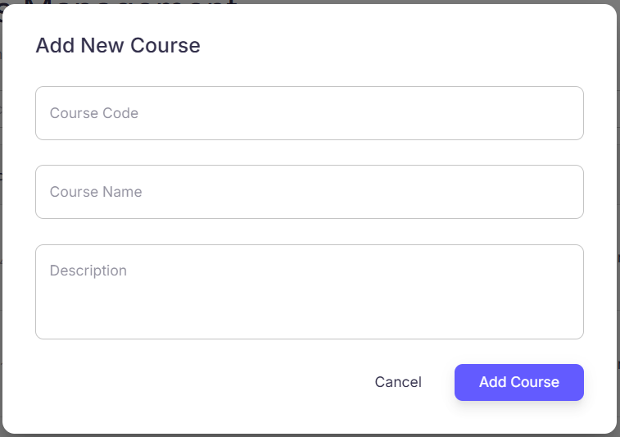
Figure 24 -Add new course
No | Field Name | Field Type | Description
1 | Add New Course | Heading | The title of the form for adding a new course.
2 | Course Code | Textbox | The unique code of the course
3 | Course Name | Textbox | The name of the course
4 | Description | Textbox | Detailed description for the new course.
5 | Cancel | Button | Closes the form and discards any changes.
6 | Add Course | Button | Confirms and submits the new course to the system.
Table 30: Manage Course (Add Course)
b. Use Case Specifications
ID and Name | UC36 – Manage Course (Add Course)
Created By | DungND | Date Created | 28/06/2025
Primary Actor |  | Secondary Actors | System
  Admin
Trigger
  The user clicks the "Add Course" button on the "Courses Management" page.
Description | As a user, I want to add a new course to the system so that new classes can be created and managed under it.
Preconditions | PRE-1. The user is authenticated and authorized (Admin or Staff role).  PRE-2. The system is online and operational.  PRE-3: The user has opened the "Add New Course" form.
Postconditions | POST-1: A new course record is created in the database.  POST-2: A confirmation message is displayed, and the user is redirected to the "Courses Management" page.  POST-3: The newly added course is visible in the course listing.
Normal Flows | Step | By | Step Details
Normal Flows | 1 | User | Fill in required fields
Normal Flows |  | User | Click the “Add Course” button
Normal Flows | 2 | System | Validate the inputs
Normal Flows | 3 | System | Create the new course record in the database.
Normal Flows | 4 | System | Displays a confirmation message ("Course added successfully") and returns to the Courses Management page with the new course visible in the list.
Alternative Flows | Alt Step | Condition | Description
Alternative Flows | A1 | Cancel | Discards all entered data and returns the user to the "Courses Management" page.
Exceptions | - E1: Backend unavailable → display toast/banner and error states; allow manual Retry.  - E2: Data inconsistency (e.g., counts mismatch) → log and show safe fallback (0 or “—”).  - E3: Network timeout → show retry option; preserve user selections (search/pagination).
Frequency of Use | Medium
Business Rules
  BR-01, BR-02
Other Information | - All new course creations are logged with a timestamp and user ID for auditing.
Assumptions | - All required fields will be clearly marked for the user.  - The system can automatically handle the unique ID generation (if not manually entered).
Table 31: Manage Course (Add Course)

3.2.1.10 Edit Course
a. Screen Layouts
Figure 25 - Edit course

No | Field Name | Field Type | Description
1 | Courses Table | Table | Displays Course Code, Course Name, Description, Actions.
2 | Actions (per row) | Icon buttons | Edit (pencil) opens the Edit Course dialog.
Table 32: Manage Course (Edit Course) layout
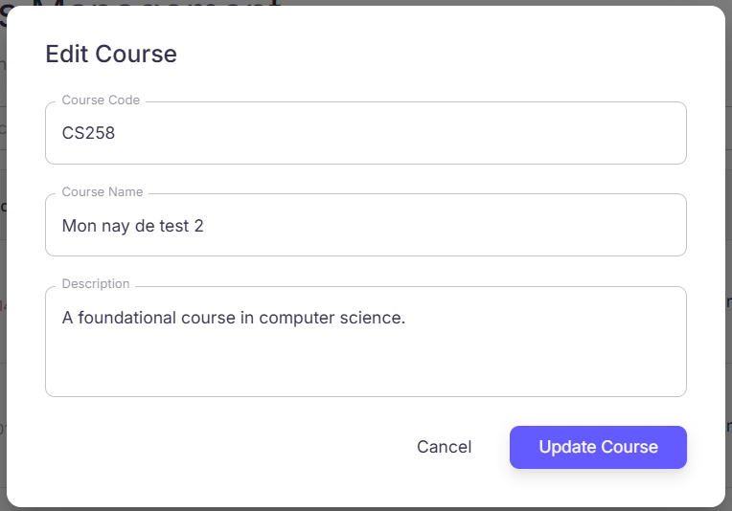
Figure 26 - Edit course dialog

No | Field Name | Field Type | Description
1 | Title (“Edit Course”) | Label | Dialog header.
2 | Course Code | Text field | Editable course code (must be unique).
3 | Course Name | Text field | Editable course name.
4 | Description | Text area | Editable description of the course.
5 | Cancel | Button (secondary) | Close dialog without saving.
6 | Update Course | Button (primary) | Save changes and update course. Disabled until changes are valid.
7 | Error Area (optional) | Label | Displays error messages if update fails.
Table 33: Manage Course (Edit Course 2)
b. Use Case Specifications
ID and Name | UC37 – Manage Course (Edit Course)
Created By | DungND | Date Created | 28/06/2025
Primary Actor |  | Secondary Actors | System
  Admin
Trigger
  User clicks the Edit (pencil) icon for a course in the Course List.
Description | As an authorized user, I want to edit course details so that I can correct mistakes or update course information.
Preconditions | PRE-1. User is authenticated (BR-01).  PRE-2. User has permission to manage courses (BR-02, BR-16).  PRE-3. The target course exists in the system.
Postconditions | POST-1. The course record is updated in the system.  POST-2. A success notification is displayed and changes are visible immediately in the course table.
Normal Flows | Step | By | Step Details
Normal Flows | 1 | User | Locate the course in the Course List and click Edit (pencil).
Normal Flows | 2 | System | Open Edit Course dialog with current values prefilled.
Normal Flows | 3 | User | Modify one or more fields (Course Code, Course Name, Description).
Normal Flows | 4 | User | Click Update Course.
Normal Flows | 5 | System | Validate input and update course in database.
Normal Flows | 6 | System | If successful: close dialog, refresh table, show green toast “Course edited successfully.” If unsuccessful: keep dialog open, display error (e.g., “Course code already exists.”).
 | Step | By | Step Details
Alternative Flows | Alt Step | Condition | Description
Alternative Flows | A1 | User clicks Cancel | Dialog closes; no changes saved.
 | A2 | Validation fails | System highlights invalid fields (e.g., empty name, duplicate code).
Exceptions | - E1: Permission error → “You don’t have permission to edit courses.”  - E2: Course not found (concurrent deletion) → Refresh list, show error.  - E3: Network/Server error → Show error toast; retry possible.
Frequency of Use | High
Business Rules
  BR-01, BR-02
Other Information | - Inline validation improves usability (e.g., prevent saving empty Course Code).  - Keep audit logs of edits (extend BR-15 Session History).
Assumptions | - Course IDs are immutable.  - Network/database are stable during listing.
Table 34: Manage Course (Edit Course) Specification

3.2.1.11 Delete Course
a. Screen Layouts
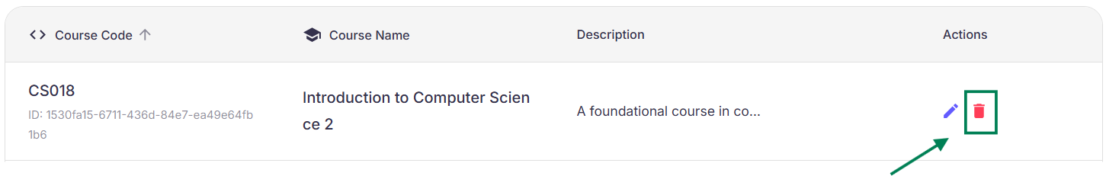
Figure 27 - Delete course icon

No | Field Name | Field Type | Description
1 | Courses Table | Table | Displays Course Code, Course Name, Description, Actions.
2 | Actions (per row) | Icon buttons | Edit (pencil) opens Edit Course dialog.
Table 35: Manage Course (Delete Course) layout
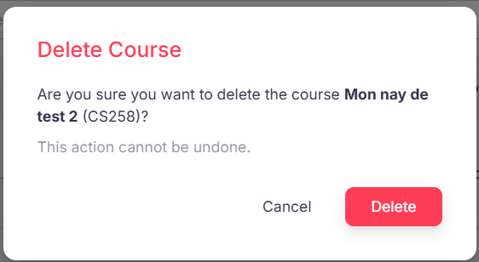
Figure 28 - Delete course confirm pop up
No | Field Name | Field Type | Description
1 | Delete Icon | Button/Icon | Trash bin icon in the Actions column of the course table.
2 | Confirmation Dialog | Modal | Dialog displayed to confirm course deletion.
3 | Warning Message | Text | Message informing user of the consequences of deletion.
4 | Delete Button | Button | Confirms deletion of the course.
5 | Cancel Button | Button | Cancels the deletion action and closes the dialog.
6 | Notification | Toast/Alert | Displays success or error message after action.
Table 36: Manage Course (Delete Course) layout
b. Use Case Specifications
ID and Name | UC38 – Manage Course (Delete Course)
Created By | DungND | Date Created | 28/06/2025
Primary Actor |  | Secondary Actors | System
  Admin
Trigger
  The user opens the Rooms Management Page (either by entering a URL or navigating Schedule Management → Rooms)
Description | As a user, I want to delete irrelevant course from the system
Preconditions | PRE-1. User is authenticated and authorized (Admin or Staff role).  PRE-2. The system is online and operational.  PRE-3. The course is not currently linked to any active classes or other dependencies.
Postconditions | POST- 1. The course is successfully deleted from the system.  POST-2. A success notification is displayed.
Normal Flows | Step | By | Step Details
Normal Flows | 1 | User | Click on the Delete button next to the course.
Normal Flows |  | System | Shows a confirmation popup
Normal Flows | 2 | User | Confirms deletion
Normal Flows | 3 | System | Deletes the course from the database.
Normal Flows | 4 | System | Displays a success message (e.g., “Course deleted successfully”).
Alternative Flows | Alt Step | Condition | Description
Alternative Flows | A1 | Cancel | Returns to the Course Management Page without deleting the course.
Exceptions | - E1: Backend unavailable → display toast/banner and error states; allow manual Retry.  - E2: Data inconsistency (e.g., counts mismatch) → log and show safe fallback (0 or “—”).  - E3: Network timeout → show retry option; preserve user selections (search/pagination).
Frequency of Use | High
Business Rules | BR-01, BR-02
Other Information | - Audit logs should record which Admin deleted the course and when.
Assumptions | - Course IDs are immutable.  - Network/database are stable during listing.
Table 37: Manage Course

3.2.1.12 View Classes
a. Screen Layouts
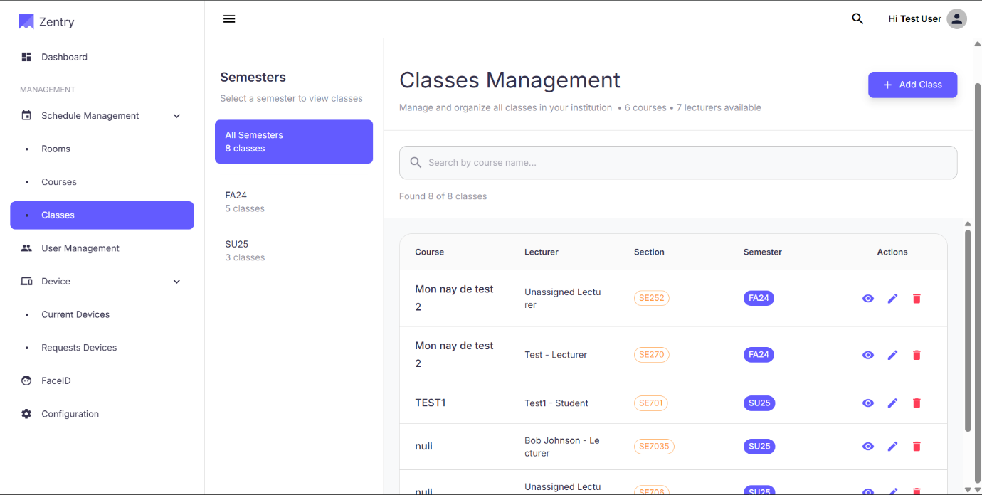
Figure 29 - Class management layout
No | Field Name | Field Type | Description
1 | Page Title (“Classes Management”) | Label | Section heading with context summary (e.g., “6 courses • 7 lecturers available”).
2 | Add Class | Button | Opens Add Class flow (handled in a separate UC). Visible to Admin (BR-02, BR-16).
3 | Search bar | Searchbox | Search classes by course name (debounced).
4 | Result Counter | Label | “Found x of y classes”.
5 | Semesters Panel | Panel | Left filter panel listing All Semesters and individual terms (FA24, SU25…).
6 | Classes Table | Table | Main list of classes with columns below.
7 | Pagination | Control | Rows per page selector, Previous/Next arrows.
Table 38: Class Management layout
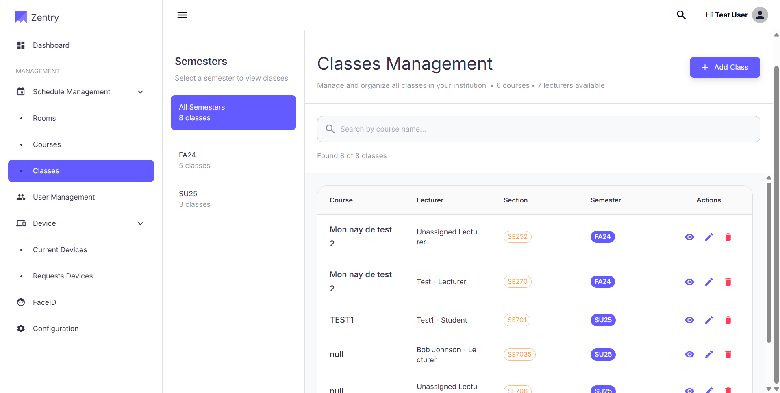
Figure 30 - Class management screen - Semester
No | Field Name | Field Type | Description
1 | All Semesters | List item | Shows all classes in the system. Selected by default.
2 | <Term> (e.g., FA24) | List item | Filter the table to the selected term. Shows class count badge.
3 | Active Indicator | Indicator | Highlights the currently selected semester.
Table 39: Semester layout
Figure 31 -Class management screen - Class Table
No | Field Name | Field Type | Description
1 | Course | Text (link) | Course name of the class; may link to course page.
2 | Lecturer | Text | Assigned lecturer’s name; shows “Unassigned Lecturer” if none.
3 | Section | Badge | Section code (e.g., SE252).
4 | Semester | Badge | Term label (e.g., FA24, SU25).
5 | Actions | Icon buttons | View (eye), Edit (pencil), Delete (trash). View navigates to Class Details; Edit/Delete invokes their own UCs and permissions (BR-02, BR-16).
Table 40: Class table layout
b. Use Case Specifications
ID and Name | UC39 - Manage Class (View Classes)
Created By | DungND | Date Created | 28/06/2025
Primary Actor |  | Secondary Actors | System
  Admin
Trigger
  The user navigates to Schedule Management → Classes from the sidebar.
Description | The Classes Management screen allows users to view all classes in the institution, organized by semester. Each row shows the course, assigned lecturer, section, semester, and available actions. The left panel lists semesters to filter the table.
Preconditions | PRE-1. User is authenticated  PRE-2. User is authorized to view class data  PRE-3. Class, course, and lecturer data exist—or empty states are handled gracefully.
Postconditions | POST- 1. No data is modified by viewing alone.  POST- 2. If a row action is selected, the user is routed to the corresponding UC (View/Edit/Delete Class).
Normal Flows | Step | By | Step Details
Normal Flows | 1 | User | In the sidebar, click Schedule Management to expand.
Normal Flows | 2 | User | Click Classes to open Classes Management.
Normal Flows | 3 | User | In the Semesters panel: choose All Semesters to view all classes, or select a specific term (e.g., FA24, SU25) to filter.
Normal Flows | 4 | User | Review the Classes Table columns: Course, Lecturer, Section, Semester, Actions (View / Edit / Delete).
Normal Flows | 5 | User | Use the Search bar to find classes by course name.
Normal Flows | 6 | User | Use Pagination: adjust Rows per page and navigate with Previous/Next arrows.
Alternative Flows | Alt Step | Condition | Description
Alternative Flows | A1 | Click View action | Navigate to UC—View Class Details
Alternative Flows | A2 | Click Edit action | Navigate to UC—Edit Class if permitted
Alternative Flows | A3 | Click Delete action | Invoke UC—Delete Class (confirmation dialog, permissions required).
Exceptions | - E1: Backend/API error while loading list → show inline error with Retry; keep filters and pagination state.  - E2: Network timeout → show toast/banner; allow retry; do not reset current selection.  - E3: Data inconsistency (e.g., missing course/lecturer reference) → display placeholder (“Unknown”) and log for admin review.
Frequency of Use | High
Business Rules
  BR-01, BR-02
Other Information | - The table may support future enhancements: sort by columns, multi-filter (semester + lecturer), and bulk actions (admin only).  - Accessibility: keyboard navigation, visible focus on row actions, ARIA labels on icons.
Assumptions | - Backend provides paginated, filterable endpoints by semester and search query.  - Terms (FA24, SU25…) follow a consistent naming convention.
Table 41: View Class

3.2.1.13 Edit Class
a. Screen Layouts
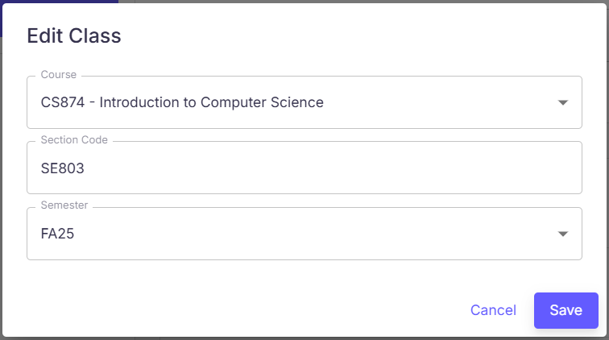
Figure 32 - Edit Class
No | Field Name | Field Type | Description
1 | Title (“Edit Class”) | Label | Dialog header.
2 | Course | Dropdown | Select a course to associate with the class. Pre-filled with the current value. Required.
3 | Section Code | Textbox | Edit the section code (e.g., SE803). Required: validation rules per system config.
4 | Semester | Dropdown | Select the term (e.g., FA25). Pre-filled with the current value. Required.
5 | Cancel | Button | Close the dialog without saving.
6 | Save | Button | Validate and persist updates. Disabled until form is valid or changes are detected.
7 | Error/Validation Area | Label | Inline messages for invalid fields or server errors.
Table 42: Edit class layout
b. Use Case Specifications
ID and Name | UC-40: Manage Classes (Edit class)
Created By | DungND | Date Created | 28/06/2025
Primary Actor | Admin | Secondary Actors | System
Trigger
  From Schedule Management → Classes, the user clicks the Edit (pencil) icon in the row of a class.
Description | As an authorized user (Admin), I want to modify an existing class’s course, section code, and semester so that the class information remains accurate and up to date.
Preconditions | PRE-1. User is authenticated  PRE-2. User is authorized to view class data  PRE-3. Target class exists and is retrievable; reference lists for Course and Semester are available.
Postconditions | POST- 1. Class record is updated with the new values.  POST- 2. The Classes table reflects the changes and shows a success notification.  POST- 3. Edit action is logged for auditing
Normal Flows | Step | By | Step Details
Normal Flows | 1 | User | Locate the class to edit in the list.
Normal Flows | 2 | User | Click the Edit icon (pencil) in Actions.
Normal Flows | 3 | System | Open Edit Class dialog pre-filled with current values.
Normal Flows | 4 | User | Update one or more fields: Course (dropdown), Section Code, Semester (dropdown).
Normal Flows | 5 | User | Click Save to apply changes.
Normal Flows | 6 | System | Validate inputs and persist updates.
Normal Flows | 7 | System | If successful, close dialog, refresh table, and show green toast: “Class edited successfully.” If unsuccessful, display an error message and keep dialog open.
Alternative Flows | Alt Step | Condition | Description
Alternative Flows | A1 | User clicks Cancel | Dialog closes; no changes saved.
Alternative Flows | A2 | No field changed | Save is disabled or results in no-op; dialog stays open.
Exceptions | - E1: Validation error (missing required field, invalid format) → inline field errors; prevent save.  - E2: Data conflict (e.g., duplicate section code within same course/semester if enforced) → show conflict message; prevent save.  - E3: Network/Server error → show error toast/banner; allow retry without losing user input.  - E4: Missing reference (course/semester no longer available) → show message and force re-selection.
Frequency of Use | Medium
Business Rules
  BR-01, BR-02
Other Information | - Form validation rules (length/pattern for Section Code) follow system configuration; errors appear inline.  - Keyboard accessibility: Tab/Shift+Tab navigation, Enter to save, Esc to cancel.
Assumptions | - Backend exposes an update endpoint with optimistic locking or equivalent conflict handling.  - The list view refreshes automatically after a successful edit.
Table 43 - Edit class specification

3.2.1.14 Delete Class
a. Screen Layouts
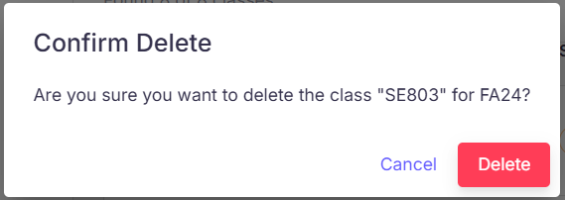
Figure 33 - Delete class confirm dialog
No | Field Name | Field Type | Description
1 | Title (“Confirm Delete”) | Label | Dialog header.
2 | Message | Label | Shows the target Section Code and Semester, e.g., “Are you sure you want to delete the class ‘SE803’ for FA24?”
3 | Cancel | Button | Closes dialog, no changes applied.
4 | Delete | Button (danger) | Confirms deletion; proceeds to remove the class. Disabled during request.
5 | Error area (optional) | Label | Displays server/validation errors if deletion fails.
Table 44 - Delete class confirm layout
b. Use Case Specifications
ID and Name | UC-41: Manage Classes (Delete class)
Created By | DungND | Date Created | 28/06/2025
Primary Actor |  | Secondary Actors | System
  Admin
Trigger
  From Schedule Management → Classes, the user clicks the Delete (trash) icon for a class.
Description | As an authorized user (Admin), I want to remove a class from the system so that outdated or incorrect class records are not shown to users.
Preconditions | PRE-1. User is authenticated  PRE-2. User is authorized to view class data  PRE-3. Target class exists and is retrievable.
Postconditions | POST- 1. The class record is removed  POST- 2. The list view refreshes and a success notification is shown.  POST- 3. Deletion event is logged for audit
Normal Flows | Step | By | Step Details
Normal Flows | 1 | User | Locate the class in the list.
Normal Flows | 2 | User | Click the Delete icon in the Actions column.
Normal Flows | 3 | System | Open Confirm Delete dialog showing Section Code and Semester of the selected class.
Normal Flows | 4 | User | Click Delete to confirm (or Cancel to abort).
Normal Flows | 5 | System | If successful, remove the class, close dialog, refresh table, and show green toast: “Class deleted successfully.” If unsuccessful, keep dialog open and display the error reason.
Alternative Flows | Alt Step | Condition | Description
Alternative Flows | A1 | User clicks Cancel | Dialog closes; no changes saved.
Exceptions | - E1: Permission error → “You don’t have permission to delete this class.”  - E2: Concurrency conflict (class already deleted/modified) → show conflict message and refresh list.  - E3: Network/Server error → show error toast, allow retry.
Frequency of Use | Medium
Business Rules
  BR-01, BR-02
Other Information | - Consider double-confirmation or reason capture if policy requires.  - Ensure protected pages are not cached so the deleted class cannot appear via back navigation.
Assumptions | - Backend exposes a delete endpoint with proper referential checks and returns actionable error messages on constraint violations.
Table 45: Delete class specification

3.2.1.15 Add Class
a. Screen Layouts
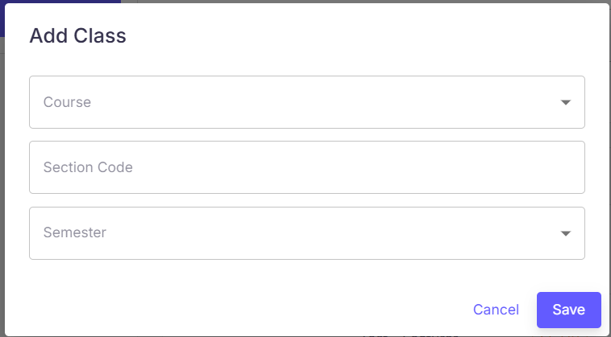
Figure 34: Add new class layout
No | Field Name | Field Type | Description
1 | Title (“Add Class”) | Label | Dialog header.
2 | Course | Dropdown | Required. Select a course from the available list.
3 | Section Code | Textbox | Required. Enter section code (e.g., SE101). Validation per system policy.
4 | Semester | Dropdown | Required. Select a term (e.g., FA25, SU25).
5 | Cancel | Button | Close dialog without saving.
6 | Save | Button | Validate and create the class. Disabled until form is valid.
7 | Error/Validation Area | Label | Inline messages for invalid fields or server errors.
Table 46: Add a new class
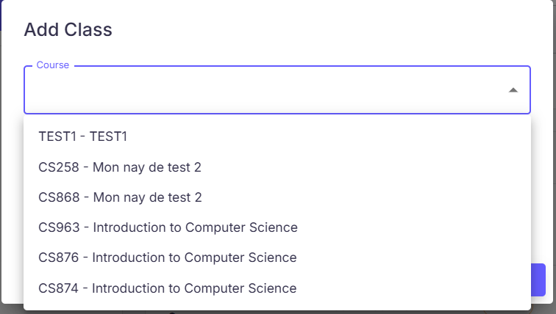
Figure 35 - Add new class selection
No | Field Name | Field Type | Description
1 | Course Options | List | e.g., TEST1 – TEST1, CS258 – …, CS963 – Introduction to Computer Science, …
Table 47: Add new class selection layout
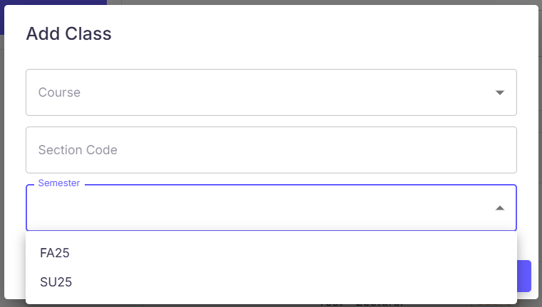
Figure 36 - Add semester Class Layout
No | Field Name | Field Type | Description
1 | Semester | List | Predefined term values selectable for the class.
Table 48: Add semester Class
b. Use Case Specifications
ID and Name | UC42 – Add new class section (Add new class)
Created By | DungND | Date Created | 28/06/2025
Primary Actor |  | Secondary Actors | System
  Admin
Trigger
  On Schedule Management → Classes, the user clicks Add Class (top-right).
Description | As an authorized user (Admin), I want to create a new class by selecting a course, entering a section code, and choosing a semester so that the class appears in the list and can be scheduled and managed.
Preconditions | PRE-1. The user has a registered account.  PRE-2. User has permission to create classes  PRE-3. Reference data is available: list of Courses and Semesters.
Postconditions | POST- 1. A new class record is created with the provided Course, Section Code, and Semester.  POST- 2. The Classes table refreshes to include the new class and a success notification is shown.  POST- 3. Creation event is logged for auditing
Normal Flows | Step | By | Step Details
Normal Flows | 1 | User | On the Classes Management page, click Add Class.
Normal Flows | 2 | User | In the dialog, provide details: Course (dropdown), Section Code, Semester (dropdown)
Normal Flows | 3 | User | Click Save to add the class.
Normal Flows | 4 | System | Validate input and create the record.
Normal Flows | 5 | System | If successful, close dialog, refresh table, and show green toast “Class created successfully.” If not, keep the dialog open and display an error message.
Alternative Flows | Alt Step | Condition | Description
Alternative Flows | A1 | User clicks Cancel | Dialog closes; no data is saved.
Alternative Flows | A2 | Duplicate or conflicting class (policy) | System blocks creation (e.g., duplicate Section Code within the same Course/Semester) and shows a clear error; users can adjust inputs.
Exceptions | - E1: Validation errors (missing required fields, invalid format) → inline field errors; prevent save.  - E2: Network/Server error → error toast; allow retry without losing entered data.  - E3: Missing reference (selected course/semester removed) → show message; force re-selection.
Frequency of Use | Medium
Business Rules
  BR-01, BR-02
Other Information | - Keyboard shortcuts: Enter to Save (when valid), Esc to Cancel.  - Consider optimistic UI: pre-append the new row then reconcile on server response.
Assumptions | - Backend provides a create endpoint and enforces uniqueness/consistency constraints for section per course/semester.
Table 49: Add semester Class Specification

3.2.1.16 View Class Details
a. Screen Layouts
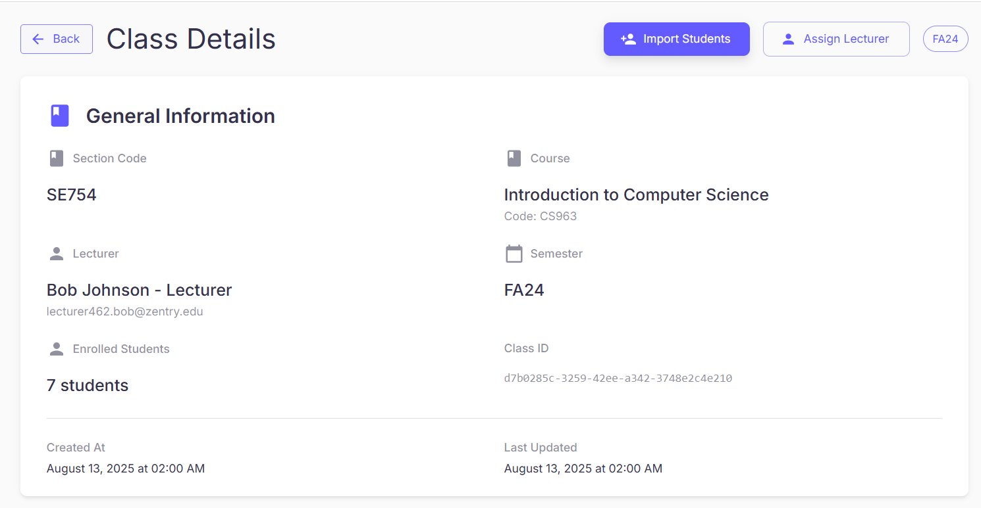
Figure 37 - View Class detail Layout
No | Field Name | Field Type | Description
1 | Back | Button | Returns to Classes Management.
2 | Page Title (“Class Details”) | Label | Header of the page.
3 | Import Students | Button | Opens bulk import & enroll flow (separate UC). Visible per permissions (BR-02).
4 | Assign Lecturer | Button | Opens lecturer assignment flow (separate UC). Visible per permissions (BR-02).
5 | Term Chip | Badge | Displays the class semester (e.g., FA24).
6 | General Information Card | Panel | Container for class attributes below.
7 | Section Code | Text | e.g., SE754.
8 | Course | Text | Course name and code (e.g., Introduction to Computer Science – CS963).
9 | Lecturer | Text | Lecturer’s display name and email. Shows “Unassigned Lecturer” if none.
10 | Semester | Text | e.g., FA24.
11 | Enrolled Students | Text | Total number of enrolled students (e.g., 7 students).
12 | Class ID | Text | Unique identifier (UUID).
13 | Created At | Text | Timestamp when the class was created.
14 | Last Updated | Text | Timestamp of last modification.
Table 50 - View Class detail layout
b. Use Case Specifications
ID and Name | UC43 – Manage Class (View class detail)
Created By | DungND | Date Created | 28/06/2025
Primary Actor | Admin | Secondary Actors | System
Trigger | From Schedule Management → Classes, the user clicks the View (eye) icon for a class.
Description | As an authorized user, I want to view all details of a specific class (section, course, lecturer, semester, enrolled students, identifiers, and timestamps) so that I can verify information and take follow-up actions such as importing students or assigning a lecturer.
Preconditions | PRE-1. The user has a registered account.  PRE-2. User has permission to view class details.  PRE-3. The target class exists.
Postconditions | POST- 1. No data is modified by viewing.  POST- 2.User may choose optional actions (Import Students / Assign Lecturer) that lead to their respective UCs.
Normal Flows | Step | By | Step Details
Normal Flows | 1 | User | On the Classes Management page, click the View icon in the row of the desired class.
Normal Flows | 2 | System | Navigate to Class Details. The page shows: Section Code, Course (name & code), Lecturer (name & email), Semester, Enrolled Students (count), Class ID, Created At, Last Updated.
Normal Flows | 3 | User | (Optional) Click Import Students to upload and enroll multiple students.
Normal Flows | 4 | User | (Optional) Click Assign Lecturer to change or assign a lecturer to the class.
Normal Flows | 5 | User | Click Back to return to Classes Management.
Alternative Flows | Alt Step | Condition | Description
Alternative Flows | A1 | No lecturer assigned | The page shows “Unassigned Lecturer” and disables the “email” link.
Exceptions | - E1: Class not found or deleted → show “Class not found” and provide a link back to Classes.  - E2: Backend/API error → show error state with Retry; do not navigate away automatically.  - E3: Permission error → show “You don’t have permission to view this class” and offer navigation back.
Frequency of Use | Medium–High
Business Rules | BR-01, BR-02
Other Information | - Dates/times follow user locale/timezone.  - Copy-to-clipboard can be enabled for Class ID.  - Accessibility: buttons and links have ARIA labels; keyboard focus order follows the layout.
Assumptions | - Service provides a single “get class by ID” endpoint returning all shown fields and counts.  - “Import Students” and “Assign Lecturer” are specified in separate use cases.
Table 51: Add new class section (View class detail) Specification

3.2.1.17 Assign Lecturer
a. Screen Layouts
Figure 38 - Assign lecturer
No | Field Name | Field Type | Description
1 | Title (“Assign Lecturer for <Section Code>”) | Label | Dialog header, e.g., Assign Lecturer for SE754.
2 | Lecturer | Searchable Dropdown | Required. Lists available Lecturer accounts (name + email). Supports type-ahead and scroll.
3 | Cancel | Button | Close dialog without saving.
4 | Assign Lecturer | Button (primary) | Confirms the assignment; disabled until a lecturer is selected.
5 | Error/Validation Area | Label | Inline error for missing/invalid selection or server errors.
Table 52: Add new class section (Assign Lecturer)
b. Use Case Specifications
ID and Name | UC44 – Add new class section (Assign Lecturer)
Created By | DungND | Date Created | 28/06/2025
Primary Actor | Admin | Secondary Actors | System
Trigger | On Class Details, the user clicks Assign Lecturer (top-right).
Description | As an authorized user (Admin), I want to assign a lecturer to a specific class by selecting from a list of available lecturers so that the class has a responsible instructor.
Preconditions | PRE-1. The user has a registered account.  PRE-2. User has permission to manage classes/lecturers.  PRE-3. The class exists and is loaded in Class Details.  PRE-4. Lecturer directory is available (accounts with role Lecturer).
Postconditions | POST- 1. The selected lecturer is set as the class lecturer.  POST- 2. Class Details updates to show the new lecturer (name & email).  POST- 3. Success notification displayed and action logged for audit.
Normal Flows | Step | By | Step Details
Normal Flows | 1 | User | On Class Details, click Assign Lecturer.
Normal Flows | 2 | System | Open the dialog.
Normal Flows | 3 | User | Click the Lecturer dropdown to view available lecturers.
Normal Flows | 4 | User | Scroll or type to search, then select the desired lecturer.
Normal Flows | 5 | User | Click Assign Lecturer to confirm.
Normal Flows | 6 | System | Validate selection and persist the assignment.
Normal Flows | 7 | System | If successful, close the dialog, refresh Class Details, and show green toast “Lecturer assigned successfully.” If unsuccessful, keep the dialog open and display the error.
Alternative Flows | Alt Step | Condition | Description
Alternative Flows | A1 | Lecturer already assigned | Dialog preselects current lecturer; choosing a different one replaces the assignment.
Alternative Flows | A2 | User clicks Cancel | Dialog closes; no changes saved.
Exceptions | - E1: Network/Server error → show error toast and allow retry.  - E2: Concurrency conflict (class updated by another user) → show conflict message and offer Reload.  - E3: Directory lookup failure → show inline error and disable dropdown until recovered.
Frequency of Use | Medium
Business Rules
  BR-01, BR-02
Other Information | - Search should match on name and email; display Full Name – Lecturer and secondary line as email.  - Consider throttled server-side search for large directories.  - Accessibility: dropdown supports keyboard navigation; Enter to confirm, Esc to cancel.
Assumptions | - Backend exposes an endpoint to assign/update lecturer for a class and returns updated class metadata.
Table 53: Add new class section (Assign Lecturer) Specification

3.2.1.18 View Enrolled Student
a. Screen Layouts
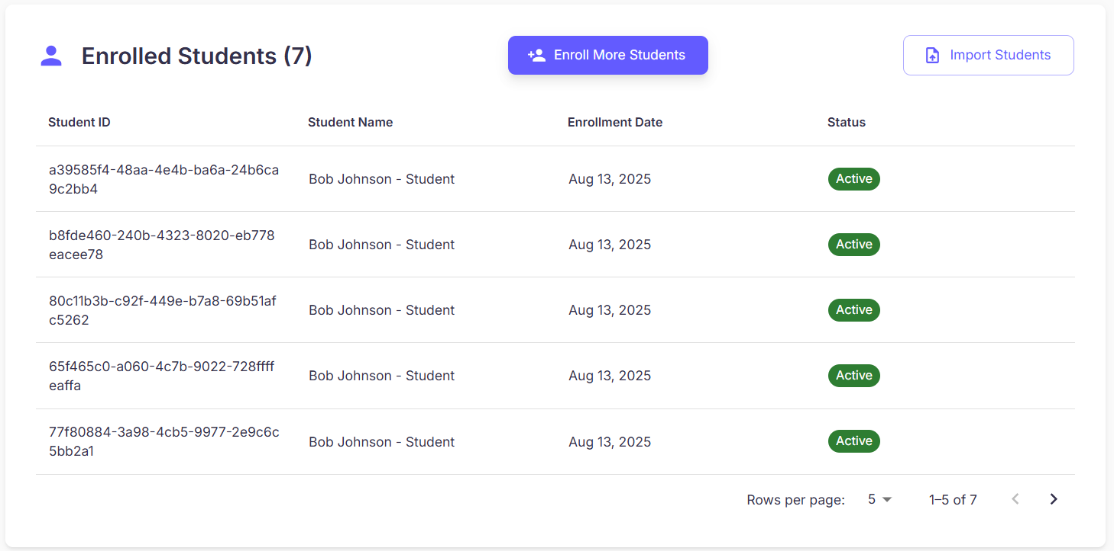
Figure 38 - Enroll Management (View Enrolled Student)
No | Field Name | Field Type | Description
1 | Section Title (“Enrolled Students (n)”) | Label | Header with total count.
2 | Enroll More Students | Button | Opens manual enrollment flow (separate UC). Visible per permissions (BR-02, BR-16).
3 | Import Students | Button | Opens CSV bulk import flow (separate UC). Visible per permissions (BR-02, BR-16).
4 | Students Table | Table | Read-only list of current enrollments with columns below.
5 | Pagination | Control | Rows per page selector and Previous/Next navigation.
Table 54: Enroll Management (View Enrolled Student) layout
Figure 39 - Enroll Management (Enrolled Student Table) layout
No | Field Name | Field Type | Description
1 | Student ID | Text | Unique identifier for each student.
2 | Student Name | Text | Full name and role (e.g., “Bob Johnson – Student”).
3 | Enrollment Date | Date | Date the student was added to the class.
4 | Status | Badge | Current enrollment status (e.g., Active).
Table 55: Enroll Management (Enrolled Student) layout
b. Use Case Specifications
ID and Name | UC45 - Manage Enrollments (View Enrolled Student)
Created By | DungND | Date Created | 28/06/2025
Primary Actor | Admin | Secondary Actors | System
Trigger | User opens Class Details and scrolls to the Enrolled Students section.
Description | As an authorized user, I want to view the list of students enrolled in a specific class—along with their IDs, names, enrollment dates, and statuses—so that I can verify enrollment and take follow-up actions (enroll more or import).
Preconditions | PRE-1. User is authenticated.  PRE-2. User has permission to view class enrollments.  PRE-3. The target class exists and has enrollment data (or supports empty state).
Postconditions | POST- 1. No data is modified by viewing alone.  POST- 2. After enrollment/import actions complete, the table auto-refreshes and the count updates.
Normal Flows | Step | By | Step Details
Normal Flows | 1 | User | On Class Details, scroll to Enrolled Students.
Normal Flows | 2 | User | Review table columns: Student ID, Student Name, Enrollment Date, Status.
Normal Flows | 3 | User | Click Enroll More Students to add individual students (separate UC).
Normal Flows | 4 | User | Click Import Students to bulk add from a CSV file (separate UC).
Normal Flows | 5 | User | If many records, use Rows per page and Previous/Next to navigate.
Normal Flows | 6 | System | Data updates automatically after students are added/removed; show green toast on success (e.g., “Student added successfully.”).
Alternative Flows | Alt Step | Condition | Description
Alternative Flows | A1 | No students enrolled | Show empty state “No students enrolled yet” with quick actions to Enroll or Import (if permitted).
Alternative Flows | A2 | Role-limited actions | Lecturer may view but cannot Import/Enroll unless granted permission.
Alternative Flows | A3 | Pagination edge | Disable Previous on first page and Next on last page; remember user’s page size selection in session.
Exceptions | - E1: Backend/API error → show inline error with Retry; keep table state.  - E2: Data changed concurrently (another user added/removed) → show non-blocking “Data updated” banner and refresh.  - E3: Import/Enroll flow fails → show error reason (e.g., invalid CSV), remain on section.
Frequency of Use | Medium–High
Business Rules | BR-01, BR-02
Other Information | - The table may later support sorting/filtering (by status/date).  - Accessibility: table headers announced to screen readers; pagination controls are keyboard accessible.
Assumptions | - The service provides a paginated endpoint for enrolled students of a class.  - After successful enroll/import/delete operations, the section refreshes automatically and updates the count.
Table 56: View Enrolled Student

3.2.1.19 Import Student
a. Screen Layouts
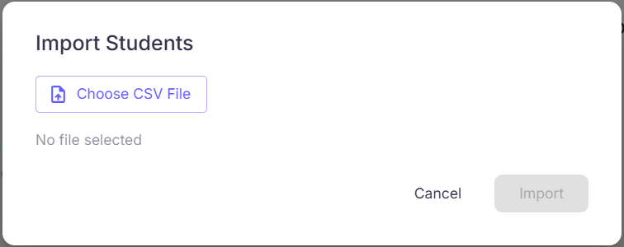
Figure 40 - Import student
No | Field Name | Field Type | Description
1 | Title (“Import Students”) | Label | Dialog header.
2 | Choose CSV File | Button | Open OS file picker to select a .csv. Accepts only CSV MIME/type.
3 | Selected File Name | Label | Shows the chosen file or “No file selected”.
4 | File Requirements Hint | Helper text | Required headers: Student ID. Optional: Full Name, Email, Enrollment Date (YYYY-MM-DD).
5 | Cancel | Button | Close dialog without importing.
6 | Import | Button (primary) | Uploads and processes the file. Disabled until a valid file is chosen.
7 | Progress / Result Area | Label | Shows upload progress, success count, and/or row-level errors after processing.
Table 57: Import Student Layout
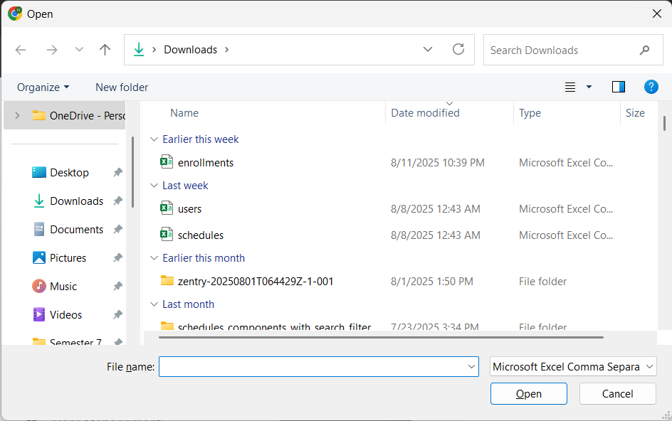
Figure 41 - Import student (2)
No | Field Name | Field Type | Description
1 | File list | Native control | User selects a .csv file from local machine.
2 | Open | Button | Confirms file selection.
3 | Cancel | Button | Closes picker without selection.
Table 58: Import Student Layout 2
b. Use Case Specifications
ID and Name | UC46 - Manage Enrollments (Import Student)
Created By | DungND | Date Created | 28/06/2025
Primary Actor |  | Secondary Actors | System
  Admin
Trigger | On Class Details, the user clicks Import Students (top-right of the page or Enrolled Students section).
Description | As an authorized user, I want to upload a CSV file to bulk enroll students into a class so that I can add many students efficiently and consistently.
Preconditions | PRE-1. User is authenticated.  PRE-2. User has permission to import/enroll students.  PRE-3. The target class exists and is loaded in Class Details.  PRE-4. CSV uses the required schema: Student ID (required), Full Name (optional), Email (optional), Enrollment Date.
Postconditions | POST- 1. Valid rows are enrolled into the class; the Enrolled Students table is refreshed.  POST- 2. A success toast is shown (e.g., “Students imported successfully”).  POST- 3. Import activity (counts, actor, class) is logged for audit.
Normal Flows | Step | By | Step Details
Normal Flows | 1 | User | On Class Details, click Import Students.
Normal Flows | 2 | User | Click Choose CSV File, pick the CSV that follows the required format.
Normal Flows | 3 | User | Click Import to upload and process the file.
Normal Flows | 4 | System | Parse CSV, validate headers & rows, then enroll valid students into the class.
Normal Flows | 5 | System | On success, show green notification “Students imported successfully” and update the Enrolled Students list automatically. On failure, show an error explaining what went wrong (e.g., missing columns, invalid format).
Alternative Flows | Alt Step | Condition | Description
Alternative Flows | A1 | No file selected | Import remains disabled; users may Cancel.
Alternative Flows | A2 | Partial success | System enrolls valid rows, lists failed rows with reasons (e.g., “Student not found”, “Invalid date”). Optionally provide a downloadable error report.
Alternative Flows | A3 | Duplicate / already enrolled | System skips duplicates and reports them as “Already enrolled”.
Alternative Flows | A4 | Policy requires existing students only | Rows whose Student ID does not exist are rejected with a clear message; none of those rows are imported. (If policy allows auto-create, prompt or document separately.)
Exceptions | - E1: Missing/incorrect headers → show “Required column ‘Student ID’ is missing.”  - E2: File type/size invalid → show constraint message and block import.  - E3: Network/server error during upload → show error toast; allow retry without reselecting file if possible.  - E4: Concurrency/conflict (class deleted/closed) → abort and show error; return to Classes page.
Frequency of Use | Medium
Business Rules | BR-01, BR-02
Other Information | - Recommended CSV encoding: UTF-8, comma-separated, first row headers (case-insensitive).  - Enrollment Date defaults to the current date if omitted.  - Timezone/locale applied when displaying dates.  - Consider idempotency: re-importing the same file should not create duplicates.
Assumptions | - Student identities are keyed by Student ID; name/email in CSV is used for verification/display only unless account creation is enabled by policy.  - Backend exposes a bulk import endpoint that validates and returns per-row results.
Table 59: Manage Enrollments (Import Student) Specification

3.2.1.20 Enroll Student
a. Screen Layouts
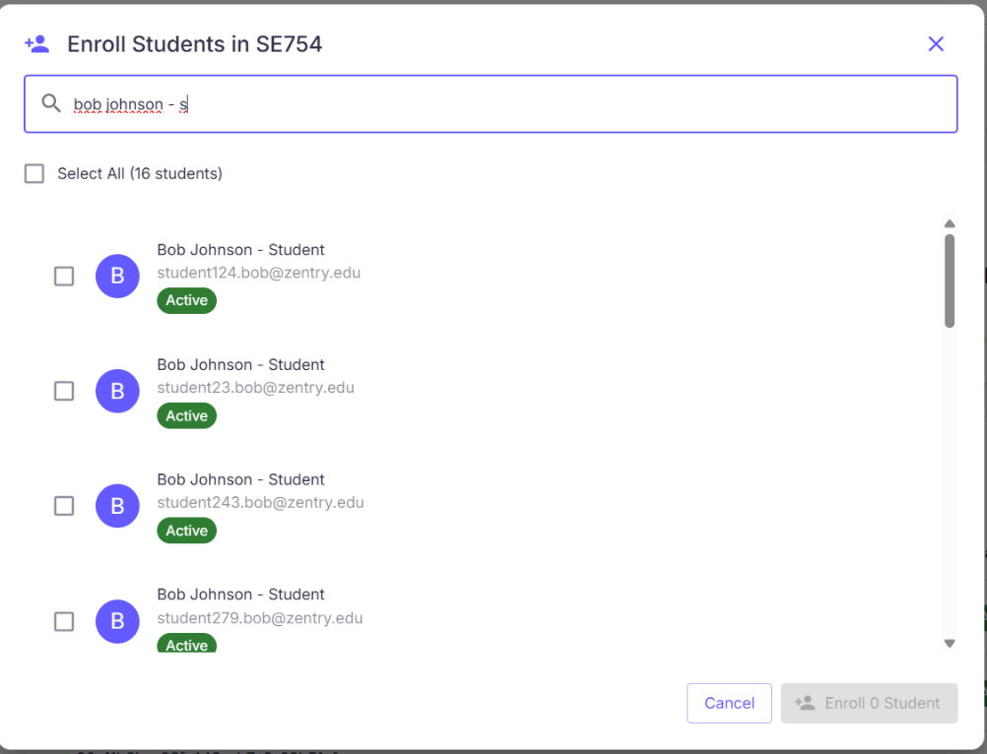
Figure 42 - Enroll Student
No | Field Name | Field Type | Description
1 | Title (“Enroll Students in <Section Code>”) | Label | Dialog header, e.g., Enroll Students in SE754.
2 | Search Bar | Searchbox | Filter available students by name, email, or ID (debounced).
3 | Select All (n students) | Checkbox | Select/deselect all students on the current page. Shows total count in view.
4 | Student List | Table / List | Scrollable list of students (see columns below).
5 | Import Students | Button (secondary) | Opens Import Students flow (CSV) — optional shortcut.
6 | Cancel | Button | Close dialog without changes.
7 | Enroll X Student(s) | Button (primary) | Disabled when 0 selected; label updates with selected count.
Table 60: Enroll Student Layout
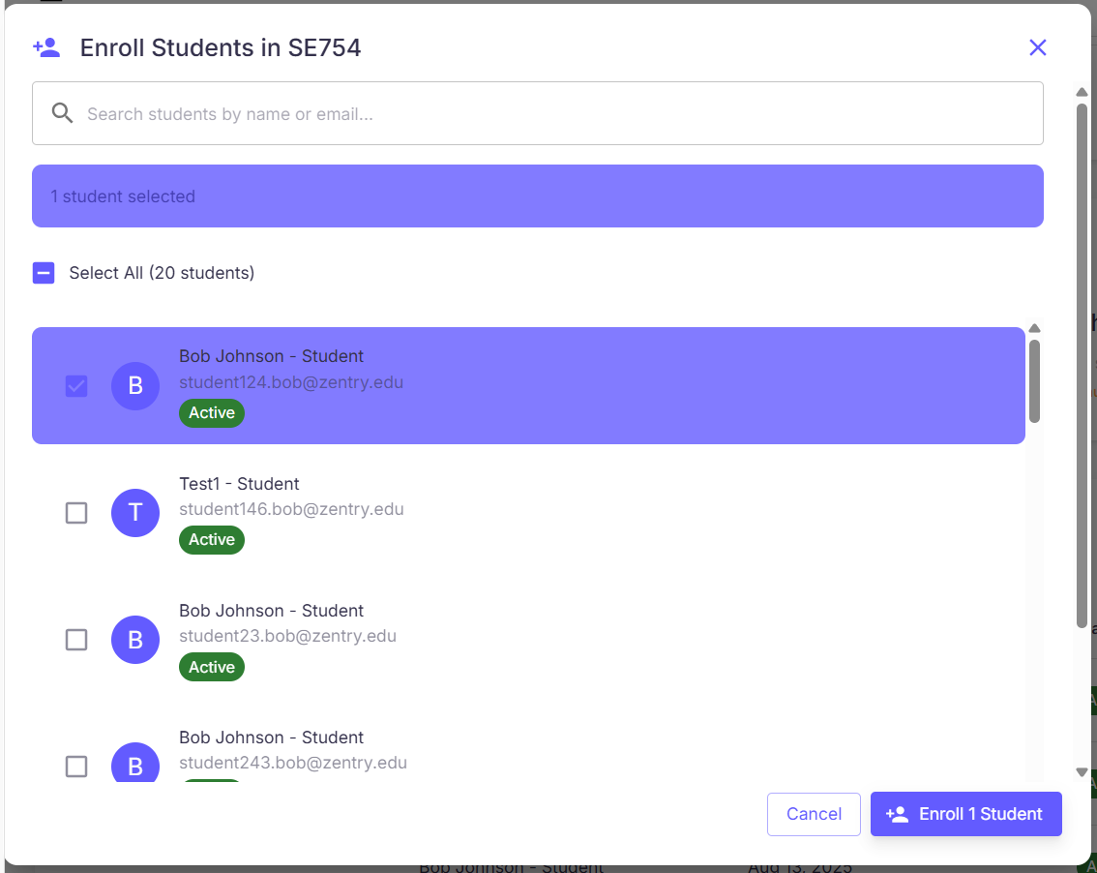
Figure 43 - Enroll Student (2)
No | Field Name | Field Type | Description
1 | Row Select | Checkbox | Select an individual student.
2 | Student ID | Text | Unique identifier.
3 | Student Name | Text | Full name and role, e.g., “Bob Johnson – Student”.
4 | Email | Text (secondary) | Contact email (if available).
5 | Status | Badge | Current status (e.g., Active). Non-active entries may be disabled per policy.
Table 61: Enroll Student Layout 2
b. Use Case Specifications
ID and Name | UC47 - Manage Enrollments (Enroll Student)
Created By | DungND | Date Created | 28/06/2025
Primary Actor | Admin | Secondary Actors | System
Trigger | On Class Details → Enrolled Students, the user clicks Enroll More Students.
Description | As an authorized user, I want to add one or more students to a class by selecting them from an available list (or by importing a CSV) so that the class roster is updated efficiently.
Preconditions | PRE-1. User is authenticated.  PRE-2. User has permission to manage enrollments.  PRE-3. Target class exists and is loaded in Class Details.  PRE-4. Directory of eligible students is available.
Postconditions | POST- 1. Selected students are enrolled into the class; the Enrolled Students table/count updates.  POST- 2. A success notification is shown and the action is logged.
Normal Flows | Step | By | Step Details
Normal Flows | 1 | User | On Class Details, click Enroll More Students to open the dialog.
Normal Flows | 2 | User | In the dialog: use the Search Bar to filter by name or ID; optionally use Select All (n students) to select all on the current page.
Normal Flows | 3 | User | Review list columns: Student ID, Student Name, Status.
Normal Flows | 4 | User | Select one or more students. When none are selected, the Enroll button is disabled; when selected, its label shows the count (e.g., Enroll 3 Students).
Normal Flows | 5 | User | (Optional) Click Import Students to bulk upload via CSV (see UC11).
Normal Flows | 6 | User | Click Enroll X Students to confirm.
Normal Flows | 7 | System | Validate selections and enroll them into the class.
Normal Flows | 8 | System | If successful, close dialog, refresh the Enrolled Students table, and show green toast “Student(s) enrolled successfully.” If unsuccessful, show error and keep dialog open.
Alternative Flows | Alt Step | Condition | Description
Alternative Flows | A1 | No results after search | Show empty state “No students found”; allow clearing the query.
Alternative Flows | A2 | Some selected students already enrolled | System skips duplicates and reports them as Already enrolled; successful rows proceed.
Alternative Flows | A3 | User cancels | Close dialog; no changes saved.
Exceptions | - E1: Network/Server error → show error toast; allow retry without losing selection.  - E2: Directory fetch failure → show inline error and a Retry control.  - E3: Concurrency conflict (class modified/closed) → abort with message and return to Class Details.
Frequency of Use | Medium–High
Business Rules | BR-01, BR-02
Other Information | - Multi-select supports Shift/keyboard navigation; list is virtualized for large directories.  - The dialog may show a small banner with “X student(s) selected”.  - Pagination or infinite scroll may apply; Select All refers to the current page only (unless “select across pages” is implemented).
Assumptions | - Backend provides a bulk-enroll endpoint accepting a list of Student IDs and the Class ID, returning per-ID results.
Table 62: Manage Enrollments (Enroll Student) Specification

3.2.1.21 View Schedules
a. Screen Layouts
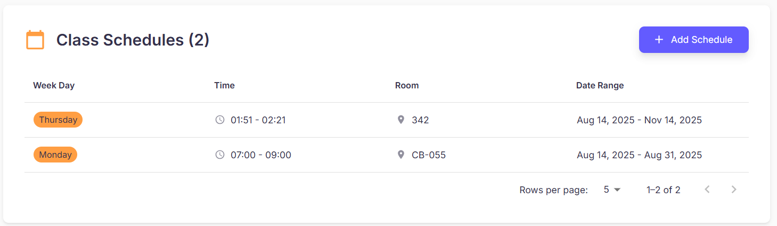
Figure 44 - View schedule layout
No | Field Name | Field Type | Description
1 | Section Title (“Class Schedules (n)”) | Label | Header with total count.
2 | Add Schedule | Button | Opens Add Schedule flow (separate UC). Visible per permissions.
3 | Schedules Table | Table | Read-only list of schedules with the columns below.
4 | Pagination | Control | Rows per page selector, Previous/Next arrows.
5 | Empty State | Label | “No schedules have been created for this class yet.” (when the list is empty).
Table 63: Manage Schedules (View schedule) layout
Figure 45 - View schedule table
No | Field Name | Field Type | Description
1 | Week Day | Badge/Text | Day of week when the class occurs (e.g., Monday, Thursday).
2 | Time | Text | Start and end time of the session (HH:MM – HH:MM).
3 | Room | Text | Room/location (e.g., CB-055).
4 | Date Range | Text | Start date → end date for the repeating schedule.
Table 64: Manage Schedules (View schedule detail) layout
b. Use Case Specifications
ID and Name | UC – 48: Manage Schedules (View scheduke)
Created By | DungND | Date Created | 28/06/2025
Primary Actor | Admin | Secondary Actors | System
Trigger | Manage Schedules (View schedule) layout
Description | As a user, I want to view all schedules for a class—showing weekday, time, room, and date range—so that I can understand when and where sessions occur and create new schedules if needed.
Preconditions | PRE-1. User is authenticated.  PRE-2. User has permission to view schedules for the class.  PRE-3. The target class exists.
Postconditions | POST- 1. No data is modified by viewing.  POST- 2. If a new schedule is added (or one is edited/deleted), the table refreshes automatically.
Normal Flows | Step | By | Step Details
Normal Flows | 1 | User | On Class Details, scroll to Class Schedules.
Normal Flows | 2 | User | Review table columns: Week Day, Time, Room, Date Range.
Normal Flows | 3 | User | Click Add Schedule to create a new schedule (opens separate UC).
Normal Flows | 4 | User | If there are many records, use Rows per page and Previous/Next pagination controls.
Normal Flows | 5 | System | The table updates automatically after a schedule is added/edited/deleted and shows a green toast on success (e.g., “Schedule added successfully.”).
Alternative Flows | Alt Step | Condition | Description
Alternative Flows | A1 | No schedules exist | Show empty state with a quick action Add Schedule (if permitted).
Alternative Flows | A2 | Role-limited view | Students can view only; Add Schedule is hidden.
Alternative Flows | A3 | Timezone/locale differences | Times render in the user’s timezone/locale; a tooltip may show server time.
Exceptions | - E1: Backend/API error → show inline error with Retry; keep pagination and scroll position.  - E2: Data inconsistency (e.g., room not found) → show placeholder (“Unknown room”) and log for admin.  - E3: Network timeout → show toast; allow retry without reloading the page.
Frequency of Use | Medium–High
Business Rules
  BR-01, BR-02
Other Information | - The table may later include actions (Edit/Delete) per row for authorized roles.  - Accessibility: table headers announced to screen readers; pagination and the Add button are keyboard accessible.
Assumptions | - Backend provides a paginated list of schedules for a class, including weekday, start/end time, room, and date range.
Table 65: Manage Schedules (View schedule) layout

3.2.1.22 Add Schedule
a. Screen Layouts
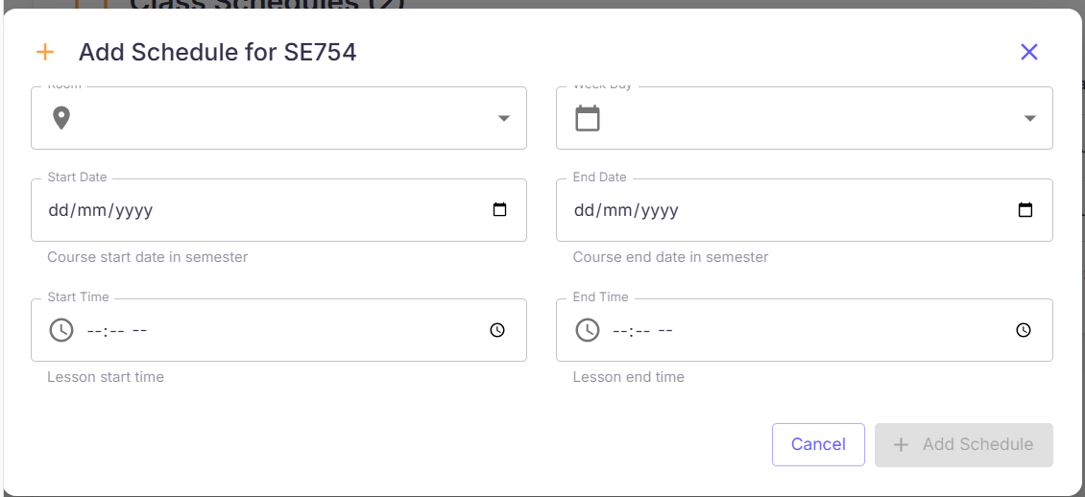
Figure 47 - Add schedule
No | Field Name | Field Type | Description
1 | Title (“Add Schedule for <Section Code>”) | Label | Dialog header, e.g., Add Schedule for SE754.
2 | Room | Dropdown | Required. Select from available rooms; each option shows name • building • capacity.
3 | Week Day | Dropdown | Required. Choose the day of week (Monday…Sunday).
4 | Start Date | DatePicker | Required. Course start date within the semester.
5 | End Date | DatePicker | Required. Course end date within the semester. Must be ≥ Start Date.
6 | Start Time | TimePicker | Required. Lesson start time (HH:MM).
7 | End Time | TimePicker | Required. Lesson end time (HH:MM). Must be > Start Time.
8 | Schedule Summary | Panel | Read-only preview of chosen Week Day, Time, Room, Date Range. Updates live.
9 | Cancel | Button | Close dialog; do not save.
10 | Add Schedule | Button (primary) | Validate & create schedule; disabled until form is valid.
11 | Error/Validation Area | Label | Inline field errors or server messages.
Table 66: Add schedule Layout (add schedule) layout
b. Use Case Specifications
ID and Name | UC49 - Manage Schedules (Add Schedule)
Created By | DungND | Date Created | 28/06/2025
Primary Actor |  | Secondary Actors | System
  Admin
Trigger | In Class Details → Class Schedules, the user clicks Add Schedule (top-right).
Description | As an authorized user, I want to add a new schedule to a class by specifying the room, weekday, date range, and lesson times so that the class timetable is accurate and visible in the schedules list.
Preconditions | PRE-1. User is authenticated.  PRE-2. User has permission to manage schedules.  PRE-3. Target class exists; room catalog and semester dates are available.
Postconditions | POST- 1. A weekly recurring schedule (on the chosen weekday between the selected dates) is created for the class.  POST- 2. Class Schedules table refreshes and shows the new row; a success toast is displayed.  POST- 3. Action is logged for auditing.
Normal Flows | Step | By | Step Details
Normal Flows | 1 | User | In Class Schedules, click Add Schedule.
Normal Flows | 2 | User | Fill the form: Room, Week Day, Start Date / End Date, Start Time / End Time.
Normal Flows | 3 | User | Review Schedule Summary to confirm selections.
Normal Flows | 4 | User | Click Add Schedule to save.
Normal Flows | 5 | System | Validate inputs, create the schedule, and update the table. On success, show green toast “Schedule added successfully.” On failure, display an error and keep the dialog open.
Alternative Flows | Alt Step | Condition | Description
Alternative Flows | A1 | User clicks Cancel | Close dialog; no data saved.
Alternative Flows | A2 | Dates outside semester / End < Start | System blocks save; show inline validation and highlight offending fields.
Exceptions | - E1: Network/Server error → show error toast; allow retry without losing input.  - E2: Missing reference data (rooms/semester) → show blocking message and disable Add Schedule.  - E3: Permission error → show “You don’t have permission to add schedules.”
Frequency of Use | Medium
Business Rules
  BR-01, BR-02
Other Information | - Timezone/locale respected when rendering and validating times.  - Consider preventing past-date creation if policy requires.  - Form may prefill Room or Week Day from previous selection within the session.
Assumptions | - Backend accepts: {classId, roomId, weekday, startDate, endDate, startTime, endTime} and returns the created schedule row.  - Schedules repeat weekly on the specified weekday within the given date range.
Table 67: Add Schedule

3.2.1.23 Edit Schedule
a. Screen Layouts
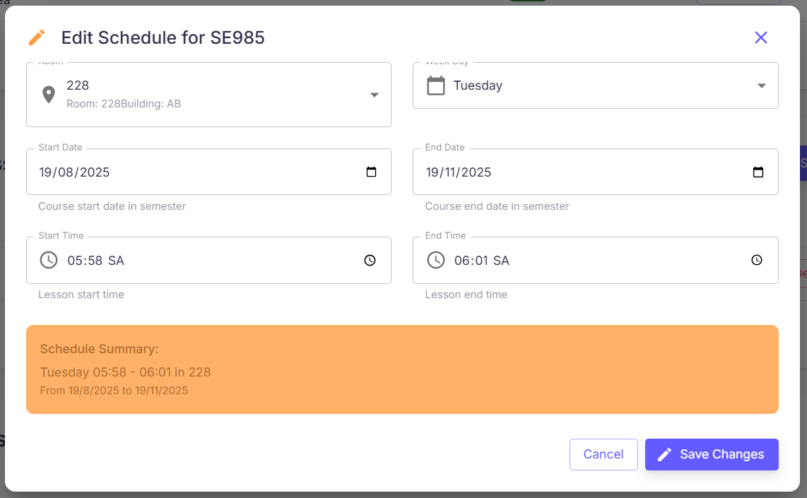
Figure 48 - Edit Schedule
No | Field Name | Field Type | Description
1 | Title (“Edit Schedule for <Section Code>”) | Label | Dialog header, e.g., Edit Schedule for SE754.
2 | Room | Dropdown | Required. Select a room (shows name • building • capacity).
3 | Week Day | Dropdown | Required. Choose the new weekday (Mon…Sun).
4 | Start Date | DatePicker | Required. New start date within the semester.
5 | End Date | DatePicker | Required. New end date (must be ≥ Start Date).
6 | Start Time | TimePicker | Required. Lesson start time (HH:MM).
7 | End Time | TimePicker | Required. Lesson end time (must be > Start Time).
8 | Schedule Summary | Panel | Live preview of Week Day, Time, Room, Date Range after edits.
9 | Cancel | Button | Close dialog; no changes saved.
10 | Save Changes | Button (primary) | Validate and persist updates; disabled until form is valid or any field changed.
11 | Error/Validation Area | Label | Inline field errors or server messages.
Table 68: Edit schedule layout
b. Use Case Specifications
ID and Name | UC49 - Manage Schedules (Add Schedule)
Created By | DungND | Date Created | 28/06/2025
Primary Actor |  | Secondary Actors | System
  Admin
Trigger | User clicks the Edit (pencil) icon for a schedule in Class Details → Class Schedules.
Description | As an authorized user, I want to update a class schedule’s room, weekday, date range, and times so that the timetable remains accurate and conflicts are avoided.
Preconditions | PRE-1. User is authenticated.  PRE-2. User has permission to manage schedules.  PRE-3. The target schedule exists and is loaded with its current values.  PRE-4. Reference data (rooms, semester dates) is available.
Postconditions | POST- 1. The schedule is updated with the new values.  POST- 2. Class Schedules list refreshes and shows the updated row; a success toast is displayed.  POST- 3. Update action is logged for audit.
Normal Flows | Step | By | Step Details
Normal Flows | 1 | User | In Class Schedules, locate the schedule and click Edit (pencil).
Normal Flows | 2 | System | Open Edit Schedule dialog pre-filled with current data.
Normal Flows | 3 | User | Update fields as needed: Room, Week Day, Start/End Date, Start/End Time.
Normal Flows | 4 | User | Review Schedule Summary to verify the changes.
Normal Flows | 5 | User | Click Save Changes to apply updates.
Normal Flows | 6 | System | Validate input and persist the changes.
Normal Flows | 7 | System | If successful, close dialog, refresh the table, and show green toast “Schedule updated successfully.” If unsuccessful, show an error (e.g., invalid time range, missing information) and keep the dialog open.
Alternative Flows | Alt Step | Condition | Description
Alternative Flows | A1 | No fields changed | Save Changes remains disabled or results in no-op; dialog stays open.
Alternative Flows | A2 | Date outside semester / End < Start | Block save; highlight invalid fields with inline messages.
Alternative Flows | A3 | Time conflict (same class or room overlap) | System blocks save with clear message (e.g., “Overlaps with another schedule in CB-055”).
Alternative Flows | A4 | Room becomes unavailable during edit | Prompt user to reselect a room and refresh options.
Alternative Flows | A5 | User clicks Cancel | Close dialog; discard edits.
Exceptions | - E1: Permission error → “You don’t have permission to edit schedules.”  - E2: Concurrency conflict (schedule modified/deleted by someone else) → show conflict notice and refresh list.  - E3: Network/Server error → show error toast; allow retry without losing edits.  - E4: Missing reference data (rooms/semester) → block save and instruct user to retry after data refresh.
Frequency of Use | Medium
Business Rules
  BR-01, BR-02
Other Information | - Times respect user timezone/locale; consider preventing edits to past occurrences if policy requires.  - If the system supports recurring exceptions, this UC edits the base weekly schedule (not individual dates).
Assumptions | - Backend exposes an update endpoint {scheduleId, roomId, weekday, startDate, endDate, startTime, endTime} with conflict detection and returns the updated schedule row.
Table 69: Manage Schedule (Edit Schedule)

3.2.1.24 Delete Schedule
a. Screen Layouts
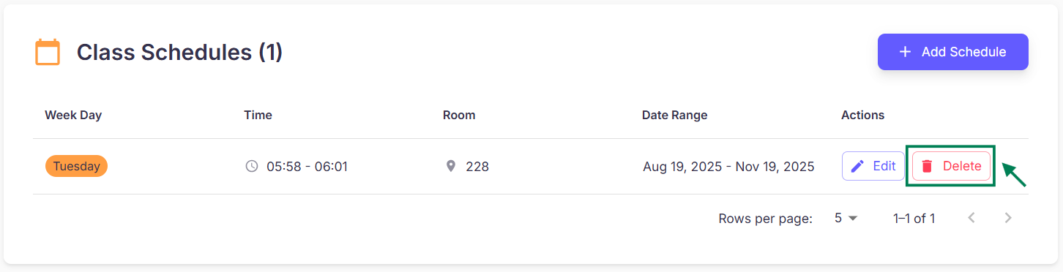
Figure 49 - Delete Schedule
No | Field Name | Field Type | Description
1 | Schedules Table | Table | Lists Week Day, Time, Room, Date Range, Actions.
2 | Actions (per row) | Icon buttons | Edit (pencil), Delete (trash bin). Delete opens confirmation dialog.
3 | Empty State | Label | “No schedules have been created for this class yet.” (when list is empty).
Table 70: Manage Schedule (Delete Schedule) layout
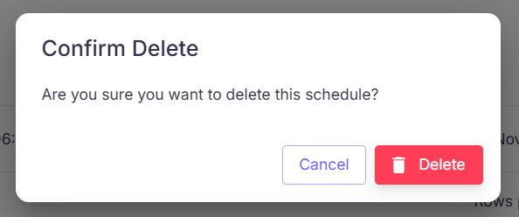
Figure 50 - Delete Schedule (2)
No | Field Name | Field Type | Description
1 | Title (“Confirm Delete”) | Label | Dialog header.
2 | Schedule Summary | Label | Shows Week Day, Time, Room, Date Range for verification.
3 | Cancel | Button (secondary) | Close dialog; no changes.
4 | Confirm | Button (primary, red) | Permanently delete the schedule. Disabled while processing.
5 | Error Area (optional) | Label | Displays server/validation errors if deletion fails.
Table 71: Manage Schedule (Delete Schedule) layout 2
b. Use Case Specifications
ID and Name | UC51 - Manage Schedule (Delete Schedule)
Created By | DungND | Date Created | 28/06/2025
Primary Actor | Admin | Secondary Actors | System
Trigger | User clicks the Delete (trash bin) icon for a schedule in Class Details → Class Schedules.
Description | As an authorized user, I want to permanently remove a schedule from a class so that outdated or incorrect timetable entries are no longer shown.
Preconditions | PRE-1. User is authenticated.  PRE-2. User has permission to manage schedules.  PRE-3. Target schedule exists for the selected class.
Postconditions | POST- 1. The schedule is removed (or marked deleted per policy) and no longer appears in the list.  POST- 2. A success notification is displayed; deletion is logged for audit.
Normal Flows | Step | By | Step Details
Normal Flows | 1 | User | In Class Schedules, locate the schedule and click Delete (trash bin).
Normal Flows | 2 | System | Show Delete Confirmation dialog with Week Day, Time, Room, Date Range.
Normal Flows | 3 | User | Click Confirm to proceed (or Cancel to abort).
Normal Flows | 4 | System | If successful, remove the schedule, refresh the table, and show green toast “Schedule deleted successfully.” If unsuccessful, keep dialog open and show error (e.g., “Unable to delete schedule. Please try again.”).
Normal Flows | 5 | User | To delete more schedules, repeat Steps 1–4 for each row.
Alternative Flows | Alt Step | Condition | Description
Alternative Flows | A1 | User clicks Cancel | Dialog closes; no changes saved.
Exceptions | - E1: Permission error → “You don’t have permission to delete schedules.”  - E2: Concurrency conflict (already deleted/edited) → show info and refresh list.  - E3: Network/Server error → show error toast; allow retry.
Frequency of Use | Medium
Business Rules | BR-01, BR-02
Other Information | - Consider double-confirmation for destructive actions in production environments.  - Ensure protected pages aren’t cached so deleted schedules don’t reappear via back navigation.
Assumptions | - Backend exposes a delete endpoint with proper referential checks and returns actionable error messages when constraints prevent deletion.
Table 72: Manage Schedule (Delete Schedule)

3.2.1.25 View Sessions
a. Screen Layouts
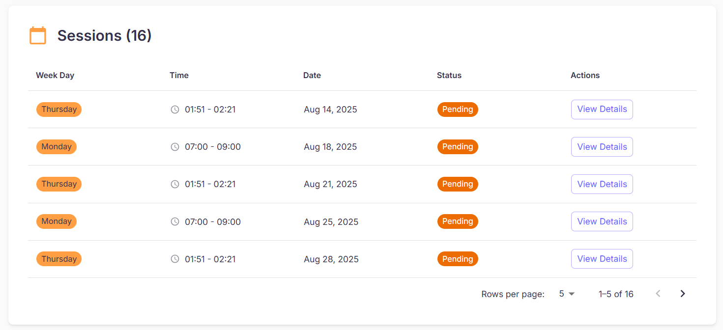
Figure 51 - View session
No | Field Name | Field Type | Description
1 | Section Title (“Sessions (n)”) | Label | Header with total count.
2 | Sessions Table | Table | Read-only list of sessions with columns below.
3 | Pagination | Control | Rows per page selector, Previous/Next arrows.
4 | Empty State | Label | “No sessions available for this class.” (shown when list is empty).
Table 73: Manage Sessions (View session) layout
Figure 51 - View session (2)

No | Field Name | Field Type | Description
1 | Week Day | Badge/Text | Day of the week the session occurs (e.g., Monday, Thursday).
2 | Time | Text | Start–end time of the session (HH:MM – HH:MM).
3 | Date | Date | Specific date of the session (localized).
4 | Status | Badge | Session state (e.g., Pending, Completed, Cancelled).
5 | Actions | Button | View Details → opens Session Details page. Edit and Delete Session.
Table 74: Manage Sessions (View session) layout 2
b. Use Case Specifications
ID and Name | UC40 – Manage Sessions
Created By | DungND | Date Created | 28/06/2025
Primary Actor | Admin | Secondary Actors | System
Trigger | From Class Details, the user scrolls to the Sessions section.
Description | As a user, I want to see all sessions for a class—showing weekday, time, date, status, and a link to details—so that I can review upcoming and past sessions and open a specific session for more information.
Preconditions | PRE-1. User is authenticated.  PRE-2. User has permission to view sessions for the class.  PRE-3. The target class exists and sessions have been generated from its schedules (or an empty state is shown).
Postconditions | POST- 1. No data is modified by viewing.  POST- 2. When the user opens a row’s View Details, the Session Details page is displayed.
Normal Flows | Step | By | Step Details
Normal Flows | 1 | User | On Class Details, scroll to Sessions.
Normal Flows | 2 | User | Review table columns: Week Day, Time, Date, Status, Actions.
Normal Flows | 3 | User | Click View Details in a row to open the Session Details page for that session.
Normal Flows | 4 | User | If many records exist, use Rows per page and Previous/Next to navigate.
Normal Flows | 5 | System | The table reflects updates automatically when sessions are added/updated; opening View Details navigates to the detailed page with full information and related actions.
Alternative Flows | Alt Step | Condition | Description
Alternative Flows | A1 | No sessions exist | Show empty state with guidance to create schedules which will generate sessions.
Exceptions | - E1: Backend/API error → show inline error with Retry; keep pagination state.  - E2: Concurrency conflict (session removed/changed) → show notice and refresh list.  - E3: Network timeout → show toast; allow retry.
Frequency of Use | Medium–High
Business Rules | BR-01, BR-02
Other Information | - Dates/times render in user’s timezone/locale.  - Accessibility: table headers are announced to screen readers; View Details buttons are keyboard accessible.
Assumptions | - Sessions are derived from schedules and stored with attributes: weekday, start/end time, date, and status.  - The “Session Details” page is handled in a separate use case.
Table 75: Manage Sessions (View session)

3.2.1.26 Edit Session
a. Screen Layouts
Updating
Figure 52 - Edit session
No | Field Name | Field Type | Description
1 | Title (“Edit Session”) | Label | Modal or page header.
2 | Week Day | Dropdown | Required. Select Monday…Sunday.
3 | Date | DatePicker | Required. Specific session date (localized). Must be valid for the class/semester window.
4 | Start Time | TimePicker | Required. Session start (HH:MM).
5 | End Time | TimePicker | Required. Session end (HH:MM). Must be after Start Time.
6 | Room | Dropdown | Required. Choose from available rooms (name • building • capacity).
7 | Status | Dropdown | Required. Pending / Completed / Cancelled (and any other configured states).
8 | Validation/Conflict Area | Inline message | Shows conflicts (e.g., overlapping room/time) or missing fields.
9 | Cancel | Button | Close without saving.
10 | Save Changes | Button (primary) | Validate and persist edits; disabled until form is valid or fields changed.
Table 76: Manage Sessions (edit session) layout
b. Use Case Specifications
ID and Name | UC53 - Manage Sessions (Edit Session)
Created By | DungND | Date Created | 28/06/2025
Primary Actor | Admin | Secondary Actors | System
Trigger | On the Sessions table, the user clicks Edit for a specific session.
Description | As an authorized user, I want to update a session’s weekday, time, date, room, and status so that the schedule reflects real-world changes and remains conflict-free.
Preconditions | PRE-1. User is authenticated.  PRE-2. User has permission to manage sessions.  PRE-3. Target session exists and its current data is loaded.  PRE-4. Room catalog and class/semester date constraints are available.
Postconditions | POST- 1. The session is updated with new values.  POST- 2. The Sessions table refreshes to show the changes and a success notification appears.  POST- 3. Update is logged for auditing.
Normal Flows | Step | By | Step Details
Normal Flows | 1 | User | In Sessions, locate the target row and click Edit.
Normal Flows | 2 | System | Open Edit Session form (modal/page) pre-filled with current values.
Normal Flows | 3 | User | Update fields: Week Day, Time (Start/End), Date, Room, Status.
Normal Flows | 4 | User | Click Save Changes to confirm (or Cancel to discard).
Normal Flows | 5 | System | Validate inputs (date in range, end > start, room availability, conflict checks).
Normal Flows | 6 | System | If successful, persist updates, refresh the Sessions table, and show green toast “Session updated successfully.” If not, show a red error (e.g., “Selected time conflicts with another session.”) and keep the form open.
Alternative Flows | Alt Step | Condition | Description
Alternative Flows | A1 | No fields changed | Save Changes disabled or no-op; remain on form.
Alternative Flows | A2 | Date outside class/semester | Block save; show inline message to choose a valid date.
Alternative Flows | A3 | Room/time conflict | Block save with clear details of the conflicting session/room.
Alternative Flows | A4 | Room becomes unavailable during edit | Prompt to reselect a room and reload availability.
Alternative Flows | A5 | User chooses Cancel | Close the dialog; no changes saved.
Exceptions | - E1: Permission error → “You don’t have permission to edit sessions.”  - E2: Concurrency conflict (session modified/deleted by another user) → show notice and refresh the table.  - E3: Network/Server error → show error toast; allow retry without losing edits.  - E4: Missing references (rooms not loaded) → disable save and instruct user to retry after data refresh.
Frequency of Use | Medium
Business Rules | BR-01, BR-02
Other Information | - Times and date pickers respect user timezone/locale.  - If status is Completed or Cancelled, policy may restrict time/room edits—surface any limits in the UI.
Assumptions | - Backend exposes an update endpoint {sessionId, weekday, date, startTime, endTime, roomId, status} with conflict detection and returns the updated session row.
Table 77: Manage Sessions (edit session) specification

3.2.1.27 Delete Session
a. Screen Layouts
Updating
Figure 53 - Delete Session
No | Field Name | Field Type | Description
1 | Sessions Table | Table | Columns: Week Day, Time, Date, Room, Status, Actions.
2 | Actions (per row) | More menu (⋯) | Contains Edit, View Details, Delete. Choosing Delete opens confirmation dialog.
3 | Empty State | Label | “No sessions available for this class.” (when list is empty).
Table 78: Manage Session (delete session) layout
b. Use Case Specifications
ID and Name | UC54 – Manage Sessions (Delete Sessions)
Created By | DungND | Date Created | 28/06/2025
Primary Actor | Admin | Secondary Actors | System
Trigger | In Class Details → Sessions, the user opens the More (⋯) menu for a row and chooses Delete.
Description | As an authorized user, I want to permanently remove a scheduled session from a class so that cancelled or obsolete sessions no longer appear in the timetable, while respecting policy checks for past or attended sessions.
Preconditions | PRE-1. User is authenticated.  PRE-2. User has permission to delete sessions.  PRE-3. Target session exists for the class.  PRE-4. Policy and validation rules are available (e.g., timeframe limits per BR-05, attendance constraints).
Postconditions | POST- 1. The session is deleted (or soft-deleted per policy) and removed from the Sessions table.  POST- 2. A success toast is shown; action is logged for audit (BR-15).  POST- 3. If deletion is blocked by policy, no data changes occur and the user is informed.
Normal Flows | Step | By | Step Details
Normal Flows | 1 | User | Locate the target session and click More (⋯) → Delete.
Normal Flows | 2 | System | Show Delete Session confirmation dialog with Week Day, Time, Date, Room, Status.
Normal Flows | 3 | System | (Optional validations) • If attendance exists/locked, show warning and require I understand the consequences checkbox. • If session date is in the past and policy forbids deletion, disable Delete and show note.
Normal Flows | 4 | User | Click Delete to proceed, or Cancel to abort.
Normal Flows | 5 | System | If successful, close dialog, remove the session from the table, and show green toast “Session deleted successfully.” If unsuccessful, show red error banner (e.g., “You don’t have permission to delete completed sessions.”) and make no changes.
Alternative Flows | Alt Step | Condition | Description
Alternative Flows | A1 | User cancels | Dialog closes; no changes saved.
Exceptions | - E1: Permission error → “You don’t have permission to delete sessions.”  - E2: Concurrency conflict (session already deleted/changed) → show info and refresh table.  - E3: Server/Network error → show error toast; allow retry.  - E4: Business constraint violation (locked attendance, policy block) → show explanatory message; prevent deletion.
Frequency of Use | Medium
Business Rules | BR-01, BR-02
Other Information | - Consider soft-delete with recovery window in production.  - Ensure back-button/page cache doesn’t show deleted rows.  - If associated attendance is removed, downstream reports should recalculate.
Assumptions | - Backend provides a delete endpoint with checks for attendance linkage, status, and date, returning actionable error messages when blocked.
Table 79: Manage Sessions (Delete Sessions)

3.2.1.28 View Session Details
a. Screen Layouts
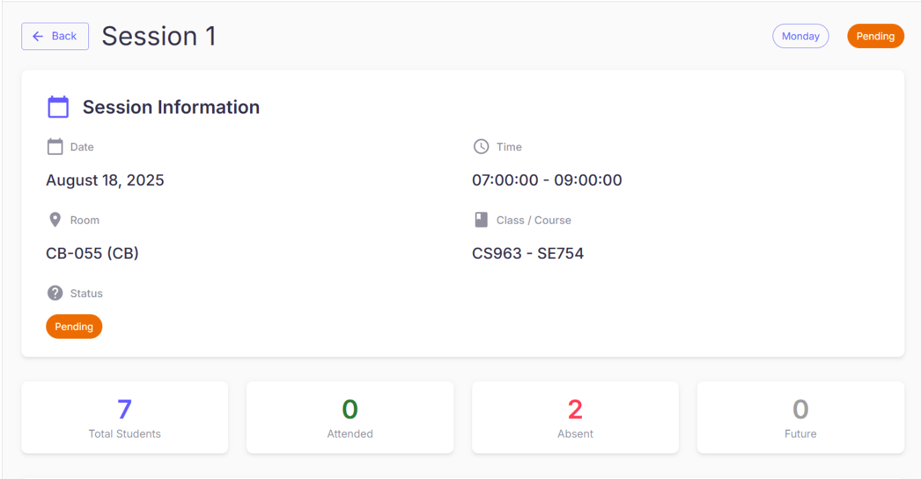
Figure 54 - View session details
No | Field Name | Field Type | Description
1 | Back | Button | Returns to Sessions list.
2 | Page Title (“Session <n>”) | Label | Header of the page.
3 | Weekday Tag | Badge | e.g., Monday, Thursday (top-right).
4 | Status Tag | Badge | Pending / Ongoing / Completed / Cancelled (top-right).
5 | Session Information Card | Panel | Container for key fields below.
6 | Date | Text | Scheduled date (localized).
7 | Time | Text | Start–end time (HH:MM:SS – HH:MM:SS).
8 | Room | Text | Room code and name (e.g., CB-055 (CB)).
9 | Class / Course | Text | Associated identifiers (e.g., CS963 – SE754).
10 | Status (inside card) | Badge | Current status; duplicates top-right for clarity.
11 | Attendance Summary | Panel | Four stat tiles: Total Students, Attended, Absent, Future.
Table 80: Manage Session (View Session Detail)
b. Use Case Specifications
ID and Name | UC55 - Manage Session (View Session Detail)
Created By | DungND | Date Created | 28/06/2025
Primary Actor | Admin | Secondary Actors | System
Trigger | From Class Details → Sessions, the user clicks View Details on a session row.
Description | As a user, I want to view complete information for a specific session—its date, time, room, related class/course, status, and attendance summary—so that I can verify the setup and quickly assess attendance.
Preconditions | PRE-1. User is authenticated.  PRE-2. User is authorized to view sessions for the class.  PRE-3. Target session exists.
Postconditions | POST- 1. No data is modified by viewing.  POST- 2. User may navigate back to the Sessions list.
Normal Flows | Step | By | Step Details
Normal Flows | 1 | User | In the Sessions list, click View Details for the target session.
Normal Flows | 2 | System | Open Session Details showing two sections: Session Information → Date, Time, Room, Class/Course, Status; Attendance Summary → Total Students, Attended, Absent, Future.
Normal Flows | 3 | User | Click Back to return to the Sessions list. Weekday and Status tags are shown at the top-right for quick identification.
Normal Flows | 4 | System | Load data in real time; reflect any updates to status or counts immediately.
Alternative Flows | Alt Step | Condition | Description
Exceptions | - E1: Session not found or deleted → redirect to Sessions list and show error “Session not found or has been removed.”  - E2: Permission error → show “You don’t have permission to view this session.” and return to previous page.  - E3: Backend/Network error → show error state with Retry; do not navigate away automatically.
Frequency of Use | Medium–High
Business Rules | BR-01, BR-02
Other Information | - Times/dates are localized to the user’s timezone/locale.  - Consider copy-to-clipboard for identifiers (class/course).  - Accessibility: all tiles and tags are screen-reader friendly and keyboard navigable.
Assumptions | None
Table 81: Manage Session (View Session Detail) Specification

3.2.1.29 Edit Attendance
a. Screen Layouts
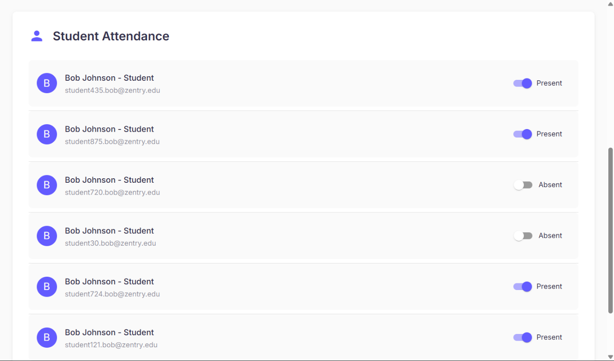
Figure 55 - Edit attendance
No | Field Name | Field Type | Description
1 | Section Title (“Student Attendance”) | Label | Header of the attendance list.
2 | Student Row | List item | Shows Avatar, Student Name – role, secondary line email/ID.
3 | Status Chip | Badge | Displays current state: Present / Absent. Auto-updates after save.
4 | Toggle | Switch | Change a student’s status (on → Present, off → Absent). Triggers confirmation dialog.
5 | Counters (top tiles) | Stat tiles | Attended, Absent, Future – refresh after successful update.
6 | Empty State | Label | “No students in this session.” (if list is empty).
Table 82: Edit Attendance layout
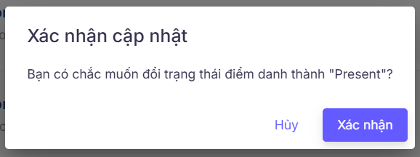
Figure 56 - Edit attendance (2)
No | Field Name | Field Type | Description
1 | Title (“Confirm update”) | Label | Dialog header.
2 | Message | Label | “Are you sure you want to change attendance to Present/Absent?”
3 | Cancel | Button (secondary) | Close dialog; keep current status.
4 | Confirm | Button (primary) | Apply the change. Disabled while processing.
5 | Error area (optional) | Label | Shows validation/server errors; toggle reverts on failure.
Table 83: Manage Session (Edit Attendance) layout 2
b. Use Case Specifications
ID and Name | UC56 - Edit Attendance
Created By | DungND | Date Created | 28/06/2025
Primary Actor | Admin | Secondary Actors | System
Trigger | On Session Details, the user toggles a student’s attendance in Student Attendance.
Description | As an authorized user, I want to update a student’s attendance for a specific session by switching between Present and Absent, with a confirmation step, so that the attendance record is accurate and the session statistics stay up to date.
Preconditions | PRE-1. User is authenticated.  PRE-2. User has permission to modify attendance.  PRE-3. Target session exists, and the student is enrolled in the class.  PRE-4. The session is within the editable window (e.g., during session or within 24 hours after end, per policy).  PRE-5. If FaceID is used, verification may be required by the lecturer.
Postconditions | POST- 1. The student’s attendance status is updated and persisted.  POST- 2. The Status chip and counters (Attended/Absent/Future) refresh immediately.  POST- 3. Action is logged for audit (BR-15).  POST- 4. (Optional) Notification may be sent if enabled (BR-12/BR-17).
Normal Flows | Step | By | Step Details
Normal Flows | 1 | User | On Session Details, scroll to Student Attendance.
Normal Flows | 2 | User | For the target student, toggle the switch: on = Present, off = Absent.
Normal Flows | 3 | System | Show Confirm update dialog displaying the new status.
Normal Flows | 4 | User | Click Confirm to proceed (or Cancel to keep the current status).
Normal Flows | 5 | System | Validate permissions and time window; persist the new status.
Normal Flows | 6 | System | If successful: update the row’s Status chip, refresh top counters, and show green toast “Attendance updated successfully.” If unsuccessful: show error, revert the toggle to the previous state, and keep counts unchanged.
Alternative Flows | Alt Step | Condition | Description
Alternative Flows | A1 | User cancels in dialog | No changes saved; toggle remains in its original state.
Exceptions | - E1: Network/Server error → show error toast; toggle reverts.  - E2: Concurrency conflict (record updated elsewhere) → inform user and refresh list.  - E3: Student not enrolled / record missing → show error and block change.
Frequency of Use | High
Business Rules | BR-01, BR-02
Other Information | - All updates are timestamped with editor identity for audit.  - UI should debounce rapid toggles to avoid duplicate writes.  - Accessibility: toggle is keyboard operable; dialog has focus trapping and ARIA labels.
Assumptions | - Backend provides an endpoint like {sessionId, studentId, status} and returns updated aggregates for counters.
Table 84: Manage Session (Edit Attendance) Specification

3.2.1.30 View Users
a. Screen Layouts
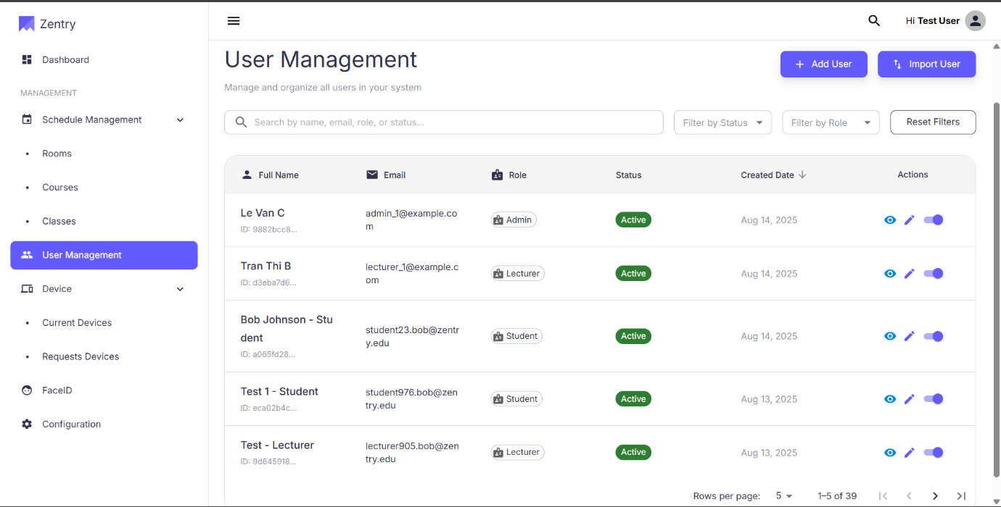
Figure 57 - View users
No | Field Name | Field Type | Description
1 | Sidebar Menu – User Management | Menu Item | Navigation item in the left sidebar that redirects to the User Management page.
2 | Page Title | Text | Displays "User Management" at the top of the page.
3 | Search Bar | Input Field | Allows searching users by name, email, role, or status.
4 | Filter by Status | Dropdown | Allows filtering users by status: Active / Inactive.
5 | Filter by Role | Dropdown | Allows filtering users by role: Admin, Lecturer, Student.
6 | User Table | Table | Displays the list of all users with details.
7 | Full Name & User ID | Table Column | Shows the full name of the user along with their unique ID.
8 | Email | Table Column | Displays the user’s email address.
9 | Role | Table Column | Displays the role of the user (Admin, Lecturer, Student).
10 | Status | Table Column | Displays whether the user is Active or Inactive.
11 | Created Date | Table Column | Displays the date when the user account was created.
12 | Actions – View | Button/Icon | Opens detailed information about the selected user.
13 | Actions – Edit | Button/Icon | Allows editing the selected user’s details.
14 | Actions – Change Status Toggle | Toggle Button | Enables changing user status between Active and Inactive.
Table 85: Manage User (View User) layout
b. Use Case Specifications
ID and Name | UC57 – Manage Users (View Users)
Created By | DungND | Date Created | 28/06/2025
Primary Actor | Admin | Secondary Actors | System
Trigger | The user navigates to the User Management page from the dashboard.
Description | As an authorized user, I want to view a list of all users and search for specific users so that I can manage their accounts.
Preconditions | PRE-1. The user is authenticated and authorized  PRE-2. The system is online and operational.
Postconditions | POST-1. The user can successfully view a list of all user records.  POST-2. The user can search and filter user records as needed.
Normal Flows | Step | By | Step Details
Normal Flows | 1 | User | From the Dashboard, navigate to User Management in the left sidebar menu.
Normal Flows | 2 | System | The User Management page is displayed, containing a table of all users. Each row shows: Full Name & User ID, Email, Role, Status, Created Date, and Actions (View, Edit, Change Status).
Normal Flows | 3 | User | Use the search bar to find a user by name, email, role, or status.
Normal Flows | 4 | User | Apply filters to narrow results: by Status (Active/Inactive) or by Role (Admin, Lecturer, Student).
Normal Flows | 5 | System | The table updates to reflect the applied search or filter criteria.
Alternative Flows | Alt Step | Condition | Description
Alternative Flows | A1 | No users found | If no matching users are found, the system displays a message: “No users match the search/filter criteria.”
Exceptions | - E1: Database connection error → System displays error message and suggests retry later.  E2: Unexpected system failure → Error logged for admin review, user notified.  - E3: If the login session time goes out, the system prompts the user to re-enter their credentials.
Frequency of Use | High
Business Rules | BR-01, BR-02
Other Information | - UI should support pagination for large user lists.  Sorting should be available for columns (e.g., Created Date, Name).
Assumptions | - The system already stores user information including name, email, role, status, and creation date.  - Only authorized users (e.g., Admin, or specific Lecturer roles) can view the User Management page.  - The search and filter functionalities are case-insensitive.  - The table is paginated for performance when displaying large datasets.
Table 86: Manage Users (View Users) Specification

3.2.1.31 Add User
a. Screen Layouts
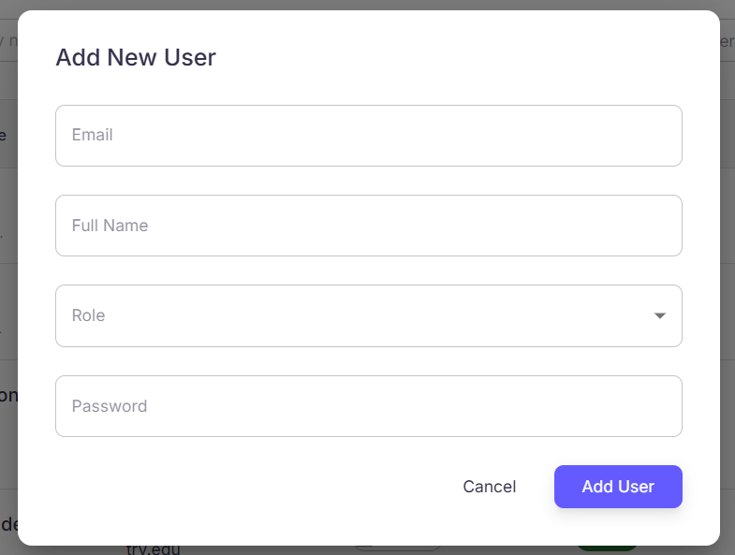
Figure 58 - Add user
No | Field Name | Field Type | Description
1 | Add User Button | Button | Add a new user
2 | Email | Text Field | Input field for user’s email address. Must be unique and valid format.
3 | Full Name | Text Field | Input field for the user’s full name.
4 | Role | Dropdown | Dropdown menu with options: Admin, Lecturer, Student.
5 | Password | Password Box | Input field for temporary password. Must meet security policy.
6 | Cancel Button | Button | Cancels the action and closes the dialog.
Table 87: Manage Users (Add Users)
b. Use Case Specifications
ID and Name | UC58 – Manage Users (Add Users)
Created By | DungND | Date Created | 28/06/2025
Primary Actor | Admin | Secondary Actors | System
Trigger | The user opens the website and attempts to log in using credentials or a linked OAuth account.
Description | As a user, I want to log in securely so that I can access system features according to my role
Preconditions | PRE-1. The user has a registered account.  PRE-2. The system is online and operational.
Postconditions | POST- 1. The user is redirected to the corresponding dashboard based on their role.
Normal Flows | Step | By | Step Details
Normal Flows | 1 | Admin | On the User Management page, click the Add User button in the top-right corner.
Normal Flows | 2 | Admin | In the Add New User dialog, fill in the fields: • Email: Enter the user’s email address • Full Name: Enter the user’s full name • Role: Open the dropdown and select Admin, Lecturer, or Student • Password: Enter a temporary password that meets the security policy.
Normal Flows | 3 | Admin | Click Add User to create the account (or Cancel to close without changes).
Normal Flows | 4 | System | Validates input data and processes the request. • If successful: A green notification appears — “User added successfully”. The dialog closes, and the new user appears in the list (status: Active by default). • If unsuccessful: An error message appears. Invalid fields are highlighted, and the dialog remains open for correction.
Alternative Flows | Alt Step | Condition | Description
Alternative Flows | A1 | Email already exists in the system | System shows error: “Email already exists”. Admin must enter a different email.
Alternative Flows | A2 | Email format is invalid | System highlights email field and shows error: “Invalid email format”.
Alternative Flows | A3 | Password is weak or does not meet security policy | System highlights password field and shows error: “Password does not meet requirements”.
Alternative Flows | A4 | Admin clicks Cancel instead of Add User | Dialog closes without creating a new user.
Exceptions | - E1: Database connection error → System displays error message and suggests retry later.  E2: Unexpected system failure → Error logged for admin review, user notified.  - E3: If the login session time goes out, the system prompts the user to re-enter their credentials.
Frequency of Use | High
Business Rules | BR-01, BR-02
Other Information | - Audit logs should capture the creation of new users (who created, when, and details).
Assumptions | - Admin has the correct permissions to create users.  - The system is online and connected to the database.  - Role list (Admin, Lecturer, Student) is predefined and up-to-date.  - The notification system is functional to display success/error messages.
Table 88: Manage Users (Add Users) Specification

3.2.1.32 Import User
a. Screen Layouts
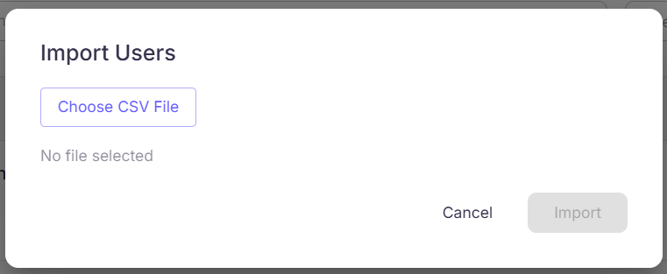
Figure 59 - Import Users layout
No | Field Name | Field Type | Description
1 | Import User Button | Button | Located on the User Management page (top-right). Opens Import Users dialog.
2 | Import Users Dialog | Modal/Dialog | Popup window displayed when clicking Import User button.
3 | Choose CSV File Button | Button | Triggers file picker window to select CSV file from computer.
4 | Import Button | Button | Confirms upload of selected CSV file.
5 | Cancel Button | Button | Closes the Import Users dialog without making changes.
Table 89: Import User Field Description Table
b. Use Case Specifications
ID and Name | UC59 – Manage User (Import User)
Created By | DungND | Date Created | 28/06/2025
Primary Actor |  | Secondary Actors | System
  Admin
Trigger
  The user clicks on “Import Users” in the “User Management”
Description | As a user, I want to import multiple users from a CSV file, so that I can quickly add many users at once without manual entry.
Preconditions | PRE-1. Admin must be logged into the system with appropriate permissions.  PRE-2. The CSV file must exist and follow the system’s required format (e.g., correct headers, valid data types).
Postconditions | POST- 1. New users are added to the system with status = Active by default.
Normal Flows | Step | By | Step Details
Normal Flows | 1 | Admin | On the User Management page, click the Import User button in the top-right corner.
Normal Flows | 2 | System | Display the Import Users dialog.
Normal Flows | 3 | Admin | Click Choose CSV File to open the file picker.
Normal Flows | 4 | Admin | In the file picker, navigate to and select the desired CSV file from the computer. The selected file name appears in the dialog.
Normal Flows | 5 | Admin | Click Import to upload the file (or Cancel to close without changes).
Normal Flows | 6 | System | Process the file and validate its contents.
Normal Flows | 7 | System | If successful: - Display green notification: “Users imported successfully”. - Close dialog. - Newly added users appear in the list with status: Active.
Alternative Flows | Alt Step | Condition | Description
Alternative Flows | A1 | File is invalid (wrong format, missing required columns) | System rejects the file and displays an error message prompting re-upload.
Alternative Flows | A3 | Admin clicks Cancel | System closes the dialog without making changes.
Exceptions | - E1: If the uploaded CSV exceeds the maximum size, system displays an error and prevents upload.  E2: Unexpected system failure → Error logged for admin review, user notified.  - E3: If the login session time goes out, the system prompts the user to re-enter their credentials.
Frequency of Use | Medium
Business Rules
  BR-01, BR-02
Other Information | - All login activities are recorded in system logs for security auditing and system health monitoring.  - The system supports both internal (username/password) and external (OAuth) authentication methods.
Assumptions | - CSV file is UTF-8 encoded and follows the predefined template format.  - Each user record must contain at least required fields (e.g., Email, Name, Role).  - Admin has sufficient permissions to perform bulk import.
Table 90: Import User Specification

3.2.1.33 Edit User
a. Screen Layouts
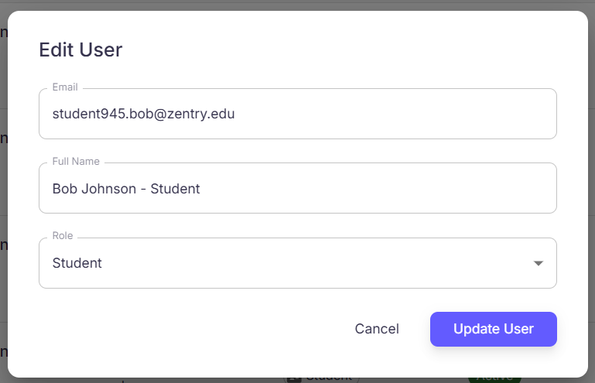
Figure 60: Edit User Layout
No | Field Name | Field Type | Description
1 | Edit User Icon | Button/Icon | Pencil icon in the Actions column of the user table, used to open the Edit User dialog.
2 | Edit User Dialog | Modal/Dialog | Dialog window that appears with the user’s current information pre-filled for editing.
3 | Email | Textbox/Input | Field for entering or modifying the user’s email. Validates email format and uniqueness.
4 | Full Name | Textbox/Input | Field for modifying the user’s full name.
5 | Role | Dropdown/List | Dropdown to select the user’s role (Admin, Lecturer, Student).
6 | Update User Button | Button | Saves the changes and updates the user information.
7 | Cancel Button | Button | Discards changes and closes the Edit User dialog.
8 | Success Notification | Toast/Alert | Green notification displayed after a successful update, closes dialog and refreshes list.
9 | Error Message | Text/Alert | Displays error message when update fails (e.g., invalid email, duplicate email). Highlights problematic fields for correction.
Table 91: Edit User Field Description Table
b. Use Case Specifications
ID and Name | UC- 60: Manage Users (Edit User)
Created By | DungND | Date Created | 28/06/2025
Primary Actor | Admin | Secondary Actors | System
Trigger | The user clicks the Edit User icon for a specific user in the User Management page.
Description | As a user, I want to edit an existing user’s information (email, full name, and role) so that the system reflects the most up-to-date and correct user data.
Preconditions | PRE-1. The user has a registered account.  PRE-2. The system is online and operational.
Postconditions | POST- 1. The selected user’s details are updated and displayed in the user list (if update is successful). If update fails, the user remains unchanged, and the admin is informed of the error
Normal Flows | Step | By | Step Details
Normal Flows | 1 | Admin | On the User Management page, locate the target user and click the Edit User icon (pencil).
Normal Flows | 2 | System | Displays the Edit User dialog with current details pre-filled (Email, Full Name, Role).
Normal Flows | 3 | Admin | Updates one or more fields: - Email - Full Name - Role (Admin, Lecturer, Student).
Normal Flows | 4 | Admin | Clicks Update User to confirm changes (or Cancel to discard).
Normal Flows | 5 | System | Validates input data (format, uniqueness of email, required fields).
 | 6 | System | If validation passes, updates the user record in the database.
 | 7 | System | Displays a green success notification: “User updated successfully”, closes the dialog, and refreshes the user list.
Alternative Flows | Alt Step | Condition | Description
Alternative Flows | A1 | Admin clicks Cancel instead of Update | The system closes the dialog without saving changes.
Exceptions | - E1: Database connection error → System displays error message and suggests retry later.  E2: Unexpected system failure → Error logged for admin review, user notified.  - E3: If the login session time goes out, the system prompts the user to re-enter their credentials.
Frequency of Use | High
Business Rules | BR-01, BR-02
Other Information | - Audit log should record the details of user updates (who edited, when, what fields changed).  - UI design reference: Figure xx - Edit User Dialog (with updated fields).  - Accessibility: Error messages must be screen-reader compatible.
Assumptions | - Email is the unique identifier for users.
Table 92: Manage Users (Edit User) Specification

3.2.1.34 Change User Status
a. Screen Layouts
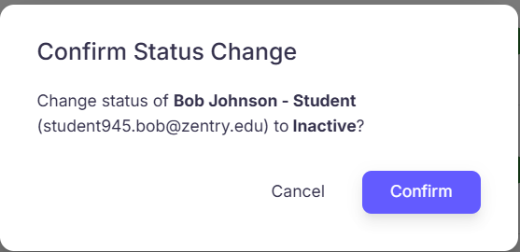
Figure 61 - Confirm status change layout
No | Field Name | Field Type | Description
1 | User List Table | Table | Displays users with their details including current status.
2 | Toggle Status Button | Button/Icon | Switch icon located in the user’s row for toggling status.
3 | Confirmation Dialog | Modal | Dialog box confirming the status change action.
4 | Current Status Label | Text/Label | Shows the user’s current status (Active/Inactive).
5 | New Status Preview | Text/Label | Shows what the status will change to (Active ↔ Inactive).
6 | Confirm Button | Button | Executes the status change action.
7 | Cancel Button | Button | Cancels the action and closes the dialog.
8 | Notification | Toast/Alert | Displays success or error message after attempting status change.
Table 93: Confirm status change Field Description Table
b. Use Case Specifications
ID and Name | UC- 61: Manage User (Change User Status)
Created By | DungND | Date Created | 28/06/2025
Primary Actor | Admin | Secondary Actors | System
Trigger | The user clicks the Toggle Status button on a specific user in the User Management page
Description | As a user, I want to change a user’s status between Active and Inactive so that I can control whether a user can access the system.
Preconditions | PRE-1. The user has a registered account.  PRE-2. The system is online and operational.
Postconditions | POST- 1. The user’s status is updated in the system and displayed in the User Management table.
Normal Flows | Step | By | Step Details
Normal Flows | 1 | Admin | Locate the user in the User Management table and click the Toggle Status button.
Normal Flows | 2 | System | Display confirmation dialog showing current status and new status.
Normal Flows | 3 | Admin | Click Confirm in the dialog. System updates the user status, updates the status label in the table, and shows a green notification: “Status updated successfully”.
Alternative Flows | Alt Step | Condition | Description
Alternative Flows | A1 | Cancel | Close the dialog without changing the user status.
Exceptions | - E1: Database connection error → System displays error message and suggests retry later.  E2: Unexpected system failure → Error logged for admin review, user notified.  - E3: If the login session time goes out, the system prompts the user to re-enter their credentials.
Frequency of Use | High
Business Rules | BR-01, BR-02
Other Information | - The toggle status action should be reflected immediately in the table without requiring a page refresh.  - The system must log each status change for audit purposes, including the admin who performed the change and the timestamp.  - Notifications should disappear automatically after a few seconds.
Assumptions | - The system’s network connection is stable; otherwise, an error message will be shown.  - Only admins have permission to change user status.  - Users in the system already have either “Active” or “Inactive” status.  - Status change cannot be performed on a user who is currently in the process of being deleted.
Table 94 - Manage User (Confirm status change) Specification

3.2.1.35 View User Details
a. Screen Layouts
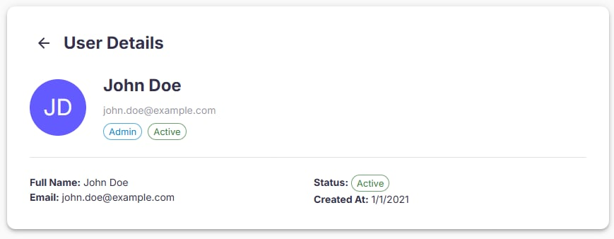
Figure 62 - User detail layout
No | Field Name | Field Type | Description
1 | View User Icon | Button/Icon | Eye icon in the Actions column of User Management table. Opens User Details page.
2 | Back Arrow | Button/Icon | Located at the top-left of the User Details page. Navigates back to User Management list.
3 | Full Name | Text Label | Displays the full name of the selected user.
4 | Email | Text Label | Displays the email address of the user.
5 | Role | Badge | Displays the user’s role (Admin, Lecturer, or Student).
6 | Status | Badge | Displays the current account status (Active/Inactive).
7 | Created At | Text Label | Displays the date when the user account was created.
8 | Error Message | Text | Displays “User not found.” if the selected user does not exist.
Table 95: User detail Field Table
b. Use Case Specifications
ID and Name | UC62 – View User Detail
Created By | DungND | Date Created | 28/06/2025
Primary Actor | Admin | Secondary Actors | System
Trigger | The user clicks the View User icon (eye symbol) on a specific user in the User Management page.
Description | As a user, I want to view detailed information about a user so that I can understand their account details, role, and status.
Preconditions | PRE-1. The user has a registered account.  PRE-2. The system is online and operational.
Postconditions | POST- 1. User details are displayed on the User Details page.
Normal Flows | Step | By | Step Details
Normal Flows | 1 | Admin | Locate the user in the User Management table and click the View User icon.
Normal Flows | 2 | System | Load and display the User Details page with full name, email, role, status, and creation date.
Normal Flows | 3 | Admin | Review the information.
Normal Flows | 4 | Admin | Click the Back button to return to the User Management list.
Alternative Flows | Alt Step | Condition | Description
Alternative Flows | A1 | User does not exist (e.g., deleted) | System displays an error message: “User not found” and remains on the User Management page.
Exceptions | - E1: Database connection error → System displays error message and suggests retry later.  E2: Unexpected system failure → Error logged for admin review, user notified.  - E3: If the login session time goes out, the system prompts the user to re-enter their credentials.
Frequency of Use | High
Business Rules | BR-01, BR-02, BR-16
Other Information | - The User Details page should always display the most up-to-date information from the database.  - Role is displayed as a badge with color coding (optional for UI clarity).  - Back button should preserve the previous table state (e.g., pagination, filters).
Assumptions | - Only admins have permission to view detailed user information.  - All users have valid data for full name, email, role, status, and created date.  - Network connection is stable for loading details.  - Deleted or non-existent users trigger the error flow.
Table 96 - User detail specification

3.2.1.36 View Active Devices
a. Screen Layouts
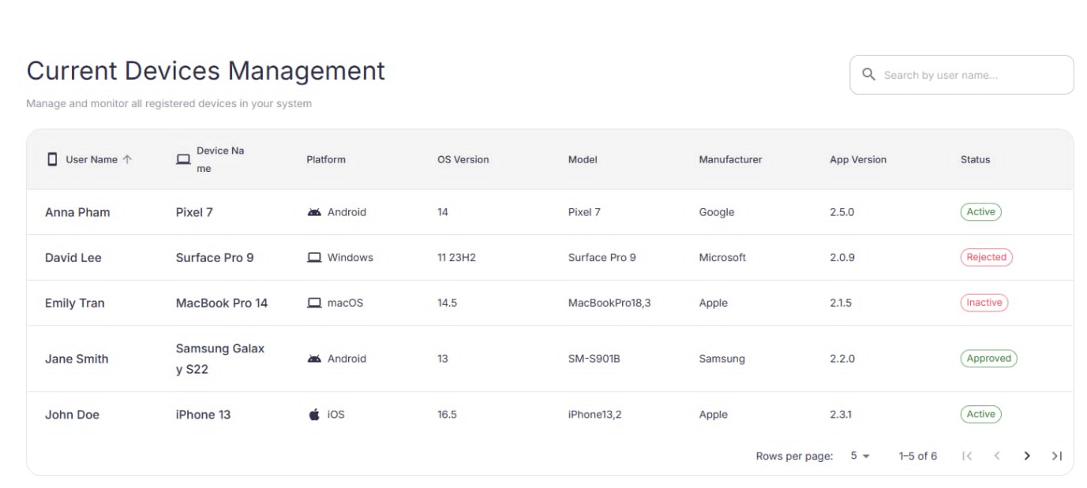
Figure 63: View Active Devices Layout
No | Field Name | Field Type | Description
1 | Page Title (“Current Devices Management”) | Label | Header and short helper text (“Manage and monitor all registered devices”).
2 | Search by user name… | Searchbox | Filter rows by user name (debounced).
3 | Status Filter | Dropdown/Chips | Optional filter with values Active, Approved, Inactive, Rejected; defaults to All (or Active if configured).
4 | Devices Table | Table | Lists device records (see columns below).
5 | Pagination | Control | Rows per page selector; Previous/Next arrows.
6 | Empty State | Label | “No active devices found.” shown when the filtered result set is empty.
Table 97: View Active Devices Field table
Figure 64: View Active Devices Table
No | Column | Field Type | Description
1 | User Name | Text | Owner’s display name.
2 | Device Name | Text | Device label/model name set by user or system.
3 | Platform | Icon + Text | Android / iOS / Windows / macOS, etc.
4 | OS Version | Text | Major/minor OS version (e.g., 16.5).
5 | Model | Text | Manufacturer model identifier.
6 | Manufacturer | Text | e.g., Apple, Samsung, Microsoft, Google.
7 | App Version | Text | Installed app version on the device.
8 | Status | Badge | Active (green), plus other statuses for context. Only Active rows are in-scope for this UC when filter is applied.
Table 98: Current Devices Management Field table
b. Use Case Specifications
ID and Name | UC-63 Manage Active Devices (View Active Devices)
Created By | DungND | Date Created | 28/06/2025
Primary Actor |  | Secondary Actors | System
  Admin
Trigger | The user navigates to Device → Current Devices from the sidebar.
Description | As an admin, I want to view and monitor all devices currently marked as Active so that I can confirm which registered/approved devices are allowed to use the system.
Preconditions | PRE-1. User is authenticated.  PRE-2. User has permission to view device inventory.  PRE-3. Devices are registered in the system (BR-03) and their approval states are recorded (BR-10).
Postconditions | POST- 1. No data is modified by viewing; the admin may refine the list via search/filters.  POST- 2. (Optional) The view remembers the last filter/pagination settings for the session.
Normal Flows | Step | By | Step Details
Normal Flows | 1 | User | In the sidebar, under Device, click Current Devices.
Normal Flows | 2 | User | In the Current Devices Management table, locate the Status column.
Normal Flows | 3 | User | Use the Search bar or scroll the list; identify rows with the Active (green) status badge.
Normal Flows | 4 | User | (Optional) Use Status Filter and Pagination to refine the displayed devices.
Normal Flows | 5 | System | Display all devices matching Active (when filtered), including User Name, Device Name, Platform, OS Version, Model, Manufacturer, App Version, Status. If none, show “No active devices found.”
Alternative Flows | Alt Step | Condition | Description
Alternative Flows | A1 | Default view shows all statuses | Admin switches Status Filter to Active to focus only on active devices.
Exceptions | - E1: Backend/API error → inline error state with Retry; keep search/filter context.  - E2: Network timeout → toast banner; allow retry without resetting pagination.  - E3: Data inconsistency (e.g., missing platform) → display placeholder (“—”) and log for review.
Frequency of Use | Medium–High
Business Rules | BR-01, BR-02
Other Information | - Common table affordances: column sort (User Name, Platform, App Version), export CSV (admin only), and row click to open device details (future UC).  - Consider periodic auto-refresh so statuses reflect recent approvals/revocations.  - Accessibility: search and table controls are keyboard-friendly with ARIA labels.
Assumptions | None
Table 99: Current Devices Specification

3.2.1.37 Inactive Device
a. Screen Layouts
Figure 65: Inactive Devices
No | Field Name | Field Type | Description
1 | Page Title (“Current Devices Management”) | Label | Header and helper text (“Manage and monitor all registered devices”).
2 | Search by user name… | Searchbox | Filter rows by user name (debounced).
3 | Status Filter | Dropdown/Chips | Choose Inactive (also supports Active/Approved/Rejected/All). For this UC, filter = Inactive.
4 | Devices Table | Table | Lists device records (see columns below).
5 | Pagination | Control | Rows-per-page selector, Previous/Next arrows.
6 | Empty State | Label | “No inactive devices found.” when result set is empty.
Table 100: Inactive Device Field Table
b. Use Case Specifications
ID and Name | UC-64 Manage Active Devices (Inactive Devices)
Created By | DungND | Date Created | 28/06/2025
Primary Actor |  | Secondary Actors | System
  Admin
Trigger
  User navigates to Device → Current Devices from the sidebar.
Description | As an admin, I want to view and manage all devices currently marked as Inactive so that I can either re-activate eligible devices or remove those that should no longer be in the system.
Preconditions | PRE-1. User is authenticated.  PRE-2. User has permission to view/manage device inventory.  PRE-3. Devices are registered and have status tracking.
Postconditions | POST- 1. Viewing alone does not modify data.  POST- 2. If the admin performs an action (reactivate/remove), the table reflects the change and the action is logged.
Normal Flows | Step | By | Step Details
Normal Flows | 1 | User | In the sidebar under Device, click Current Devices.
Normal Flows | 2 | User | In the Current Devices Management table, focus on the Status column.
Normal Flows | 3 | User | Use the Search bar or Status Filter to locate devices; identify rows with the Inactive status badge (gray/red outline).
Normal Flows | 4 | User | (Optional) Click a specific inactive device to open Device Details (shows Last Active, Registered User, Platform, OS Version, etc.).
Normal Flows | 5 | System | The table lists all devices with status Inactive. If none, display “No inactive devices found.”
Alternative Flows | Alt Step | Condition | Description
Alternative Flows | A1 | Reactivate device | Admin clicks Reactivate → confirmation dialog → on success, device status becomes Active/Approved and row moves out of the Inactive view; show success toast “Device re-activated successfully.”
Exceptions | - E1: Permission error → “You don’t have permission to manage devices.”  - E2: Network/Server error → inline error with Retry; preserve filters/pagination.  - E3: Concurrency conflict (device already reactivated/removed) → show info and refresh list.  - E4: Data inconsistency (missing attributes) → show placeholders (“—”) and log for review.
Frequency of Use | Medium
Business Rules
  BR-01, BR-02
Other Information | - Auto-refresh interval can be enabled to reflect recent changes.  - Accessibility: search/filter controls and table rows are keyboard/reader-friendly.
Assumptions | None
Table 101 - Inactive Device Specification

3.2.1.38 View Device Requests
a. Screen Layouts
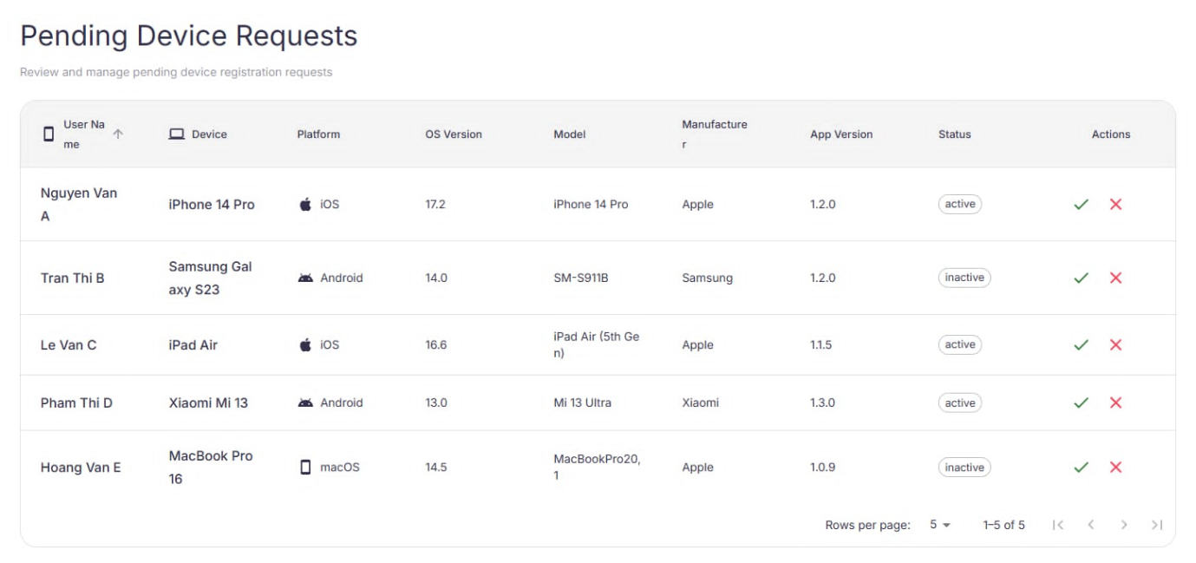
Figure 66: Requests Devices Layout
No | Field Name | Field Type | Description
1 | Page Title (“Requests Devices”) | Label | Header with helper text: “Review and manage device registration requests.”
2 | Search… | Searchbox | Filter by user name or device name (debounced).
3 | Status Filter | Dropdown/Chips | Defaults to Pending; may include Approved, Rejected (history view).
4 | Requests Table | Table | List of pending requests (see columns below).
5 | Pagination | Control | Rows-per-page selector; Previous/Next arrows.
6 | Empty State | Label | “No pending device requests.” when list is empty.
Table 102 - Requests Devices Layout
Figure 67: Requests Devices Table
No | Column | Field Type | Description
1 | User Name | Text | Requester’s display name.
2 | Device Name | Text | Submitted device label/model.
3 | Platform | Icon + Text | Android / iOS / Windows / macOS, etc.
4 | OS Version | Text | e.g., 16.5, 14, 11 23H2.
5 | Model | Text | Manufacturer model identifier.
6 | Manufacturer | Text | Apple, Samsung, Microsoft, Google, …
7 | App Version | Text | Installed app version reported by client.
8 | Current Status | Badge | Active / Inactive if the device already exists; otherwise Pending.
9 | Actions | Icon buttons | ✓ Approve and ✕ Reject. Optional “View details”/“History” in a row menu.
Table 103 - Requests Devices Table
b. Use Case Specifications
ID and Name | UC65 - Manage Device Requests (View Device Requests)
Created By | DungND | Date Created | 28/06/2025
Primary Actor |  | Secondary Actors | System
  Admin
Trigger
  From the sidebar, the admin opens Device → Requests Devices.
Description | As an admin, I want to review pending device registration requests and approve or reject them so that only eligible devices become active in the system.
Preconditions | PRE-1. Admin is authenticated.  PRE-2. Admin has permission to manage device requests.  PRE-3. Requests are submitted by users and stored with device metadata.
Postconditions | POST- 1. Approved requests move to Current Devices with appropriate status; rejected requests disappear from the pending list.  POST- 2. Actions are logged for audit (BR-15) and (optionally) notifications are sent to the requester.
Normal Flows | Step | By | Step Details
Normal Flows | 1 | User | In the sidebar, go to Device → Requests Devices.
Normal Flows | 2 | System | Display Pending Device Requests with columns: User Name, Device Name, Platform, OS Version, Model, Manufacturer, App Version, Current Status.
Normal Flows | 3 | User | To decide on a request, click ✓ (Approve) or ✕ (Reject) in the Actions column.
Normal Flows | 4 | System | If approved: move device to Current Devices, set status (e.g., Active/Approved), and remove from Requests list. If rejected: remove from pending list and notify the user of rejection.
Normal Flows | 5 | System | Show a green notification confirming the action (e.g., “Device approved successfully.” or “Device request rejected.”).
Alternative Flows | Alt Step | Condition | Description
Exceptions | - E1: Permission error → “You don’t have permission to approve/reject device requests.”  - E2: Network/Server error → inline error; keep table state and allow retry.  - E3: Concurrency conflict (request already processed) → show info and refresh list.  - E4: Invalid metadata → show warning; allow admin to reject with reason.
Frequency of Use | Medium–High
Business Rules
  BR-01, BR-02
Other Information | - Provide optional Reject reason field (template list + free text) to improve user guidance.  - Consider SLA indicators (e.g., “Waiting 3 days”) and sorting by Submitted At.  - Accessibility: action icons have ARIA labels; table fully keyboard-navigable.
Assumptions | None
Table 104 - View Device Request Specification

3.2.1.39 Edit Device Request
a. Screen Layouts
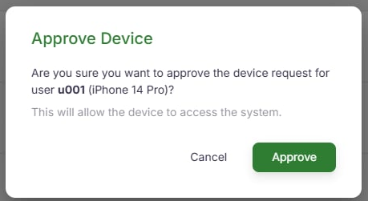
Figure 68: Approve Device Layout
No | Field Name | Field Type | Description
1 | Title (“Approve Device”) | Label | Dialog header.
2 | Request Summary | Read-only block | Shows User ID / User Name, Device Name, Platform, OS Version, Model, Manufacturer, App Version.
3 | Note (optional) | Textarea | Internal note stored with the decision.
4 | Cancel | Button (secondary) | Close without changes.
5 | Approve | Button (primary) | Confirms approval and moves device to Current Devices.
6 | Error Area | Inline message | Displays server/policy errors if approval fails.
Table 105 - Approve Device Layout
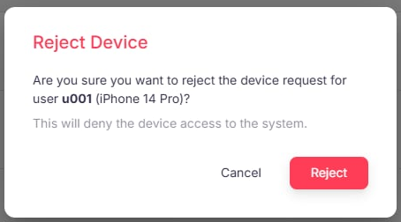
Figure 69: Reject Device Layout
No | Field Name | Field Type | Description
1 | Title (“Reject Device”) | Label | Dialog header.
2 | Request Summary | Read-only block | Same fields as above to verify the target request.
3 | Reject Reason | Textarea / Select+Textarea | Required. Reason to notify the requester (e.g., “OS version below minimum”).
4 | Cancel | Button (secondary) | Close without changes.
5 | Reject | Button (danger) | Confirms rejection and removes request from the pending list.
6 | Error Area | Inline message | Displays server/policy errors if rejection fails.
Table 106 - Reject Device Layout
b. Use Case Specifications
ID and Name | UC66 - Manage Device Requests (Edit Device Requests)
Created By | DungND | Date Created | 28/06/2025
Primary Actor |  | Secondary Actors | System
  Admin
Trigger
  On Device → Requests Devices, the admin clicks ✔ (Approve) or ✖ (Reject) in the Actions column for a pending request.
Description | As an admin, I want to review a pending device request and confirm either approval or rejection—optionally adding a note/reason—so that the decision is finalized and reflected in device inventory.
Preconditions | PRE-1. Admin is authenticated.  PRE-2. Admin is authorized to manage device requests.  PRE-3. Request exists in Pending state with complete device metadata.
Postconditions | POST- 1. If approved, the device appears in Current Devices with the correct status (e.g., Active/Approved).  POST- 2. If rejected: the request is removed from the pending list and a rejection notice (with reason, if provided) is sent to the requester.  POST- 3. Decision (who/when/what) is recorded for audit.
Normal Flows | Step | By | Step Details
Normal Flows | 1 | User | Click ✔ (Approve) or ✖ (Reject) in the row’s Actions.
Normal Flows | 2 | System | Open the corresponding confirmation dialog showing User ID + device info.
Normal Flows | 3 | User | In the dialog, click Approve or Reject to continue, or Cancel to abort. (For Reject, provide a Reject Reason.)
Normal Flows | 4 | System | Persist decision and update lists.
Normal Flows | 5 | System | Show notification: “Device approved successfully.” (green) or “Device rejected successfully.” (red). On error, display an inline error and keep the dialog open.
Alternative Flows | Alt Step | Condition | Description
Exceptions | - E1: Permission error → “You don’t have permission to approve/reject device requests.”  - E2: Concurrency conflict (already processed) → inform user and refresh list.  - E3: Network/Server error → show error and allow retry without losing entered notes/reason.  - E4: Validation error (missing reject reason when required) → highlight the field and prevent submission.
Frequency of Use | Medium–High
Business Rules
  BR-01, BR-02
Other Information | - Capture Approved By / Rejected By, timestamp, and optional note/reason for reports.  - Keyboard accessibility: Enter submits, Esc cancels; focus is trapped inside the dialog.
Assumptions | - Backend provides endpoints to approve and reject requests, returning updated device/request states and enforcing policy checks.  - Rejection requires a reason (stored and included in the user notification).  - On success, the requests table refreshes in place without a full page reload.
Table 107 - Sign In Specification

3.2.1.40 View Active FaceIDs
a. Screen Layouts
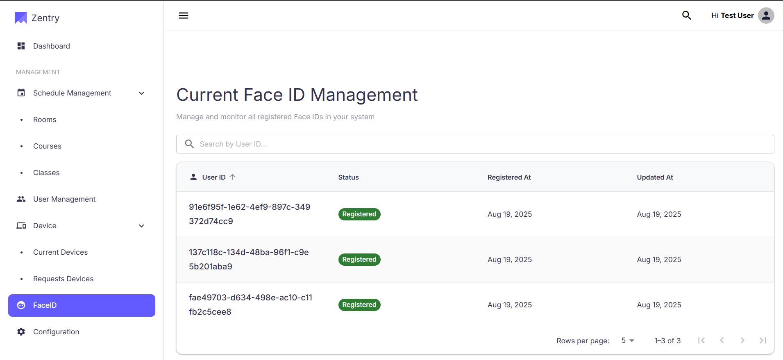
Figure 70: Current Face ID Management
No | Field Name | Field Type | Description
1 | Page Title (“Current Face ID Management”) | Label | Header with helper text: Manage and monitor registered Face IDs in your system.
2 | Search by User ID… | Searchbox | Filters rows by User ID (debounced).
3 | FaceID Table | Table | Lists users and FaceID info (see columns below).
4 | Pagination | Control | Rows-per-page selector; Previous/Next arrows at bottom-right.
5 | Empty State | Label | “No active FaceIDs found.” when no Registered rows match.
Table 108 - Current Face ID Management Layout
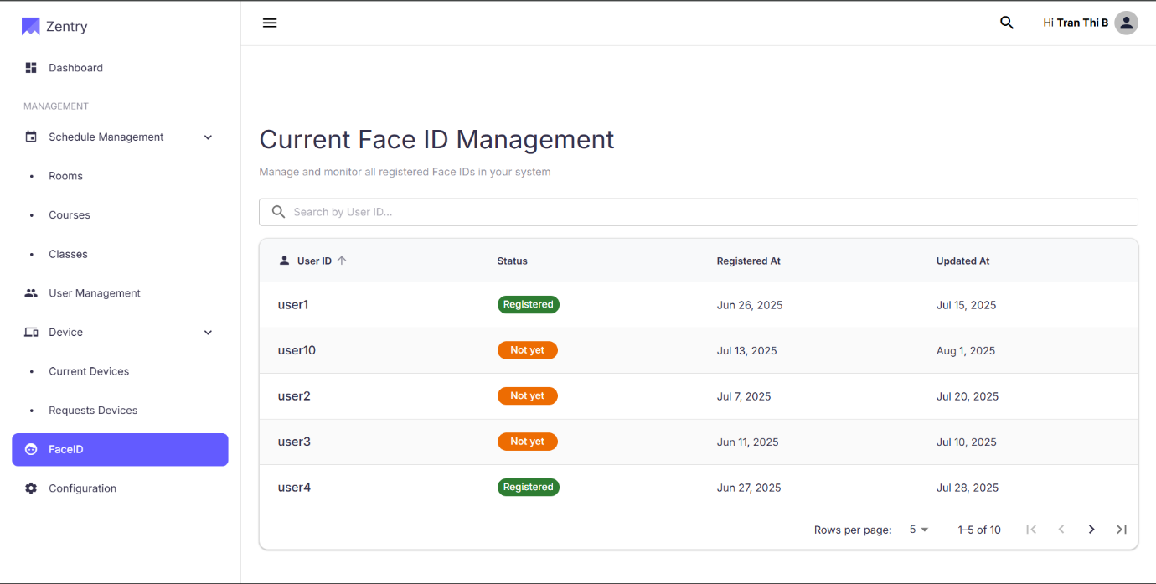
Figure 71: Current Face ID Management Table
No | Column | Field Type | Description
1 | User ID | Text | Unique identifier of the user (e.g., user1).
2 | Status | Badge | Registered (green) or Not yet (orange/gray).
3 | Registered At | Date | Initial FaceID registration date.
4 | Updated At | Date | Most recent update to FaceID data.
Table 109 - Current Face ID Management Table
b. Use Case Specifications
ID and Name | UC67 - View Active FaceIDs
Created By | DungND | Date Created | 28/06/2025
Primary Actor |  | Secondary Actors | System
  Admin
Trigger
  From the sidebar, the admin clicks FaceID.
Description | As an admin, I want to view all users with active (registered) FaceIDs—along with registration and last-updated timestamps—so that I can verify who is enabled for FaceID and quickly find specific users.
Preconditions | PRE-1. Admin is authenticated.  PRE-2. Admin has permission to view FaceID registry.  PRE-3. FaceID records exist for some users.
Postconditions | POST- 1. No data is modified by viewing.  POST- 2. Filters/search and pagination reflect the current dataset.
Normal Flows | Step | By | Step Details
Normal Flows | 1 | User | On the sidebar, click FaceID.
Normal Flows | 2 | System | Display a table of all users with columns User ID, Status, Registered At, Updated At.
Normal Flows | 3 | User | To focus on active FaceIDs, check the Status column and identify rows marked Registered (green).
Normal Flows | 4 | User | Use the Search box to find a user by User ID quickly.
Normal Flows | 5 | User | If records span multiple pages, use Pagination at the bottom-right to navigate.
Alternative Flows | Alt Step | Condition | Description
Alternative Flows | A1 | Status filter is available | Set Status = Registered to display only active FaceIDs.
Alternative Flows | A2 | Sorting is enabled | Sort by Registered At or Updated At to review newest/oldest registrations.
Alternative Flows | A3 | Large dataset / server-side paging | Server-side search and pagination are used; results update without a full page reload and current filters are preserved.
Exceptions | - E1: Permission error → “You don’t have permission to view FaceID data.”  - E2: Network/Server error → inline error with Retry; keep search/pagination state.  - E3: Data inconsistency (missing timestamps) → show placeholder “—” and log for follow-up.
Frequency of Use | Medium
Business Rules
  BR-01, BR-02
Other Information | - All login activities are recorded in system logs for security auditing and system health monitoring.  - The system supports both internal (username/password) and external (OAuth) authentication methods.
Assumptions | - Privacy: show metadata only; never expose biometric templates/images.  - Sorting/Filtering: default Updated At (desc); quick status chips (All/Registered/Not yet); search by User ID.  - Time/Locale: dates shown in admin’s timezone/locale.
Table 110 - View Active FaceIDs Specification

3.2.1.41 View Attribute Definitions
a. Screen Layouts
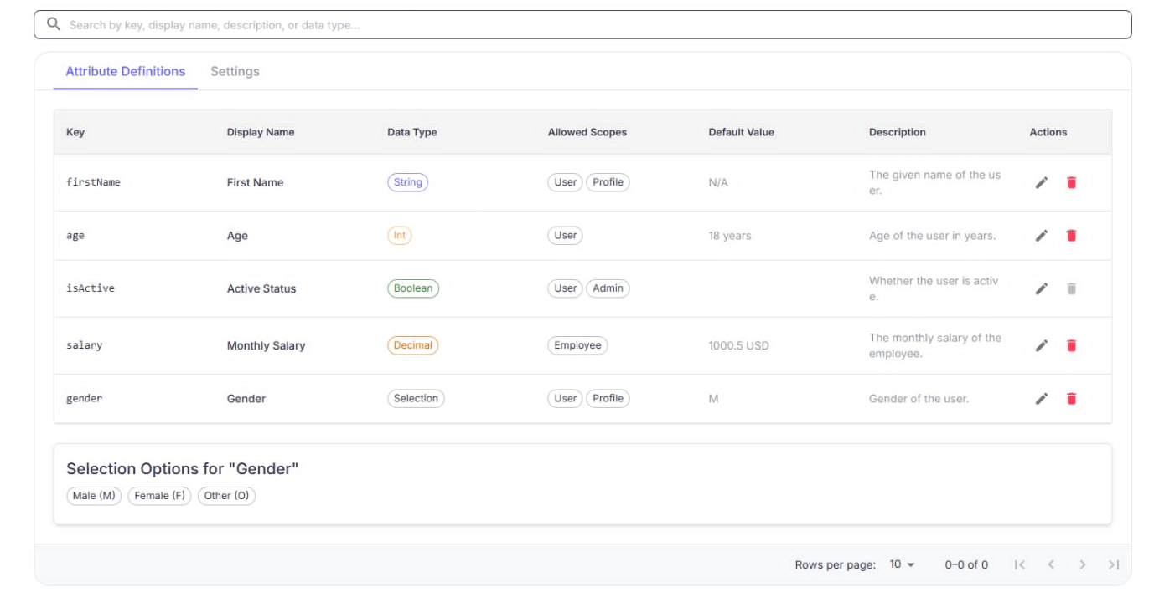
Figure 72: View Attribute Definitions
No | Field Name | Field Type | Description
1 | Page Title (“Configuration Management”) | Label | Header with helper text.
2 | Quick Actions | Buttons | Create Attribute Definition, Create Setting (out of scope here).
3 | Search… | Searchbox | Filter by key, display name, description, or data type.
4 | Tabs | Tabs | Attribute Definitions (active), Settings.
5 | Definitions Table | Table | Columns below; shows all attributes.
6 | Pagination | Control | Rows-per-page selector; Previous/Next.
Table 111 - View Attribute Definitions Layout
Figure 73: View Attribute Definitions Table
No | Column | Field Type | Description
1 | Key | Text | Internal identifier.
2 | Display Name | Text | Human-readable label.
3 | Data Type | Badge | String, Int, Boolean, Decimal, Selection, …
4 | Allowed Scopes | Badges | e.g., User, Profile, Employee, Admin.
5 | Default Value | Text | Value used if none provided.
6 | Description | Text | Purpose/meaning.
7 | Actions | Icon buttons | View (eye), Edit (pencil), Delete (trash). This UC uses View.
Table 112 - View Attribute Definitions Table
b. Use Case Specifications
ID and Name | UC68 - View Attribute Definitions
Created By | DungND | Date Created | 28/06/2025
Primary Actor |  | Secondary Actors | System
  Admin
Trigger
  User clicks View (eye) for an attribute on Configuration Management → Attribute Definitions.
Description | As an authorized user, I want to view a specific attribute definition—its key, display name, data type, allowed scopes, default value, description, and (if applicable) selection options—so that I understand how it’s configured and used.
Preconditions | PRE-1. User is authenticated.  PRE-2. User has permission to view configuration data.  PRE-3. Target attribute definition exists.
Postconditions | POST- 1. No configuration is modified by viewing.  POST- 2. User can navigate back to the list.
Normal Flows | Step | By | Step Details
Normal Flows | 1 | User | On Configuration Management → Attribute Definitions, click View (eye) for the desired attribute.
Normal Flows | 2 | System | Open Attribute Definition Details showing: Key, Display Name, Data Type, Allowed Scopes, Default Value, Description, and Selection Options if type = Selection.
Alternative Flows | Alt Step | Condition | Description
Alternative Flows | A1 | Use search | Filter the list using the search box to locate the attribute quickly.
Exceptions | - E1: Attribute not found or deleted → show error and return to list.  - E2: Permission error → “You don’t have permission to view attribute definitions.”  - E3: Network/Server error → display error state with Retry.
Frequency of Use | Medium
Business Rules
  BR-01, BR-02
Other Information | - Read-only view; editing/deleting handled in separate UCs.  - Dates/metadata (e.g., created/updated by) may be shown if available.
Assumptions | - Backend exposes endpoints to list and fetch attribute definition by key/ID.  - “Allowed Scopes” are predefined enumerations enforced server-side.  - Selection options are stored and returned in display order.
Table 113 - View Attribute Definition Specification

3.2.1.42 Create Attribute Definition
a. Screen Layouts
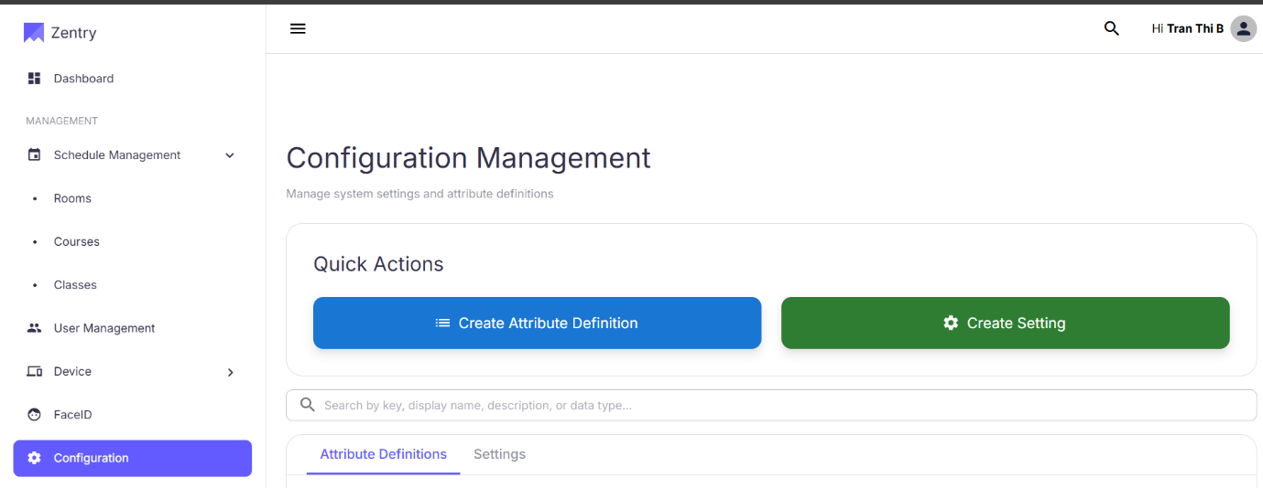
Figure 74: Create Attribute Definition Layout
No | Field Name | Field Type | Description
1 | Page Title (“Configuration Management”) | Label | Header and helper text.
2 | Quick Actions | Buttons | Create Attribute Definition, Create Setting.
3 | Tabs | Tabs | Attribute Definitions (active), Settings.
4 | Search… | Searchbox | Filter list by key, display name, description, or data type.
Table 114 - Create Attribute Definition Layout
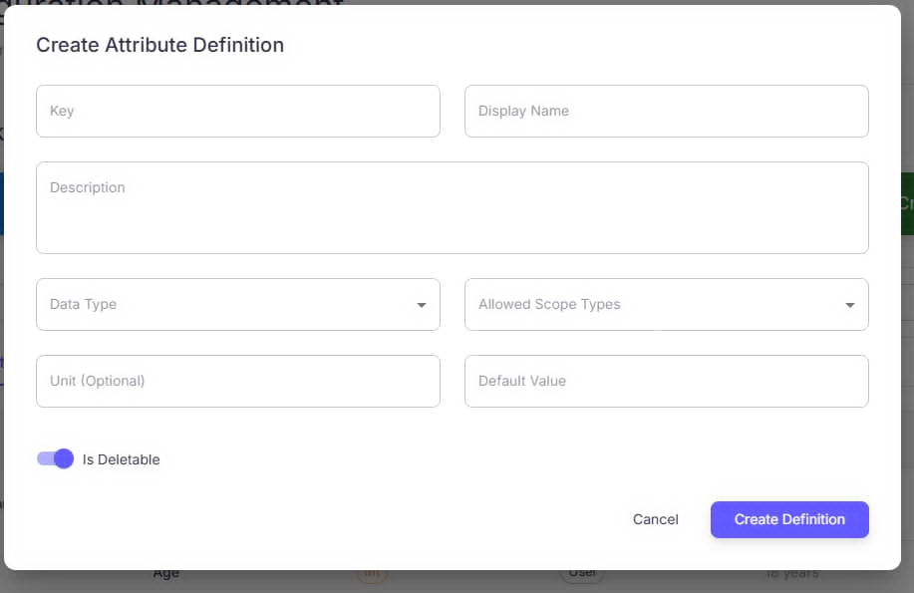
Figure 75: Create Attribute Definition
No | Field Name | Field Type | Description
1 | Title (“Create Attribute Definition”) | Label | Dialog header.
2 | Key | Text (required) | Unique identifier; must be unique and follow key format.
3 | Display Name | Text (required) | Human-readable name shown in UI.
4 | Description | Textarea | Purpose/explanation of the attribute.
5 | Data Type | Dropdown (required) | String, Int, Boolean, Decimal, Date, Json, Selection.
6 | Allowed Scope Types | Multi-select / Checkboxes (required) | Global, Course, Session.
7 | Unit (Optional) | Text | Measurement unit (e.g., %, hrs, USD).
8 | Default Value | Dynamic input | Widget depends on Data Type.
9 | Is Deletable | Toggle | Prevents standard deletion when off.
10 | Cancel | Button (secondary) | Close without saving.
11 | Create Definition | Button (primary) | Enabled when required fields are valid.
12 | Validation/Error Area | Inline message | Field/type/uniqueness errors.
Table 115 - Create Attribute Definition
b. Use Case Specifications
ID and Name | UC69 Create Attribute Definition
Created By | DungND | Date Created | 28/06/2025
Primary Actor |  | Secondary Actors | System
  Admin
Trigger
  On Configuration Management, the user clicks Create Attribute Definition.
Description | As an authorized user, I want to define a new system attribute with key, display name, data type, scope, unit, and default value so that it can be reused across configured scopes.
Preconditions | PRE-1. User is authenticated.  PRE-2. User has permission to manage configuration  PRE-3. Attribute key is unique.
Postconditions | POST- 1. New attribute definition is saved and shown in Attribute Definitions list.  POST- 2. Success notification is displayed; action is logged.
Normal Flows | Step | By | Step Details
Normal Flows | 1 | User | On Configuration Management, click Create Attribute Definition.
Normal Flows | 2 | System | Open Create Attribute Definition dialog.
Normal Flows | 3 | User | Fill fields: Key, Display Name, Description, select Data Type, select Allowed Scope Types , set Unit (Optional), Default Value, and Is Deletable.
Normal Flows | 4 | User | Click Create Definition to save, or Cancel to abort.
Normal Flows | 5 | System | Validate inputs (required/type/uniqueness). On success, persist and show green toast “Attribute Definition created successfully.” On failure, show inline error (e.g., “Key already exists”, “Missing required field”).
Alternative Flows | Alt Step | Condition | Description
Exceptions | - E1: Permission error → “You don’t have permission to create attribute definitions.”  - E2: Network/Server error → show error; keep dialog data so the user can retry.  - E3: Concurrency (key taken during save) → show Key already exists and request a new key.
Frequency of Use | Medium
Business Rules
  BR-01, BR-02
Other Information | - Auto-suggest Key from Display Name; enforce allowed pattern (lowercase, hyphen/underscore, no spaces).  - Numbers/dates use locale-aware inputs; client + server validation.
Assumptions | - Backend provides a create API enforcing uniqueness, type constraints, and scopes.  - For Selection type, option values and default are created with the definition in the same request.  - List view auto-refreshes to include the newly created definition.
Table 116 - Create Attribute Definition Specification

3.2.1.43 Update Attribute Definitions
a. Screen Layouts
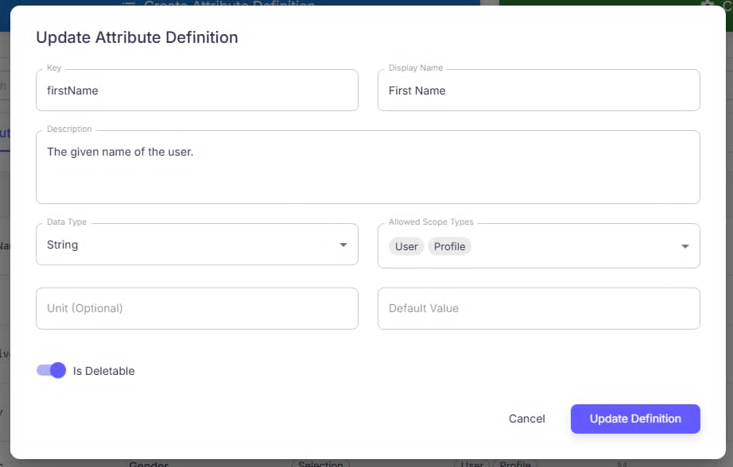
Figure 76: Update Attribute Definition
No | Field Name | Field Type | Description
1 | Title (“Update Attribute Definition”) | Label | Dialog header.
2 | Key | Text (read-only) | Unique identifier; non-editable.
3 | Display Name | Text | Human-readable name.
4 | Description | Textarea | Purpose/notes.
5 | Data Type | Dropdown | String, Int, Boolean, Decimal, Date, Json, Selection. (Figure xx – Select Data Type)
6 | Allowed Scope Types | Multi-select / Chips | User, Profile, Global, Course, Session. (Figure xx – Allowed Scope Types)
7 | Unit (Optional) | Text | Measurement unit (%, hrs, USD…).
8 | Default Value | Dynamic input | Widget depends on Data Type.
9 | Is Deletable | Toggle | Allow/restrict deletion.
10 | Cancel | Button | Close without saving.
11 | Update Definition | Button (primary) | Validate and save.
12 | Validation/Error Area | Inline message | Field/type/constraint errors.
Table 117 - Sign In - Sign in form
b. Use Case Specifications
ID and Name | UC70 Update Attribute Definitions
Created By | DungND | Date Created | 28/06/2025
Primary Actor |  | Secondary Actors | System
  Admin
Trigger
  On Configuration Management → Attribute Definitions, the user clicks Edit for an attribute.
Description | As an authorized user, I want to update an existing attribute definition (display name, description, data type, allowed scopes, unit, default value, deletable option) so that its configuration stays accurate and usable across the system.
Preconditions | PRE-1. User is authenticated.  PRE-2. User has permission to manage configuration.  PRE-3. Target attribute definition exists.  PRE-4. Key is immutable and uniquely identifies the definition.
Postconditions | POST- 1. Changes are saved and reflected in the list.  POST- 2. Success notification is shown; action logged
Normal Flows | Step | By | Step Details
Normal Flows | 1 | User | From the list, click Edit on the target attribute.
Normal Flows | 2 | System | Open Update Attribute Definition dialog prefilled with current values.
Normal Flows | 3 | User | Update fields: Display Name, Description, Data Type, Allowed Scope Types, Unit, Default Value, Is Deletable.
Normal Flows | 4 | User | Click Update Definition to save (or Cancel to discard).
Normal Flows | 5 | System | Validate inputs; on success persist changes, close dialog, refresh list, and show green toast “Attribute Definition updated successfully.” On failure, show inline errors.
Alternative Flows | Alt Step | Condition | Description
Alternative Flows | A1 | Data Type = Selection | Show Options panel to manage choices and default option (require ≥1 choice).
Alternative Flows | A2 | Change Data Type | If Default Value no longer matches the new type, system clears/blocks it and shows a type-mismatch warning.
Alternative Flows | A3 | Scope change impact | If removing a scope that currently uses the attribute, system warns and may block or require confirmation.
Alternative Flows | A4 | Unsaved changes | Closing the dialog with edits prompts a discard confirmation.
Alternative Flows | A5 | No field changes | Update Definition disabled or results in no-op.
Exceptions | - E1: Permission error → “You don’t have permission to edit attribute definitions.”  - E2: Network/Server error → show error toast; keep dialog open and allow retry.  - E3: Invalid data (e.g., Invalid data type, Missing required field, type mismatch with default value) → highlight fields, block save.  - E4: Concurrency conflict (definition changed/deleted by another user) → show notice and refresh list; reopen with latest data if applicable.
Frequency of Use | Medium
Business Rules
  BR-01, BR-02
Other Information | - Key is immutable once created.  - Inputs respect locale (numbers/dates).  - Changes may affect downstream forms that consume the attribute; consider cache busting.
Assumptions | - Backend provides an update API that enforces type compatibility, scope constraints, and immutability of Key.  - Selection options are editable when type = Selection and saved with the same request.  - List auto-refreshes after a successful update.
Table 118 - Update Attribute Definitions Specification

3.2.1.44 Delete Attribute Definition
a. Screen Layout
Figure 77: Delete Attribute Definition
No | Field Name | Field Type | Description
1 | Title | Label | “Delete Attribute Definition”
2 | Message | Label | “Are you sure you want to delete the attribute definition <AttributeName>? This action cannot be undone.”
3 | Cancel | Button (secondary) | Close dialog; no changes.
4 | Delete | Button (primary, red) | Confirms permanent deletion; disabled while processing or when policy blocks.
5 | Error Area (optional) | Inline message | Shows reason if deletion is blocked.
Table 119 - Delete Attribute Definition
b. Use Case Specifications
ID and Name | UC71 Delete Attribute Definition
Created By | DungND | Date Created | 28/06/2025
Primary Actor |  | Secondary Actors | System
  Admin
Trigger
  On Configuration Management → Attribute Definitions, the user clicks Delete (🗑) for a specific attribute.
Description | As an authorized admin, I want to permanently delete an attribute definition—when it is marked deletable—so that obsolete attributes are removed from the system.
Preconditions | PRE-1. User is authenticated.  PRE-2. User has rights to manage configuration.  PRE-3. Target attribute exists and is Is Deletable = true.
Postconditions | POST- 1. If successful, the attribute is removed from the list and no longer available for use.  POST- 2. A success toast is shown and the action is logged.
Normal Flows | Step | By | Step Details
Normal Flows | 1 | User | Locate the attribute and click Delete (🗑).
Normal Flows | 2 | System | Show Delete Confirmation dialog with the irreversible warning.
Normal Flows | 3 | User | Click Delete to confirm (or Cancel to abort).
Normal Flows | 4 | System | Validate deletability/constraints; on success, delete, refresh the list, and show green toast “Attribute Definition deleted successfully.”
Alternative Flows | Step | By | Step Details
Alternative Flows | A1 | Admin | Click Cancel
Exceptions | - E1: Permission error → “You don’t have permission to delete attribute definitions.”  - E2: Network/Server error → show error; keep dialog open and allow retry.  - E3: Constraint violation (linked/critical use) → “This attribute cannot be deleted.”  - E4: Concurrency conflict (already deleted/changed) → inform user and refresh list.
Frequency of Use | Low–Medium
Business Rules
  BR-01, BR-02
Other Information | - Consider exporting affected references in the error to help remediation.  - Back navigation should not restore deleted rows from cache.
Assumptions | - Backend exposes a delete API that enforces Is Deletable and dependency checks, returning clear error messages.  - List view auto-refreshes after deletion without a full page reload.
Table 120 - Delete Attribute Definition

3.2.1.45 View Settings
a. Screen Layouts
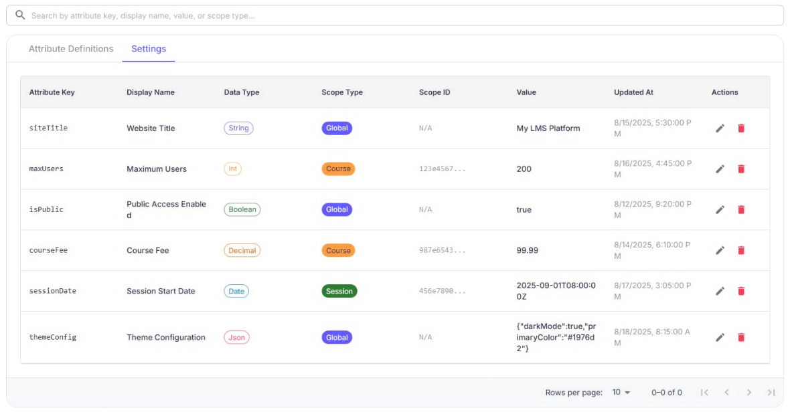
Figure 77: View Settings Layout
No | Field Name | Field Type | Description
1 | Page Title (“Configuration Management”) | Label | Header with helper text.
2 | Tabs | Tabs | Attribute Definitions, Settings (active).
3 | Search… | Searchbox | Filter by key, display name, value, or scope type.
4 | Settings Table | Table | Lists settings with columns below.
5 | Pagination | Control | Rows-per-page selector; Prev/Next arrows.
Table 121 - View Settings Layout
Figure 78: View Settings Table
No | Column | Field Type | Description
1 | Attribute Key | Text | Unique ID (e.g., siteTitle, maxUsers).
2 | Display Name | Text | Human-readable name.
3 | Data Type | Badge | String, Int, Boolean, Decimal, Date, JSON.
4 | Scope Type | Badge | Global, Course, Session, User, Profile…
5 | Scope ID | Text | Identifier of scope (or N/A for Global).
6 | Value | Text/Code | Current configured value (pretty-prints JSON).
7 | Updated At | Date/Time | Last modification timestamp.
8 | Actions | Icon buttons | Edit, Delete.
Table 122 - View Settings Table
b. Use Case Specifications
ID and Name | UC72 View Setting
Created By | DungND | Date Created | 28/06/2025
Primary Actor |  | Secondary Actors | System
  Admin
Trigger
  User navigates to Configuration Management → Settings.
Description | As an admin, I want to view all system configuration settings in a structured table—showing key, display name, data type, scope, value, and last update—so I can understand and audit current configuration.
Preconditions | PRE-1. User is authenticated.  PRE-2. User has permission to view configuration.
Postconditions | POST- 1. No data is modified by viewing.  POST- 2. Filters and pagination reflect the current dataset.
Normal Flows | Step | By | Step Details
Normal Flows | 1 | User | Open Configuration Management → Settings.
Normal Flows | 2 | System | Display the Settings table with columns Attribute Key, Display Name, Data Type, Scope Type & Scope ID, Value, Updated At, Actions.
Normal Flows | 3 | User | Use the Search bar to filter by key, display name, value, or scope type.
Normal Flows | 4 | System | Dynamically update the table to reflect filters.
Normal Flows | 5 | User | Use Pagination (rows per page, Prev/Next) to navigate large datasets.
Alternative Flows | Alt Step | Condition | Description
Alternative Flows | A1 | Sort enabled | Sort by Updated At (desc by default) or other columns.
Alternative Flows | A2 | Scope-focused review | Filter by Scope Type (e.g., Global only) using search or chips (if available).
Alternative Flows | A3 | JSON values | Values of type JSON open a read-only pretty viewer on hover/click.
Exceptions | - E1: Permission error → “You don’t have permission to view settings.”  - E2: Network/Server error → Show inline error with Retry; keep current filters/pagination.  - E3: Data inconsistency (e.g., missing Scope ID/Value) → Render placeholders “—” and log for review.  - E4: Concurrency conflict (setting edited/deleted by another user) → Inform user and refresh the table to latest data.
Frequency of Use | Medium
Business Rules
  BR-01, BR-02, BR-15, BR-16
Other Information | - Default sort Updated At (desc); supports CSV export of the filtered view (admin only).  - Clicking Edit/Delete transitions to their respective UCs.
Assumptions | - Backend provides a paginated Settings API returning display metadata, scope, value, and timestamps with server-side search/sort.
Table 123 - View Settings Specification

3.2.1.46 Create Setting
a. Screen Layouts
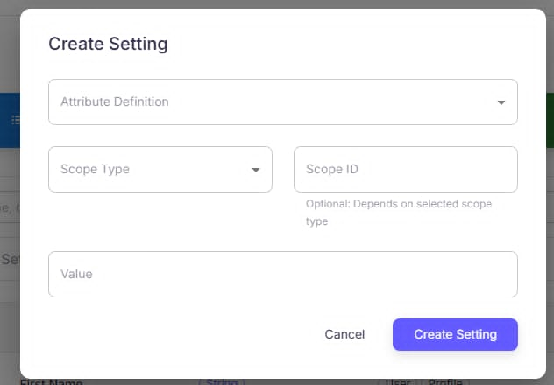
Figure 79: Create Settings Layout
No | Field Name | Field Type | Description
1 | + Create Setting | Button | Opens the creation dialog.
2 | Create Setting (dialog title) | Label | Header of the modal dialog.
3 | Attribute Definition | Dropdown (required) | Choose an existing attribute definition. The attribute’s data type and allowed scopes drive the Value widget and scope options.
4 | Scope Type | Dropdown (required) | Global, Course, Session (and others if enabled).
5 | Scope ID | Text (conditional) | Required when Scope Type ≠ Global. Shows helper text.
6 | Value | Dynamic input (required) | Widget depends on the selected attribute’s data type: String (text), Int/Decimal (number), Boolean (switch), Date (date picker), JSON (code editor), Selection (options list).
7 | Cancel | Button | Close without saving.
8 | Create Setting | Button (primary) | Saves when validation passes.
9 | Validation/Error Area | Inline message | Shows format/type/required errors.
Table 124 - Create Settings Layout
b. Use Case Specifications
ID and Name | UC73 Create Setting
Created By | DungND | Date Created | 28/06/2025
Primary Actor |  | Secondary Actors | System
  Admin
Trigger
  On Configuration Management → Settings, the user clicks + Create Setting.
Description | As an authorized user, I want to create a new Setting by selecting an Attribute Definition, choosing a Scope Type (and Scope ID if needed), and providing a Value so that the configuration is applied to the chosen scope.
Preconditions | PRE-1. User is authenticated.  PRE-2. User has permission to manage settings.  PRE-3. At least one Attribute Definition exists and supports the chosen scope.
Postconditions | POST- 1. The new Setting is stored and appears in the Settings table.  POST- 2. A success toast is shown; action is logged.
Normal Flows | Step | By | Step Details
Normal Flows | 1 | User | Click + Create Setting on the Settings page.
Normal Flows | 2 | System | Open Create Setting dialog.
Normal Flows | 3 | User | Select Attribute Definition from dropdown.
Normal Flows | 4 | User | Choose Scope Type (Global/Course/Session). If Course or Session, enter Scope ID.
Normal Flows | 5 | User | Enter Value using the widget that matches the attribute’s data type.
Normal Flows | 6 | User | Click Create Setting to save (or Cancel to abort).
Normal Flows | 7 | System | Validate inputs and persist. If successful: add the row to the table and show “Setting created successfully.” If unsuccessful: show inline error (e.g., “Invalid value format”).
Alternative Flows | Alt Step | Condition | Description
Alternative Flows | A1 | Non-Global scope | Scope ID becomes required; system validates the referenced Course/Session exists.
Alternative Flows | A2 | Data-type driven value | Value control changes with type (Boolean switch, Date picker, JSON editor, Selection options).
Alternative Flows | A3 | Duplicate combination | If a Setting for (Attribute Key, Scope Type, Scope ID) already exists, system blocks creation and suggests editing the existing one.
Alternative Flows | A4 | Default value assist | If the definition has a Default Value, prefill the Value field (user may override).
Exceptions | - E1: Permission error → “You don’t have permission to create settings.”  - E2: Invalid value format/type mismatch → highlight Value and show guidance.  - E3: Invalid or missing Scope ID for non-Global scope → prompt to correct.  - E4: Duplicate setting exists → “A setting for this attribute and scope already exists.”  - E5: Network/Server error → show error; keep dialog data and allow retry.
Frequency of Use | Medium
Business Rules
  BR-01, BR-02
Other Information | - Respect attribute’s allowed scope types; disable unsupported scopes.  - JSON values are validated with a parser; dates use locale/timezone aware pickers.
Assumptions | - Backend enforces uniqueness on (attributeKey, scopeType, scopeId) and validates value by data type.  - Settings table refreshes immediately after successful creation.
Table 125 - Create Settings Specification

3.2.1.47 Edit Setting
a. Screen Layouts
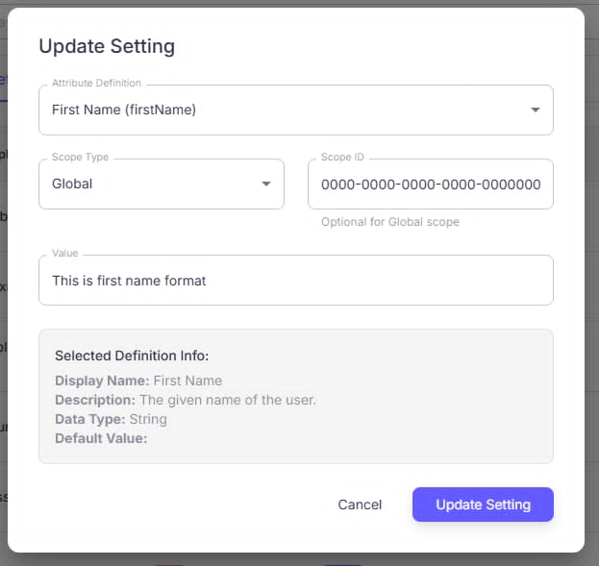
Figure 80: Update Settings Layout
No | Field Name | Field Type | Description
1 | Title (“Update Setting”) | Label | Dialog header.
2 | Attribute Definition | Dropdown (read-only) | Fixed to the current attribute (not editable).
3 | Scope Type | Dropdown | Global, Course, Session (and others if enabled).
4 | Scope ID | Text (conditional) | Required for non-Global scopes; optional for Global.
5 | Value | Dynamic input | Widget follows attribute Data Type (text/number/switch/date/JSON/selection).
6 | Selected Definition Info | Read-only panel | Shows Display Name, Description, Data Type, Default Value for reference.
7 | Cancel | Button | Close without saving.
8 | Update Setting | Button (primary) | Save when validation passes.
9 | Validation/Error Area | Inline message | Type/format/scope errors.
Table 126 - Update Settings Layout
b. Use Case Specifications
ID and Name | UC74 - Update Setting
Created By | DungND | Date Created | 28/06/2025
Primary Actor |  | Secondary Actors | System
  Admin
Trigger
  On Configuration Management → Settings, the user clicks Edit (✎) on a row.
Description | As an authorized user, I want to modify an existing Setting’s scope (type/ID) and value—while keeping the attribute fixed—so that configuration remains correct for the intended scope.
Preconditions | PRE-1. User is authenticated.  PRE-2. User has permission to manage settings.  PRE-3. Target Setting exists; Attribute Definition is immutable.
Postconditions | POST- 1. On success, the Setting is updated in storage and the list reflects new values.  POST- 2. Success toast is shown; action is logged
Normal Flows | Step | By | Step Details
Normal Flows | 1 | User | Click Edit (✎) on the desired Setting.
Normal Flows | 2 | System | Open Update Setting dialog with pre-filled details: Attribute Definition (fixed), Scope Type, Scope ID, Value, and Selected Definition Info.
Normal Flows | 3 | User | Modify Scope Type/Scope ID and/or Value as needed.
Normal Flows | 4 | User | Click Update Setting to save (or Cancel to discard).
Normal Flows | 5 | System | Validate and persist. If successful: update the table row. If unsuccessful: show inline error (e.g., “Invalid Scope ID”).
Alternative Flows | Alt Step | Condition | Description
Alternative Flows | A1 | Non-Global scope | Scope ID becomes required; system validates that the referenced Course/Session exists.
Alternative Flows | A2 | Data-type driven value | Value control adapts to the attribute’s Data Type (Boolean switch, Date picker, JSON editor, etc.).
Alternative Flows | A3 | Duplicate combination | Changing to a (Attribute Key, Scope Type, Scope ID) that already exists → block update and suggest editing that record instead.
Alternative Flows | A4 | Scope not allowed | If the attribute doesn’t support the chosen scope, disable it or show a validation message.
Alternative Flows | A5 | Unsaved changes | Closing the dialog with edits prompts to confirm discarding.
Alternative Flows | A6 | No field changes | Update Setting disabled or results in no-op.
Exceptions | - E1: Permission error → “You don’t have permission to edit settings.”  - E2: Invalid Scope ID (format or not found) → highlight field and show guidance.  - E3: Value type/format mismatch with attribute’s Data Type → block save and highlight Value.  - E4: Network/Server error → keep dialog data; show retryable error.  - E5: Concurrency conflict (setting changed/deleted elsewhere) → inform user and refresh list.  - E6: Scope not allowed by definition → error: “This attribute cannot be applied to the selected scope.”
Frequency of Use | Medium
Business Rules
  BR-01, BR-02, BR-15, BR-16
Other Information | - Show full timestamps in tooltips; localize numbers/dates.  - Preserve filter/pagination state when returning to the list.
Assumptions | - Backend update API validates scope permissions, uniqueness on (attributeKey, scopeType, scopeId), and value type.  - Table auto-refreshes after success without reloading the page.
Table 127 - Sign In Specification

3.2.1.48 Delete Setting
a. Screen Layouts
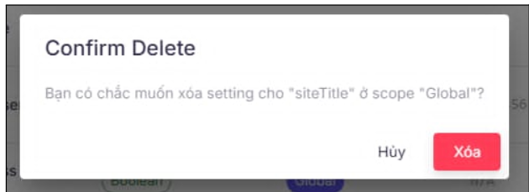
Figure 81 - Delete Setting
No | Field Name | Field Type | Description
1 | Settings Table | Table | Columns: Attribute Key, Display Name, Data Type, Scope Type, Scope ID, Value, Updated At, Actions.
2 | Actions | Icon buttons | Delete (🗑️) opens confirmation dialog.
Table 128 – Delete Setting Field Description Table
Figure 82: Confirm delete Layout
No | Field Name | Field Type | Description
1 | Title | Label | “Confirm Delete”.
2 | Message | Label | Shows setting key and scope (e.g., siteTitle @ Global) and warns that the action cannot be undone.
3 | Cancel | Button (secondary) | Hủy / Cancel – close without changes.
4 | Delete | Button (primary, red) | Xóa / Delete – confirms permanent removal.
5 | Error Area | Inline message | Displays reason if deletion is blocked.
Table 129 - Confirm delete Layout
b. Use Case Specifications
ID and Name | UC75 Delete Setting
Created By | DungND | Date Created | 28/06/2025
Primary Actor |  | Secondary Actors | System
  Admin
Trigger
  On Configuration Management → Settings, the user clicks Delete (🗑️) on a row.
Description | As an authorized user, I want to permanently remove an existing Setting after confirming the action so that obsolete or incorrect configurations are cleared from the system.
Preconditions | PRE-1. User is authenticated.  PRE-2. User has permission to manage settings.  PRE-3. Target setting exists.
Postconditions | POST- 1. On success, the setting is deleted and removed from the list; success toast displayed.  POST- 2. Deletion is recorded for audit.
Normal Flows | Step | By | Step Details
Normal Flows | 1 | User | In Settings list, click Delete (🗑️) for the desired setting.
Normal Flows | 2 | System | Show Confirm Delete dialog with key and scope.
Normal Flows | 3 | User | Click Xóa (Delete) to confirm, or Hủy (Cancel) to abort.
Normal Flows | 4 | System | If confirmed and allowed, delete the setting, refresh the table, and show green toast “Setting deleted successfully.”
Alternative Flows | Alt Step | Condition | Description
Alternative Flows | A1 | User cancels | Click Hủy / Cancel; dialog closes; no change.
Alternative Flows | A2 | Soft-delete policy (optional) | System archives the setting instead of hard delete; hidden from default view.
Exceptions | - E1: Permission error → “You don’t have permission to delete settings.”  - E2: Network/Server error → show error and allow retry; keep dialog open.  - E3: Constraint/lock (e.g., protected system setting) → “This setting cannot be deleted.”  - E4: Concurrency conflict (already deleted/changed) → inform user and refresh list.
Frequency of Use | Low–Medium
Business Rules
  BR-01, BR-02, BR-15, BR-16
Other Information | - Show full key and scope in dialog; include a short, irreversible warning.  - Preserve table filters/pagination after returning from deletion.
Assumptions | - Backend delete API enforces protections and returns clear errors; list view updates without full page reload.
Table 130 - Sign In Specification

3.2.2. Mobile

3.2.2.1 Sign In
a. Screen Layouts
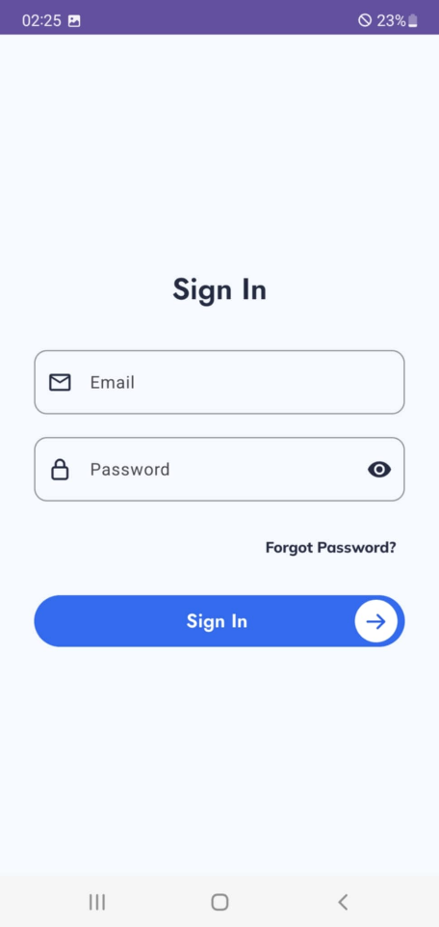
Figure 51: Sign in
No | Field Name | Field Type | Description
1 | Email | Text Field | Input field for the user’s registered email address. Includes an envelope icon.
2 | Password | Password Field | Input field for the user’s password, with an eye icon to show/hide password.
3 | Forgot Password? | Text Link | Link that redirects the user to the password recovery process.
4 | Sign In Button | Button | Action button to sign in, labeled “Sign In” with an arrow icon.

b. Use Case Specifications
ID and Name | UC – 01: Sign in
Created By | Dungktn | Date Created | 28/06/2025
Primary Actor | Student, Lecturer | Secondary Actors | System
Trigger | User opens the mobile app and chooses to log in.
Description | The system allows users to sign in using their account credentials or via OAuth (e.g., Google). Upon successful authentication, users are redirected to their homepage.
Preconditions | PRE-1. The user has already registered and has valid credentials.
Postconditions | POST-1. The user is authenticated and redirected to the home screen.
Normal Flow | Step | By | Step Details
Normal Flow | 1 | User | Launches the app and taps "Sign In."
Normal Flow | 2 | System | Displays login options: username/password or "Login with OAuth."
Normal Flow | 3 | User | Enters credentials or selects OAuth provider.
Normal Flow | 4 | System | Validates credentials or redirects to OAuth service.
Normal Flow | 5 | System | Upon successful authentication, stores session and redirects to home screen.
Alternative Flow | Alt Step | Condition | Description
Alternative Flow | A1 | User selects "Login with OAuth" | System redirects to OAuth provider. If successful, continue from Step 5.
Exceptions | E1: If login credentials are invalid, display: “Incorrect username or password.”  E2: If authentication service is unavailable, show error: “Unable to connect. Please try again later.”
Frequency of Use | High
Business Rules | BR-01, BR-02
Other Information | - Session tokens are stored securely in mobile storage.  - FaceID or biometric unlock may be added as an enhancement (not in this version).
Assumptions | - The device is connected to the internet.  - Users have active accounts with correct roles assigned.
Table 108: Sign in Specification

3.2.2.2 Sign Out
a. Screen Layouts
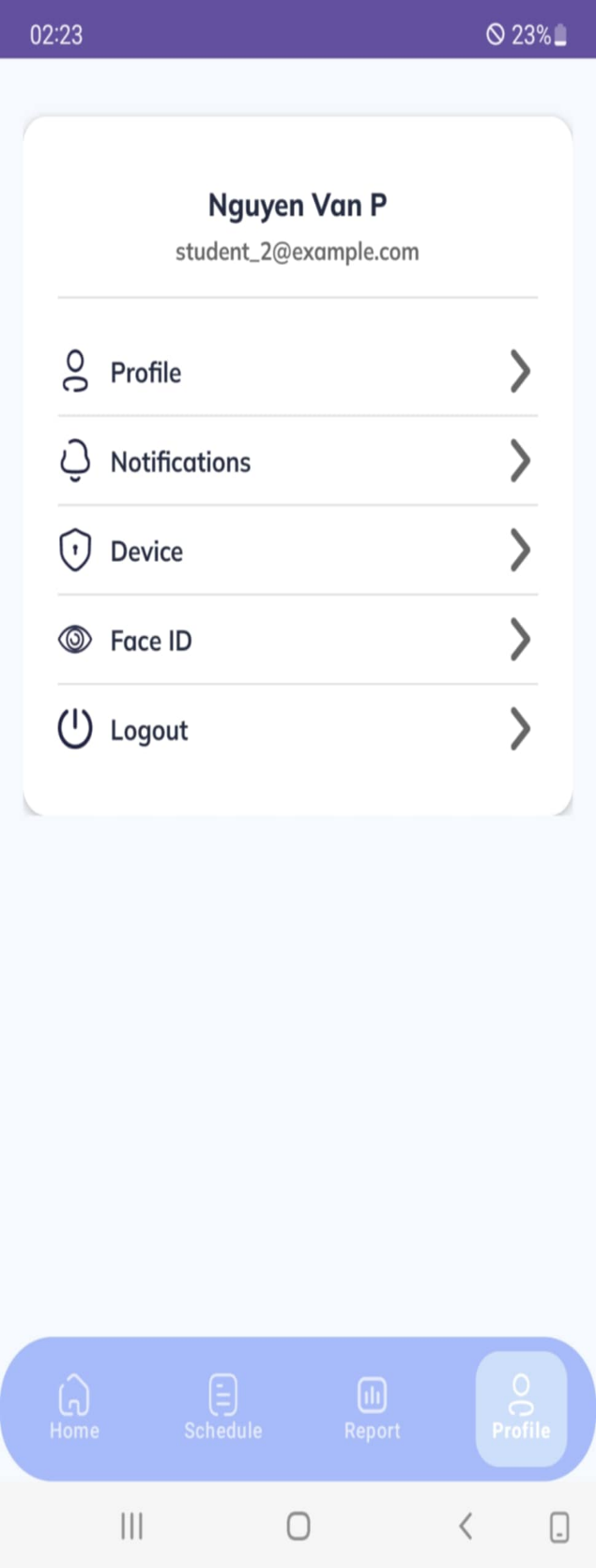
Figure 52: Sign out layout
No | Field Name | Field Type | Description
1 | Logout (menu item) | Menu Item | Menu option in the Profile screen; tap to trigger immediate logout.
Table 109: Sign Out Field Table
b. Use Case Specifications
ID and Name | UC – 02: Sign Out
Created By | Dungktn | Date Created | 28/06/2025
Primary Actor | Student, Lecturer | Secondary Actors | System
Trigger | User initiates a logout action from the settings menu.
Description | The user can securely sign out from the application, ending the current session and clearing all locally stored authentication tokens.
Preconditions | PRE-1. The user is currently signed in.
Postconditions | POST-1. Session data is cleared.  POST-2. User is returned to the login screen.
Normal Flows | Step | By | Step Details
Normal Flows | 1 | User | Opens settings and taps “Sign Out.”
Normal Flows | 2 | System | Displays confirmation dialog.
Normal Flows | 3 | User | Confirms action.
Normal Flows | 4 | System | Clears session data and stored tokens.
Normal Flows | 5 | System | Redirects user to login screen.
Alternative Flow | Alt Step | Condition | Description
Alternative Flow | A1 | User cancels confirmation | System closes dialog and keeps user signed in.
Exceptions | E1: If system fails to clear local storage, show: “Logout failed. Please try again.”
Frequency of Use | Medium
Business Rules | BR-02
Other Information | - Tokens and session information must be securely removed from device storage.  - Push notification tokens may be deregistered as part of logout.
Assumptions | - User has access to settings and the app is functioning normally.
Table 110: Sign out specification

3.2.2.3 View Student Setting
a. Screen Layouts
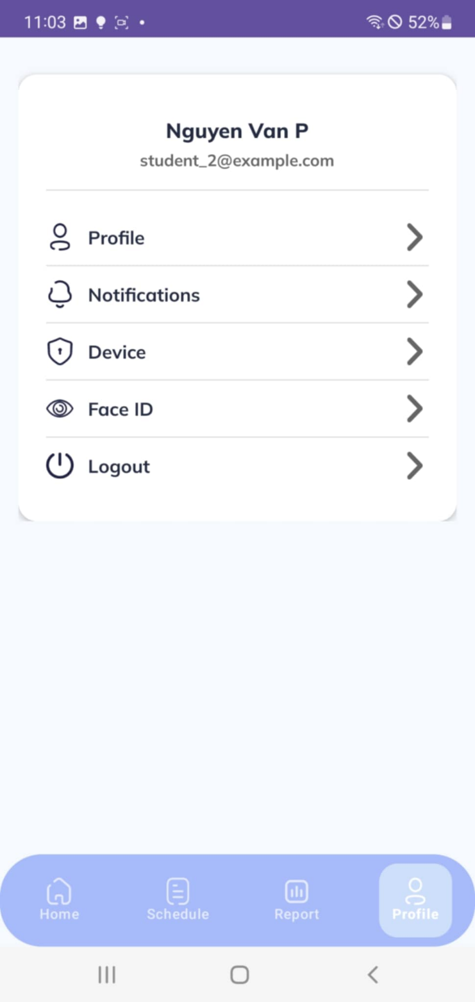
Figure 53: View Student Setting
No | Field Name | Field Type | Description
1 | User Name | Text Label | Displays student’s name (e.g., “Nguyen Van P”).
2 | User Email | Text Label | Displays student’s email (e.g., student_2@example.com).
3 | Profile | Menu Item | Option to view/edit personal profile.
4 | Notifications | Menu Item | Option to access notification settings.
5 | Device | Menu Item | Option to manage logged-in devices.
6 | Face ID | Menu Item | Option to manage Face ID login settings.
7 | Logout | Menu Item | Option to log out immediately.
8 | Bottom Tab – Home | Navigation Tab | Shortcut to Home screen.
9 | Bottom Tab – Schedule | Navigation Tab | Shortcut to Schedule screen.
10 | Bottom Tab – Report | Navigation Tab | Shortcut to Report screen.
11 | Bottom Tab – Profile | Navigation Tab | Highlights current Profile screen (active).
Table 111: View Student Setting Field Table
b. Use Case Specifications
ID and Name | UC – 03: View Student Setting
Created By | Dungktn | Date Created |  |  | 28/06/2025
Primary Actor | Student | Secondary Actors |  |  | System
Trigger | Students open the Settings tab from the navigation menu.
Description | The student can access their settings, including personal profile, notification toggle, device and FaceID management, and logout option.
Preconditions | PRE-1. Students are signed into the mobile app.  PRE-2. The system displays all available settings for the student.
Postconditions | POST-1. Accessibility permissions are granted, enabling automation scenarios.
Normal Flows | Step |  | By | Step Details
Normal Flows | 1 |  | Student | Taps the “Settings” icon in the bottom navigation bar.
Normal Flows | 2 |  | System | Displays the Settings screen with the following options:  - View/Edit Profile  - Manage Device  - Manage FaceID  - Notifications  - Log out
Normal Flows | 3 |  | Student | Taps on any option to navigate to its detailed configuration page.
Alternative Flows | Alt Step |  | Condition | Description
Alternative Flows | A1 |  | No internet connection | System shows cached data or displays offline message.
Exceptions | E1. If system cannot load settings, show error: “Unable to load settings. Please try again.”
Frequency of Use | Medium
Business Rules | BR-01, BR-02, BR-03, BR-04, BR-12
Other Information | - Navigation to sub-settings like FaceID and Device links directly to respective Use Cases (UC-08 to UC-14).  - Dark mode and app version info may also appear here (optional feature).
Assumptions | - All profile and system data is synced and accessible when settings are opened.  - Each student is linked to one active device and one FaceID (if registered).
Table 112: View Student Setting Specification

3.2.2.4 View Lecturer Setting
a. Screen Layouts
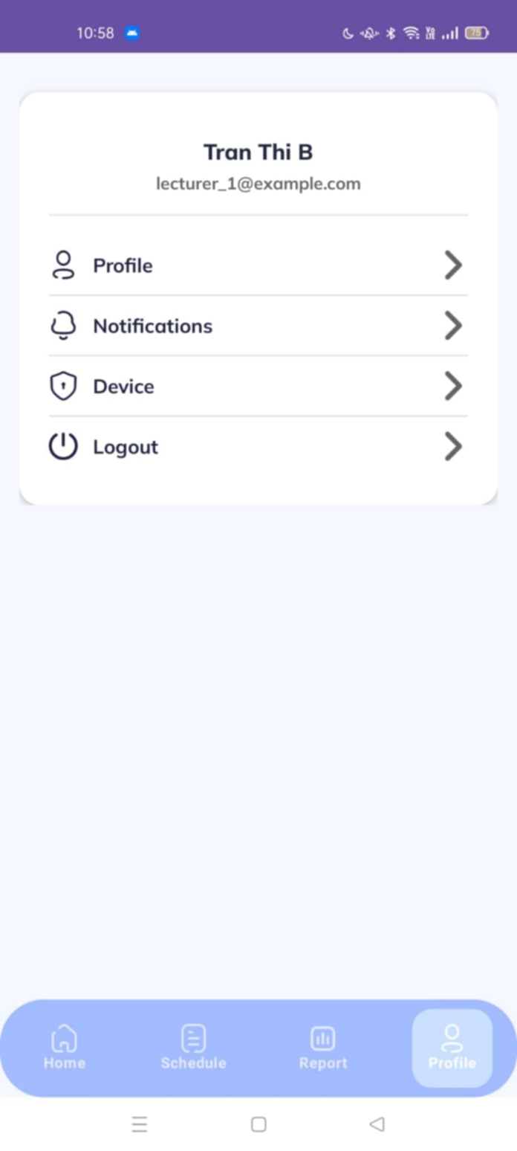
Figure 54: View Lecturer Setting
No | Field Name | Field Type | Description
1 | Lecturer Name | Text Label | Displays lecturer’s full name (e.g., “Tran Thi B”).
2 | Lecturer Email | Text Label | Displays lecturer’s registered email (e.g., lecturer_1@example.com).
3 | Profile | Menu Item | Option to view/edit lecturer’s personal profile.
4 | Notifications | Menu Item | Option to access notification settings.
5 | Device | Menu Item | Option to view/manage logged-in devices.
6 | Logout | Menu Item | Option to log out immediately.
7 | Bottom Tab – Home | Navigation Tab | Shortcut to Home screen.
8 | Bottom Tab – Schedule | Navigation Tab | Shortcut to Schedule screen.
9 | Bottom Tab – Report | Navigation Tab | Shortcut to Report screen.
10 | Bottom Tab – Profile | Navigation Tab | Highlights the active Profile tab (current screen).
Table 113: View Lecturer Setting Field Layout
b. Use Case Specifications
ID and Name | UC – 04: View Lecturer Setting
Created By | Dungktn | Date Created |  |  | 28/06/2025
Primary Actor | Lecturer | Secondary Actors |  |  | System
Trigger | Lecturer accesses the Settings page from the app.
Description | Lecturer views and manages their account settings including profile, device, notifications, and logout options. Unlike students, lecturers do not manage FaceID here.
Preconditions | PRE-1. Lecturer is signed into the mobile app.
Postconditions | POST-1. The system loads and displays all relevant setting options.
Normal Flows | Step |  | By | Step Details
Normal Flows | 1 |  | Lecturer | Taps on “Settings” from the bottom navigation bar.
Normal Flows | 2 |  | System | Displays a list of setting options:  - View/Edit Profile  - Manage Device  - Notification Settings  - Log Out
Normal Flows | 3 |  | Lecturer | Taps an item to open corresponding configuration screen.
Alternative Flows | Alt Step |  | Condition | Description
Alternative Flows | A1 |  | No internet connection | System shows cached profile settings or a warning message.
Exceptions | - E1: If data fails to load, system displays: “Failed to load settings. Please try again.”
Frequency of Use | Medium
Business Rules | BR-01, BR-02, BR-03, BR-12
Other Information | - The lecturer setting screen excludes FaceID sections.  - Notification toggle is for receiving complaints and attendance-related alerts.
Assumptions | - Lecturers use one device per session.  - System settings are fetched from the server and cached locally.
Table 114: View Lecturer Setting Specification

3.2.2.5 View Profile
a. Screen Layouts
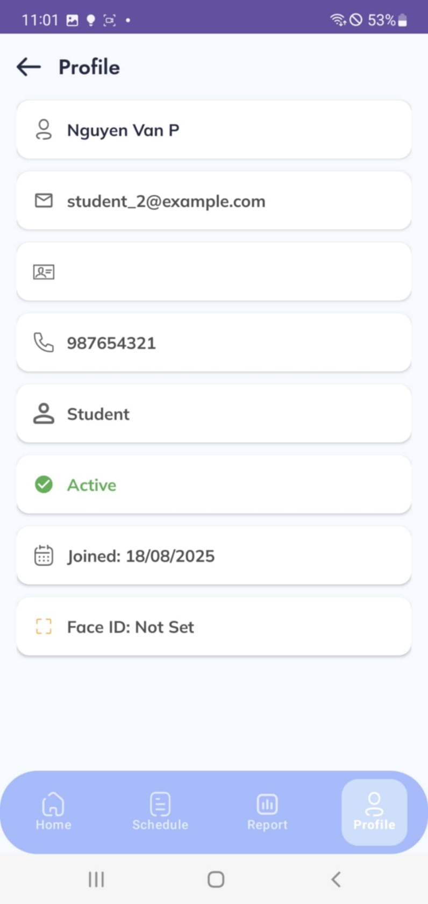
Figure 55: View Student Profile
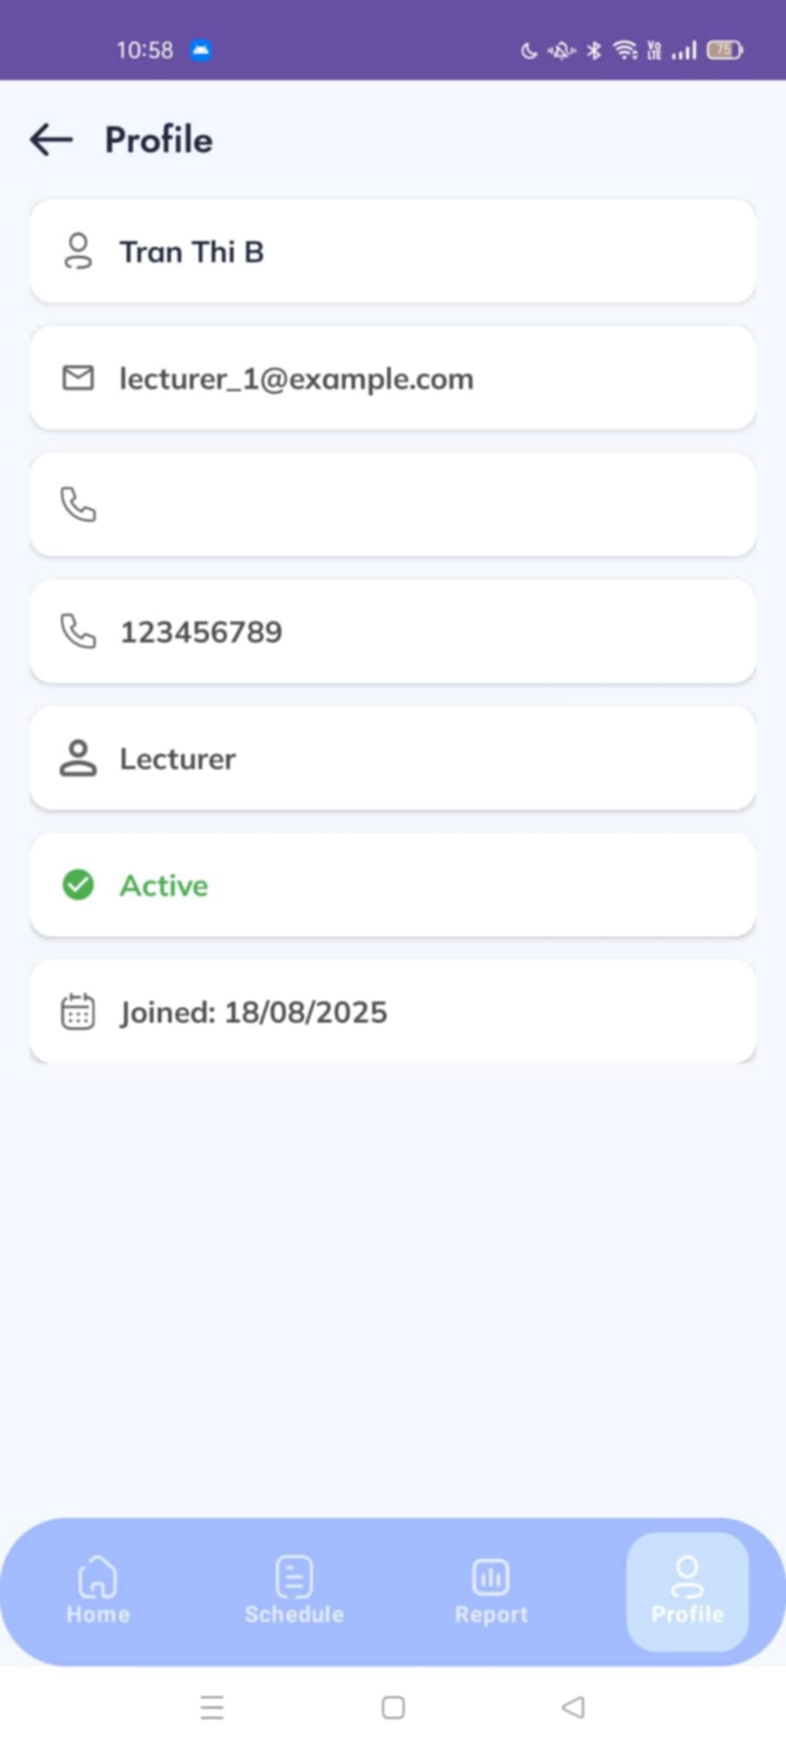
Figure 56: View Lecture Profile
No | Field Name | Field Type | Description
1 | User Name | Text Label | Displays full name of the user (e.g., “Nguyen Van P”).
2 | User Email | Text Label | Displays registered email of the user (e.g., student_2@example.com).
3 | Phone Number | Text Label | Displays the user’s phone number (e.g., 987654321).
4 | Role | Text Label | Displays the role of the user (e.g., Student or Lecturer).
5 | Account Status | Text Label | Shows whether the account is active/inactive (e.g., “Active”).
6 | Joined Date | Text Label | Displays the account creation/joined date (e.g., 18/08/2025).
7 | Face ID Status | Text Label | Displays whether Face ID is set or not (e.g., “Not Set”).
8 | Bottom Tab – Home | Navigation Tab | Shortcut to Home screen.
9 | Bottom Tab – Schedule | Navigation Tab | Shortcut to Schedule screen.
10 | Bottom Tab – Report | Navigation Tab | Shortcut to Report screen.
11 | Bottom Tab – Profile | Navigation Tab | Highlights the active Profile tab (current screen).
Table 115: View Profile Field Table
b. Use Case Specifications
ID and Name | UC – 05: View Profile
Created By | Dungktn | Date Created |  |  | 28/06/2025
Primary Actor | Lecturer, Student | Secondary Actors |  |  | System
Trigger | User selects the “View Profile” option from the settings menu.
Description | Allows the user to view their personal profile information such as name, email, date of birth, phone number, gender, and role.
Preconditions | PRE-1. User is signed into the mobile app.
Postconditions | POST-1. The system displays the user’s profile data.
Normal Flows | Step |  | By | Step Details
Normal Flows | 1 |  | User | Opens Settings and selects “View Profile.”
Normal Flows | 2 |  | System | Retrieves and displays current profile info: full name, email, date of birth, phone number, gender, and role.
Alternative Flows | Alt Step |  | Condition | Description
Alternative Flows | A1 |  | Profile not fully set up | System shows placeholders and suggests user to complete info.
Exceptions | - E1: If system fails to load data, show: “Unable to load profile. Please try again.”
Frequency of Use | Medium
Business Rules | BR-01, BR-02
Other Information | - Profile fields are read-only in this use case. Edit is handled in UC-07.  - The screen may include a user avatar and “Edit Profile” button.
Assumptions | - User information is synced and retrieved from the central database.  - All fields are stored and updated by Admin or by user via edit flow.
Table 116: View Profile Specification

3.2.2.6 View Device
a. Screen Layouts
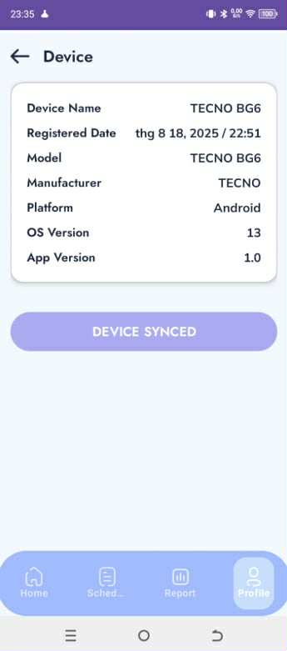
Figure 57: View Device
No | Field Name | Field Type | Description
1 | Device Name | Text Label | Shows the device name (e.g., TECNO BG6).
2 | Registered Date | Text Label | Displays the date and time the device was registered (e.g., 18/08/2025 22:51).
3 | Model | Text Label | Shows the device model (e.g., TECNO BG6).
4 | Manufacturer | Text Label | Shows the device manufacturer (e.g., TECNO).
5 | Platform | Text Label | Displays the operating system platform (e.g., Android).
6 | OS Version | Text Label | Displays the version of the operating system (e.g., 13).
7 | App Version | Text Label | Displays the installed application version (e.g., 1.0).
8 | Device Synced Button | Button | Indicates sync status; pressed to re-sync or confirm sync with system.
9 | Bottom Tab – Home | Navigation Tab | Shortcut to Home screen.
10 | Bottom Tab – Schedule | Navigation Tab | Shortcut to Schedule screen.
11 | Bottom Tab – Report | Navigation Tab | Shortcut to Report screen.
Table 117: View Device Field Table
b. Use Case Specifications
ID and Name | UC – 06: View Device
Created By | Dungktn | Date Created |  |  | 28/06/2025
Primary Actor | Student, Lecturer | Secondary Actors |  |  | System
Trigger | User navigates to the “Device Management” section from settings.
Description | Allows users to view information about their currently registered Bluetooth device used for attendance. Includes device name, ID, and registration date.
Preconditions | PRE-1. User is signed in.  PRE-2. User has previously registered at least one device.
Postconditions | POST-1. System displays registered device information.
Normal Flows | Step |  | By | Step Details
Normal Flows | 1 |  | User | Navigates to Settings > Device Management.
Normal Flows | 2 |  | System | Retrieves and displays registered device data: name, ID, registration date.
Normal Flows | 3 |  | User | Reviews the device status. If needed, can choose to request update (UC-10).
Alternative Flows | Alt Step |  | Condition | Description
Alternative Flows | A1 |  | No device is registered | System shows: “No device registered. Please register a device.”
Exceptions | - E1: If data retrieval fails, system shows: “Unable to load device information.”
Frequency of Use | Medium
Business Rules | BR-01, BR-02, BR-03
Other Information | - Each user can have only one active device at a time.  - Updating a device requires approval via UC-10.
Assumptions | - Device info is synced from system database.  - Device registration is linked to user authentication and attendance mechanism.
Table 118: View Device Specification

3.2.2.7 Register Device
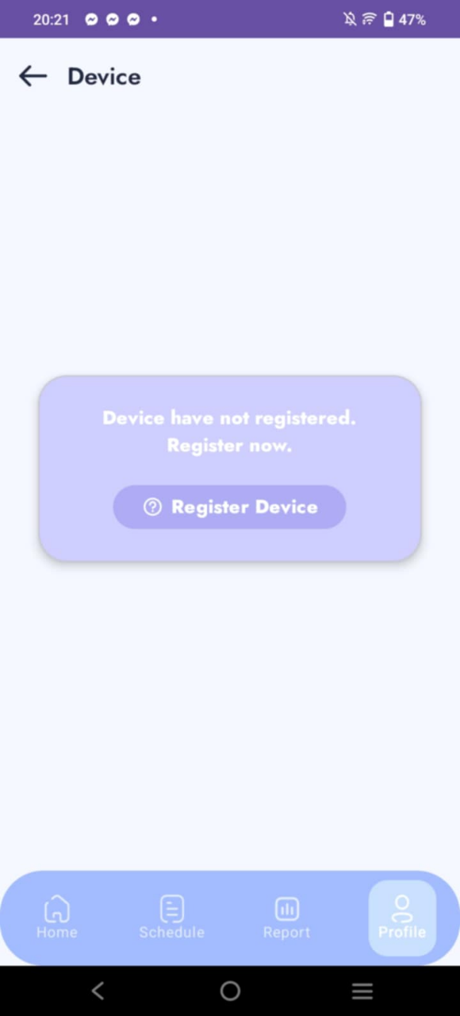
Figure 58: Register Device Layout
No | Field Name | Field Type | Description
1 | Device Not Registered Message | Text Label | Displays message when no device is registered (e.g., “Device have not registered. Register now.”).
2 | Register Device Button | Button | Action button to start device registration process.
Table 119: Register Device Field Table
b. Use Case Specifications
ID and Name | UC – 07: Register Device
Created By | Dungktn | Date Created |  |  | 28/06/2025
Primary Actor | Student, Lecturer | Secondary Actors |  |  | System
Trigger | Lecturer accesses the Settings page from the app.
Description | Allow the user to register their Bluetooth-enabled mobile device for use in attendance sessions. The device will be linked to the user's identity and used for signal broadcasting or detection.
Preconditions | PRE-1. User is signed in.  PRE-2. Device is Bluetooth-capable.
Postconditions | POST-1. Device is registered and stored in the system as the user’s active device.
Normal Flows | Step |  | By | Step Details
Normal Flows | 1 |  | User | Opens Settings > Device Management > Register Device.
Normal Flows | 2 |  | System | Detects available Bluetooth information (device ID, name).
Normal Flows | 3 |  | User | Confirms registration of detected device.
Normal Flows | 4 |  | System | Send registration data to server.
Normal Flows | 5 |  | System | Saves device as active and displays confirmation.
Alternative Flows | Alt Step |  | Condition | Description
Alternative Flows | A1 |  | Device already registered | System shows warning: “You already have a registered device.”
Exceptions | - E1: If Bluetooth is turned off, system prompts user: “Please enable Bluetooth to register device.”  - E2: If server is unreachable, show: “Device registration failed. Please try again later.”
Frequency of Use | Low
Business Rules | BR-01, BR-02, BR-03, BR-10
Other Information | - Only one active device is allowed per user.  - Further changes to the device must go through UC-10 – Request Update Device.
Assumptions | - Bluetooth is supported and available on the user’s device.  - Admin approval may be required if the device is replaced.
Table 120: Register Device Specification

3.2.2.8. View Face ID
a. Screen Layouts
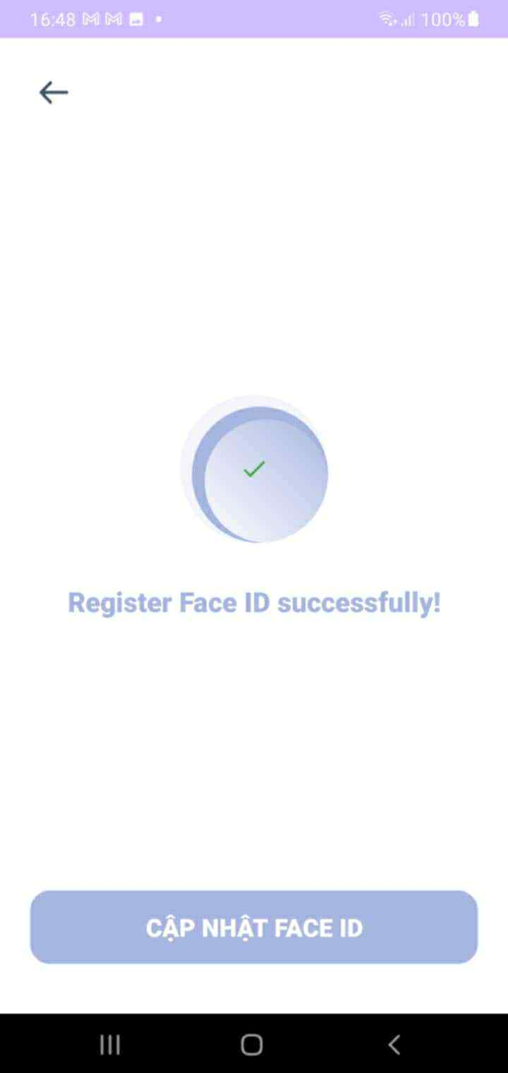
Figure 59: View Face ID Status Layout
No | Field Name | Field Type | Description
1 | Success Icon (Check mark) | Graphic/Icon | Indicates that Face ID registration was successful.
2 | Success Message | Text Label | Displays confirmation text (e.g., “Register Face ID successfully!”).
3 | Update Face ID Button | Button | Allows the user to update/re-register Face ID if needed.
Table 121: View Face ID Field Table
b. Use Case Specifications
ID and Name | UC – 08: View FaceID
Created By | Dungktn | Date Created |  |  | 28/06/2025
Primary Actor | Student | Secondary Actors |  |  | System
Trigger | Student navigates to the FaceID section from the settings screen.
Description | Student views their registered FaceID details, such as registration status and last update time. This FaceID is used for verifying identity in attendance sessions.
Preconditions | PRE-1. User is signed in.  PRE-2. A FaceID may or may not have been registered.
Postconditions | POST-1. The system displays current FaceID status.
Normal Flows | Step |  | By | Step Details
Normal Flows | 1 |  | Student | Opens Settings > FaceID.
Normal Flows | 2 |  | System | Retrieves FaceID registration status and last update timestamp.
Normal Flows | 3 |  | Student | Reviews the displayed information.
Alternative Flows | Alt Step |  | Condition | Description
Alternative Flows | A1 |  | FaceID not registered | System displays: “FaceID not yet registered.” Prompts for UC-12.
Exceptions | - E1: If data retrieval fails, system shows: “Unable to load FaceID data. Please try again.”
Frequency of Use | Medium
Business Rules | BR-01, BR-02, BR-04
Other Information | - Only one FaceID profile can be registered per student.  - FaceID is used during in-class verification (e.g., UC-23).  - Stored securely and protected under privacy policy.
Assumptions | - The device camera and system support FaceID features.  - FaceID is required for attendance verification flows.
Table 122: View Face ID Specification

3.2.2.9. Register Face ID
a. Screen Layouts
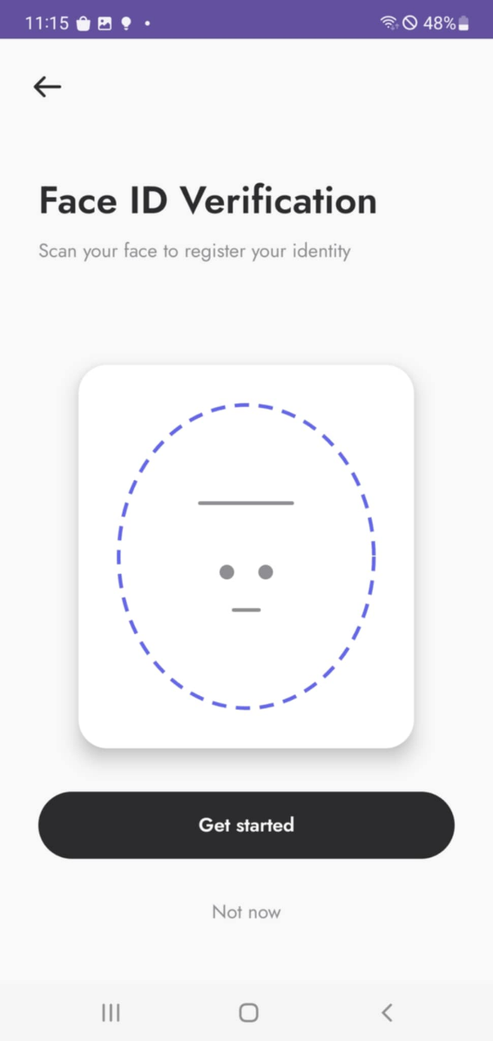
Figure 60: Register Face ID layout
No | Field Name | Field Type | Description
1 | Title – “Face ID Verification” | Text Label | Screen title.
2 | Subtitle – instruction | Text Label | Helper text: “Scan your face to register your identity.”
3 | Face Frame/Illustration | Graphic/Widget | Visual guide indicating where the face should align during capture.
4 | Get started | Primary Button | Begins the Face ID registration flow (opens camera / capture steps).
5 | Not now | Text Link | Skips Face ID registration and returns to the previous context.
Table 123: Register Face ID Field Table
b. Use Case Specifications
ID and Name | UC – 09: Register Face ID
Created By | Dungktn | Date Created |  |  | 28/06/2025
Primary Actor | Student | Secondary Actors |  |  | System
Trigger | Students choose to register FaceID from the FaceID setting screen.
Description | Allow a student to register their facial data to be used for FaceID verification in attendance sessions.
Preconditions | PRE-1. User is signed in.  PRE-2. The device has a working front-facing camera.  PRE-3. Student has not registered FaceID before.
Postconditions | POST-1. FaceID is successfully stored and associated with student’s profile.
Normal Flows | Step |  | By | Step Details
Normal Flows | 1 |  | Student | Navigates to Settings > FaceID > Register.
Normal Flows | 2 |  | System | Opens device camera with on-screen instruction for face capture.
Normal Flows | 3 |  | Student | Positions face and confirms capture.
Normal Flows | 4 |  | System | Processes and validates the image (e.g., quality, clarity).
Normal Flows | 5 |  | System | Saves FaceID and displays confirmation: “FaceID registered successfully.”
Alternative Flows | Alt Step |  | Condition | Description
Alternative Flows | A1 |  | Face not properly detected | System prompts: “Face not clear. Please try again.”
Exceptions | - E1: If camera permission is denied, show: “Please enable camera to register FaceID.”  - E2: If registration fails due to network/server error, show: “Failed to register. Try again later.”
Frequency of Use | Low
Business Rules | BR-01, BR-02, BR-04
Other Information | - FaceID data may be encrypted and stored securely.  - Student can update FaceID later using UC-13 – Update FaceID.
Assumptions | - Device supports biometric capture and has internet connection.  - Students agree to privacy policy and biometric data usage terms.
Table 124: Register Face ID Specification

3.2.2.10 Update Face ID
a. Screen Layouts
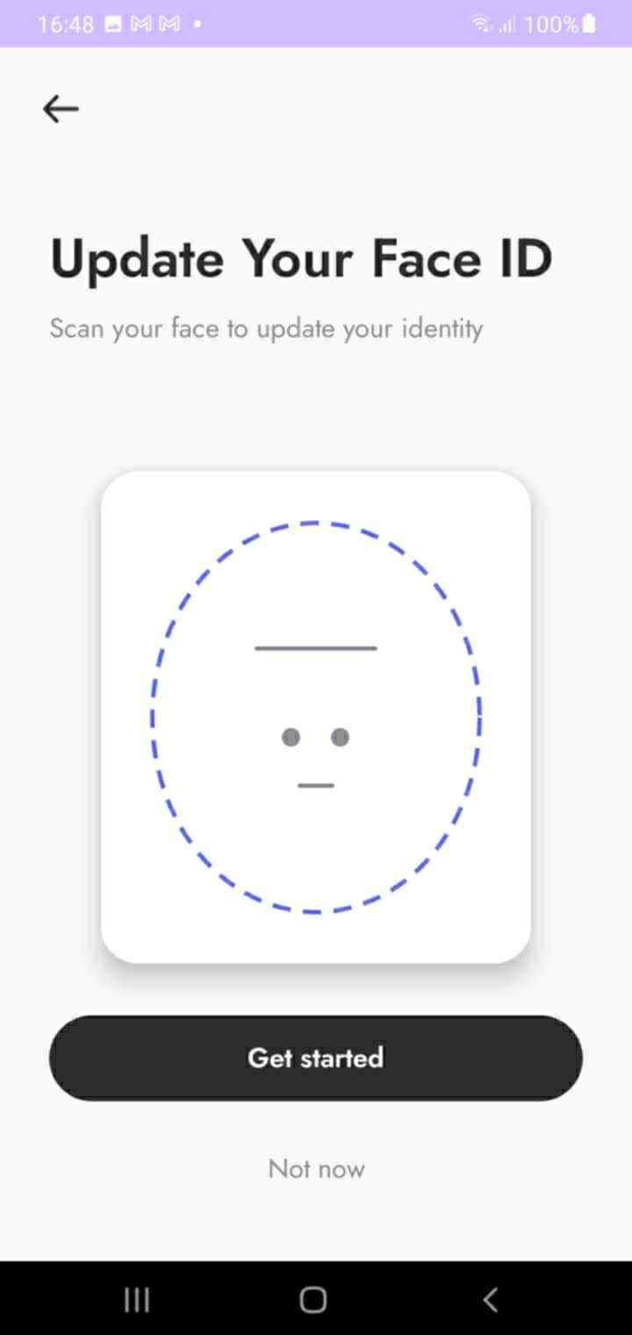
Figure 61: Update Face ID Layout
No | Field Name | Field Type | Description
1 | Title – “Update Your Face ID” | Text Label | Screen title.
2 | Subtitle – instruction | Text Label | Instruction text: “Scan your face to update your identity.”
3 | Face Frame/Illustration | Graphic/Widget | Visual guide showing where to position the face during scan.
4 | Get started | Primary Button | Begins the Face ID update process (camera capture).
Table 125: Update Face ID Field Table
b. Use Case Specifications
ID and Name | UC – 10: Update Face ID
Created By | Dungktn | Date Created |  |  | 28/06/2025
Primary Actor | Student | Secondary Actors |  |  | System
Trigger | Students choose to re-register FaceID from the FaceID settings screen.
Description | Allow a student to update their previously registered FaceID data. This may be required if their facial features have changed, or if the original registration failed.
Preconditions | PRE-1. User is signed in.  PRE-2. FaceID has already been registered.  PRE-3. Device has a functioning front-facing camera.
Postconditions | POST-1. The system displays current FaceID status.
Normal Flows | Step |  | By | Step Details
Normal Flows | 1 |  | Student | Opens Settings > FaceID > Update FaceID.
Normal Flows | 2 |  | System | Launches front-facing camera with on-screen guidance.
Normal Flows | 3 |  | Student | Positions face correctly and confirms image capture.
Normal Flows | 4 |  | System | Processes the image and checks quality (e.g., lighting, clarity).
Normal Flows | 5 |  | System | Saves updated FaceID and shows success message.
Alternative Flows | Alt Step |  | Condition | Description
Alternative Flows | A1 |  | Image quality is insufficient | System prompts user to recapture: “Face not clear. Try again.”
Exceptions | - E1: If FaceID has not been registered, system shows: “No FaceID found. Please register first.”  - E2: If camera permission is denied, show: “Please allow camera access to update FaceID.”  - E3: If update fails due to network/server issue, system shows: “Update failed. Try again later.”
Frequency of Use | Low
Business Rules | BR-01, BR-02, BR-04
Other Information | - FaceID update completely replaces the previous one.  - Timestamp of update may be stored for system audit.
Assumptions | - The student’s device has a working camera.  - Students accept privacy policies related to facial data usage.
Table 126: Update Face ID Specification

3.2.2.11 View Student Home Page
a. Screen Layouts
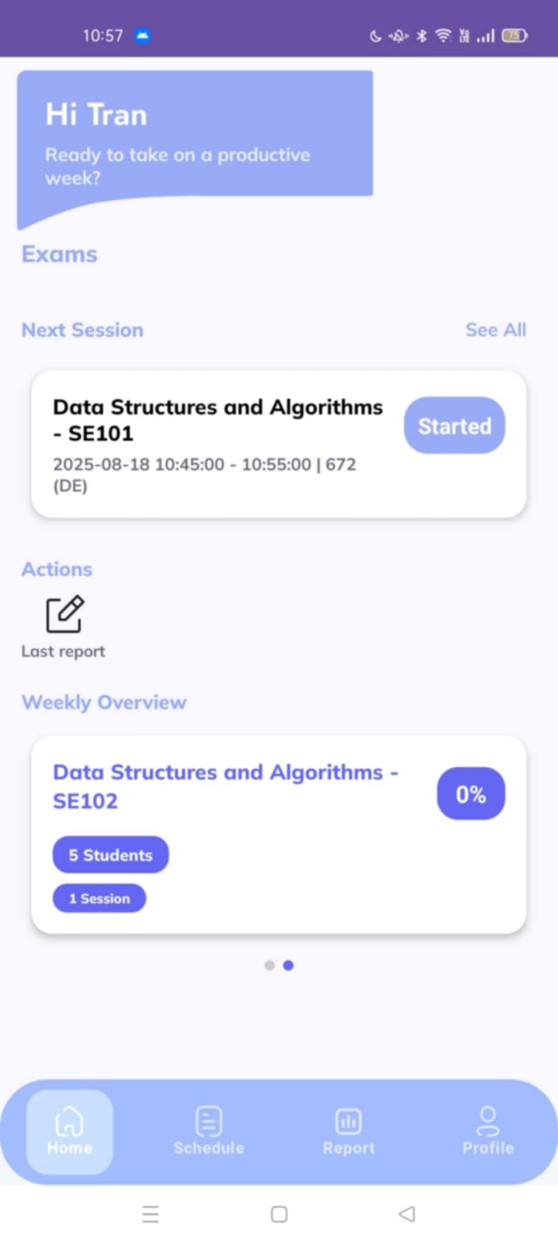
Figure 62: Homepage layout
No | Field Name | Field Type | Description
No | Field Name | Field Type | Description
1 | Greeting Section | Text Label | Displays student’s name and welcome message.
2 | Next Session | Card Widget | Shows details of the upcoming class/session.
3 | See All | Text Link | Navigates to full list of sessions/exams.
4 | Last Report | Menu Item | Shortcut to view the latest report.
5 | Weekly Overview | Card Widget | Displays weekly class information and progress.
6 | Bottom Tab – Home | Navigation Tab | Active tab for Home screen.
7 | Bottom Tab – Schedule | Navigation Tab | Shortcut to Schedule screen.
8 | Bottom Tab – Report | Navigation Tab | Shortcut to Report screen.
9 | Bottom Tab – Profile | Navigation Tab | Shortcut to Profile screen.
No | Field Name | Field Type | Description
Table 127: View Student Home Page Field Table
b. Use Case Specifications
ID and Name | UC – 11: View Student Home Page
Created By | Dungktn | Date Created |  |  | 28/06/2025
Primary Actor | Student | Secondary Actors |  |  | System
Trigger | Students open the app or navigates to the home screen.
Description | Displays an overview of the student’s day, including today’s class schedule, important announcements, and attendance warnings (if any).
Preconditions | PRE-1. Students are signed in.  PRE-2. Students have classes or announcements scheduled for the current date.
Postconditions | POST-1. System shows personalized dashboard content.
Normal Flows | Step |  | By | Step Details
Normal Flows | 1 |  | Student | Launches app or taps “Home” from bottom navigation bar.
Normal Flows | 2 |  | System | Fetches today’s schedule and latest announcements.
Normal Flows | 3 |  | System | Displays home screen with:  – Today’s class list  – Announcements  – Attendance warnings (if any)
Alternative Flows | Alt Step |  | Condition | Description
Alternative Flows | A1 |  | No classes or data for today | System shows message: “No scheduled classes or announcements.”
Exceptions | - E1: If data fails to load due to network issues, show: “Unable to load homepage data. Please check your connection.”
Frequency of Use | High
Business Rules | BR-01, BR-02, BR-14, BR-17
Other Information | - This is the landing page after login.  - Displays notification badge for pending complaints or session alerts.
Assumptions | - Backend supports real-time sync of schedule and notification data.  - Classes and announcements are time-sensitive and auto-refresh daily.
Table 128: View Student Home Page Specification

3.2.2.12 View Student Schedule
a. Screen Layouts
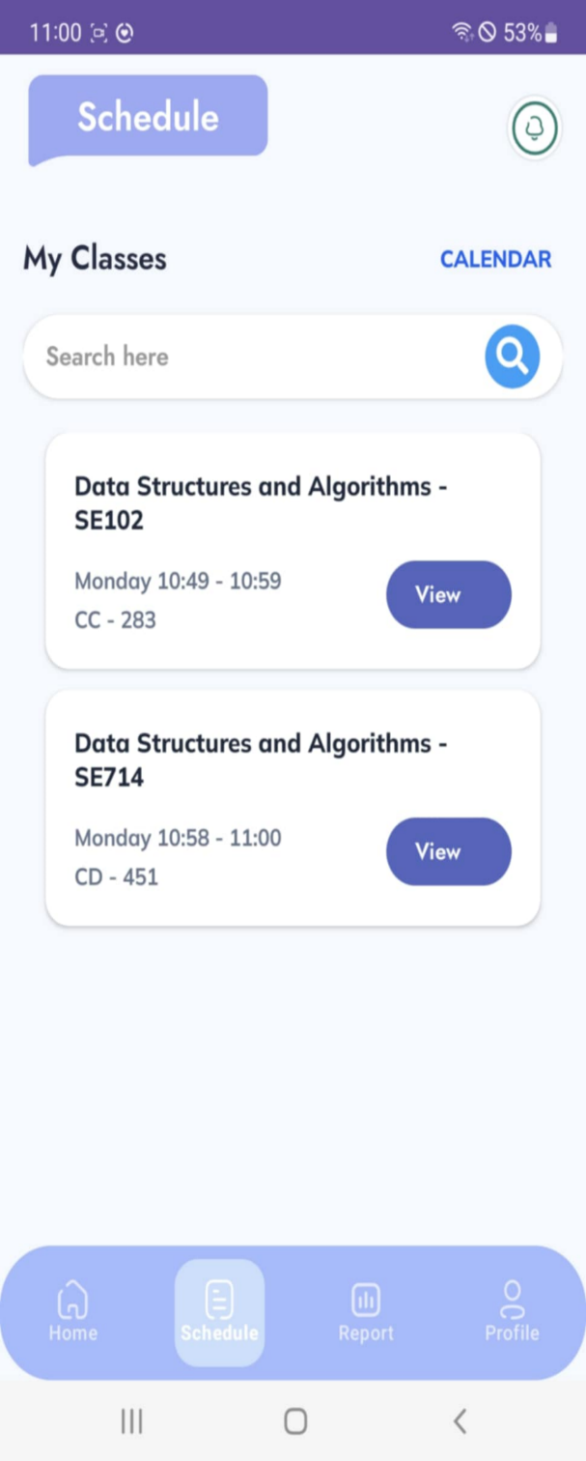
Figure 63: View Student Schedule Layout
No | Field Name | Field Type | Description
1 | Title – Schedule | Text Label | Screen title.
2 | Calendar Switch | Text Link/Button | Allows switching to calendar view.
3 | Search Bar | Search Field | Search for a class by name/code.
4 | Class List | Card Widget | Displays class information (course name, code, time, room). Each card includes a View button.
5 | Bottom Tab – Home | Navigation Tab | Shortcut to Home screen.
6 | Bottom Tab – Schedule | Navigation Tab | Active tab, showing current Schedule screen.
7 | Bottom Tab – Report | Navigation Tab | Shortcut to Report screen.
8 | Bottom Tab – Profile | Navigation Tab | Shortcut to Profile screen.
Table 129: View Student Schedule Field Table
b. Use Case Specifications
ID and Name | UC – 12: View Student Schedule
Created By | Dungktn | Date Created |  |  | 28/06/2025
Primary Actor | Student | Secondary Actors |  |  | System
Trigger | Student navigates to the “Schedule” section from the mobile app.
Description | Displays an overview of the student’s day, including today’s class schedule, important announcements, and attendance warnings (if any).
Preconditions | PRE-1. Students are signed in.  PRE-2. Schedule has been uploaded and linked to the student.
Postconditions | POST-1. Schedule information is retrieved and displayed.
Normal Flows | Step |  | By | Step Details
Normal Flows | 1 |  | Student | Taps “Schedule” from bottom navigation or Home screen.
Normal Flows | 2 |  | System | Loads current week’s timetable based on student’s class data.
Normal Flows | 3 |  | System | Displays each session with subject name, time, room, and status (e.g., upcoming, ongoing, completed).
Normal Flows | 4 |  | Student | Taps on a class item to view session details (linked to UC-22).
Alternative Flows | Alt Step |  | Condition | Description
Alternative Flows | A1 |  | No schedule available | System displays: “No classes scheduled for this period.”
Exceptions | - E1: If schedule fails to load, system displays: “Unable to retrieve schedule. Please try again.”
Frequency of Use | High
Business Rules | BR-01, BR-02
Other Information | - May include filters (day/week view) and indicators for attendance status.  - Supports redirection to attendance flow if session is active.
Assumptions | - System integrates schedule from central timetable or admin-imported files.  - Student is assigned to at least one active class.
Table 130: View Student Schedule Specification

3.2.2.13 View Student Calendar
a. Screen Layouts
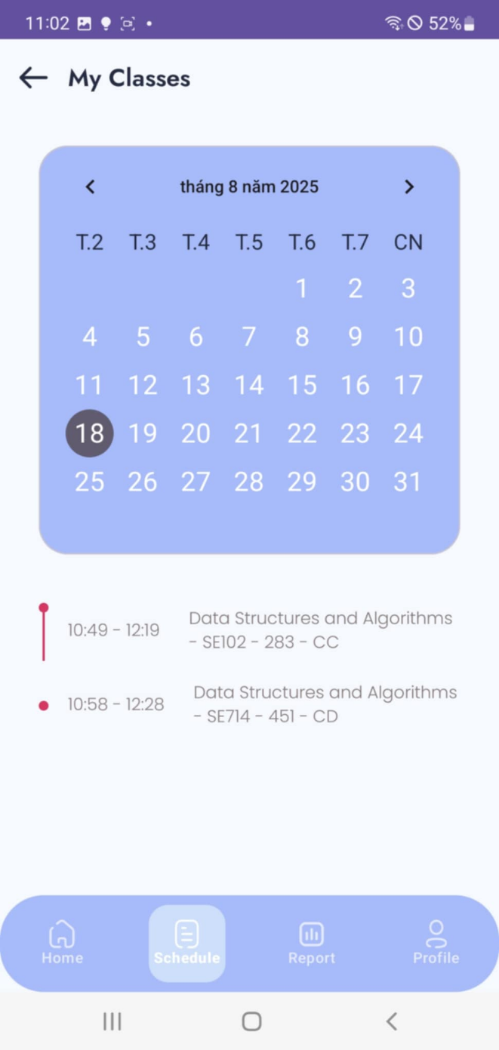
Figure 64: View Student Calendar Layout
No | Field Name | Field Type | Description
1 | Title – My Classes | Text Label | Screen title.
2 | Calendar Widget | Calendar UI | Displays monthly calendar with selectable dates.
3 | Date Indicator | Highlight | Highlights the selected date (e.g., 18).
4 | Class List | List Item | Shows sessions scheduled for the selected date (course name, code, time, room).
5 | Bottom Tab – Home | Navigation Tab | Shortcut to Home screen.
6 | Bottom Tab – Schedule | Navigation Tab | Active tab, showing current Schedule/Calendar screen.
7 | Bottom Tab – Report | Navigation Tab | Shortcut to Report screen.
8 | Bottom Tab – Profile | Navigation Tab | Shortcut to Profile screen.
Table 131: View Student Calendar Field Table
b. Use Case Specifications
ID and Name | UC – 13: View Student Calendar
Created By | Dungktn | Date Created |  |  | 28/06/2025
Primary Actor | Student | Secondary Actors |  |  | System
Trigger | Student access the calendar section from the app.
Description | Allow students to view their class schedule in a calendar format, providing a monthly or weekly overview of all upcoming and past sessions.
Preconditions | PRE-1. Students are signed in.  PRE-2. Class schedule is available.
Postconditions | POST-1. Calendar view is populated with class sessions.
Normal Flows | Step |  | By | Step Details
Normal Flows | 1 |  | Student | Taps “Calendar” icon/tab from the bottom menu or navigation drawer.
Normal Flows | 2 |  | System | Loads calendar view (default to current month).
Normal Flows | 3 |  | System | Displays all scheduled classes in date blocks with subject name and time.
Normal Flows | 4 |  | Student | Taps on a date to see daily class details and navigate to session info.
Alternative Flows | Alt Step |  | Condition | Description
Alternative Flows | A1 |  | No events for selected date | System shows: “No classes scheduled for this date.”
Exceptions | - E1: If calendar data fails to load, system shows: “Unable to retrieve calendar. Please try again later.”
Frequency of Use | High
Business Rules | BR-01, BR-02
Other Information | - May include color-coding for past, current, and future classes.  - Calendar view supports navigation between months and weeks.
Assumptions | - Calendar data is synced from the same source as the weekly schedule (UC-16).  - Time zone and date localization are handled by the app.
Table 132: View Student Calendar Specification

3.2.2.14 View Lecturer Home Page
a. Screen Layouts
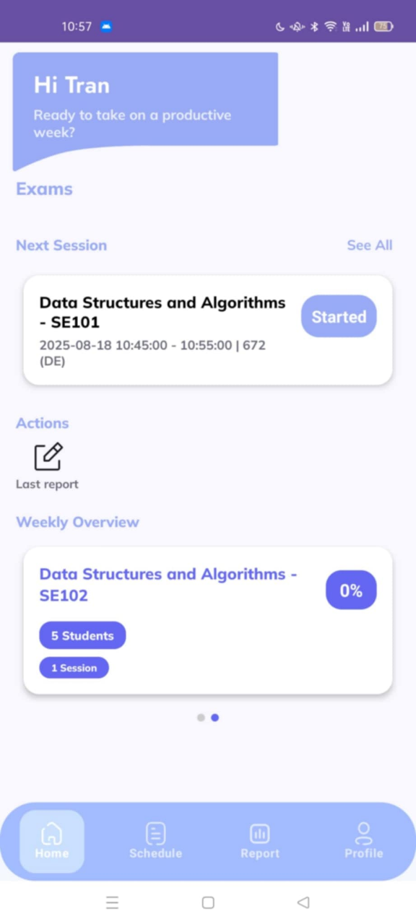
Figure 65: View Lecturer Home Page Layout
No | Field Name | Field Type | Description
1 | Greeting Section | Text Label | Displays lecturer’s name and welcome message.
2 | Next Session | Card Widget | Shows details of the upcoming class/session.
3 | See All | Text Link | Navigates to full list of sessions/exams.
4 | Last Report | Menu Item | Shortcut to view the latest report.
5 | Weekly Overview | Card Widget | Displays weekly class overview (subject, progress, student count, sessions).
6 | Bottom Tab – Home | Navigation Tab | Active tab for Home screen.
7 | Bottom Tab – Schedule | Navigation Tab | Shortcut to Schedule screen.
8 | Bottom Tab – Report | Navigation Tab | Shortcut to Report screen.
9 | Bottom Tab – Profile | Navigation Tab | Shortcut to Profile screen.
Table 133: View Lecturer Home Page Field Table
b. Use Case Specifications
ID and Name | UC – 19: View Lecturer Home Page
Created By | Dungktn | Date Created |  |  | 28/06/2025
Primary Actor | Lecturer | Secondary Actors |  |  | System
Trigger | The lecturer opens the app or navigates to the home screen.
Description | Displays an overview of today’s teaching schedule, class status, student attendance summaries, and pending tasks such as complaints or sessions requiring finalization.
Preconditions | PRE-1. Lectures are signed in.  PRE-2. The lecturer has assigned classes for the day.
Postconditions | POST-1. Home dashboard is shown with relevant teaching information.
Normal Flows | Step |  | By | Step Details
Normal Flows | 1 |  | Lecturer | Opens the app or taps “Home” from navigation.
Normal Flows | 2 |  | System | Retrieves today’s teaching schedule and attendance overview.
Normal Flows | 3 |  | System | Displays:  – List of classes  – Student attendance rates  – Action items (e.g., complaints, sessions to finalize)
Alternative Flows | Alt Step |  | Condition | Description
Alternative Flows | A1 |  | No classes assigned for today | System shows message: “No classes scheduled for today.”
Exceptions | - E1: If data fails to load, system shows: “Unable to retrieve teaching data. Please try again.”
Frequency of Use | High
Business Rules | BR-01, BR-02, BR-14
Other Information | - Entry point for accessing class sessions, launching attendance, and handling complaints.  - May include summary KPIs like number of students absent today.
Assumptions | - Lecturer’s classes are preloaded and synced via admin-imported schedule (UC-39).  - Data refreshes automatically when app is opened.
Table 134: View Lecturer Home Page Specification

3.2.2.15 View Lecturer Schedule
a. Screen Layouts
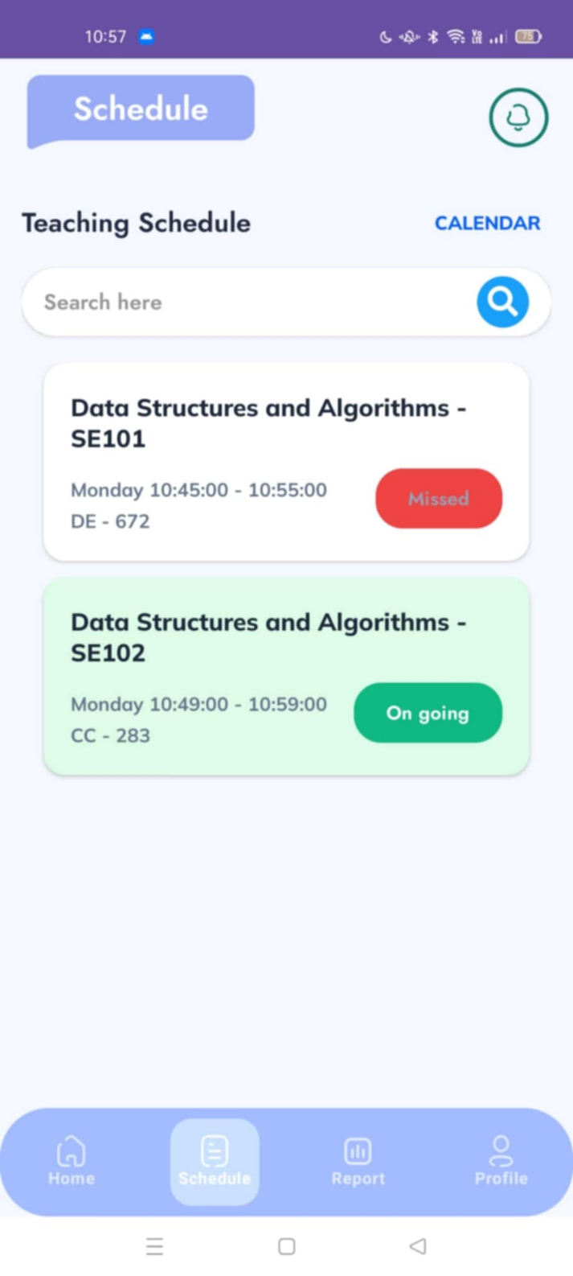
Figure 66: View Lecturer Schedule Layout
No | Field Name | Field Type | Description
1 | Title – Schedule | Text Label | Screen title.
2 | Calendar Switch | Text Link/Button | Allows switching to calendar view.
3 | Search Bar | Search Field | Search for a teaching session/class.
4 | Teaching Schedule List | Card Widget | Displays scheduled classes for the lecturer (course, time, room). Each card shows a status badge (e.g., Missed, On going).
5 | Bottom Tab – Home | Navigation Tab | Shortcut to Home screen.
6 | Bottom Tab – Schedule | Navigation Tab | Active tab, showing current Schedule screen.
7 | Bottom Tab – Report | Navigation Tab | Shortcut to Report screen.
8 | Bottom Tab – Profile | Navigation Tab | Shortcut to Profile screen.
1 | Title – Schedule | Text Label | Screen title.
Table 135: View Lecturer Schedule Field Table
b. Use Case Specifications
ID and Name | UC – 20: View Lecturer Schedule
Created By | Dungktn | Date Created |  |  | 28/06/2025
Primary Actor | Lecturer | Secondary Actors |  |  | System
Trigger | Lecturer navigates to the “Schedule” section in the mobile app.
Description | Allow lecturers to view their teaching schedule in a daily or weekly list, including class times, room information, and links to session detail or start session directly.
Preconditions | PRE-1. Lectures are signed in.  PRE-2. The schedule has been imported and linked to the lecturer’s account.
Postconditions | POST-1. Teaching schedule is displayed.
Normal Flows | Step |  | By | Step Details
Normal Flows | 1 |  | Lecturer | Opens the “Schedule” tab from the bottom navigation bar.
Normal Flows | 2 |  | System | Loads the current week’s teaching schedule from server.
Normal Flows | 3 |  | System | Displays subjects by day and time, including room info and session options.
Normal Flows | 4 |  | Lecturer | Taps a session to:  – View session details (UC-27)  – Start session (UC-35)
Alternative Flows | Alt Step |  | Condition | Description
Alternative Flows | A1 |  | No assigned classes this week | System shows: “No classes scheduled for this week.”
Exceptions | - E1: If schedule data fails to load, system shows: “Unable to retrieve schedule. Please try again later.”
Frequency of Use | High
Business Rules | BR-01, BR-02
Other Information | - May include filtering by week/day and direct links to class actions.  - Designed for fast access during class hours.
Assumptions | - Schedule data is synced from centralized timetable managed by Admin (via UC-39/40).  - Internet connection required for real-time session launching.
Table 136: View Lecturer Schedule Specification

3.2.2.16 View Lecturer Calendar
a. Screen Layouts
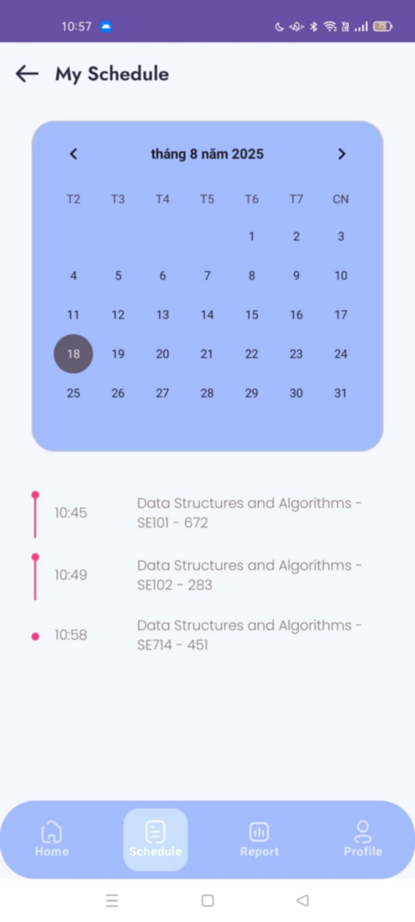
Figure 67: View Lecturer Calendar Layout
No | Field Name | Field Type | Description
1 | Title – My Schedule | Text Label | Screen title.
2 | Calendar Widget | Calendar UI | Monthly calendar allowing lecturers to pick a date.
3 | Date Indicator | Highlight | Marks the selected date (e.g., 18).
4 | Class List | List Item | Shows classes for the selected date (time, course code, room).
5 | Bottom Tab – Home | Navigation Tab | Shortcut to Home screen.
6 | Bottom Tab – Schedule | Navigation Tab | Active tab, showing current Schedule/Calendar screen.
7 | Bottom Tab – Report | Navigation Tab | Shortcut to Report screen.
8 | Bottom Tab – Profile | Navigation Tab | Shortcut to Profile screen.
Table 137: View Lecturer Calendar Field Table
b. Use Case Specifications
ID and Name | UC – 21: View Lecturer Calendar
Created By | Dungktn | Date Created |  |  | 28/06/2025
Primary Actor | Lecturer | Secondary Actors |  |  | System
Trigger | Lecturer opens the “Calendar” section from the app.
Description | Provides lecturers with a full calendar view of their scheduled classes and events by day, week, or month, with the ability to navigate and view session details for any date.
Preconditions | PRE-1. Lectures are signed in.  PRE-2. Class schedule has been assigned and synchronized.
Postconditions | POST-1. Teaching schedule is displayed.
Normal Flows | Step |  | By | Step Details
Normal Flows | 1 |  | Lecturer | Taps “Calendar” icon/tab from main navigation.
Normal Flows | 2 |  | System | Loads calendar view with default to current month.
Normal Flows | 3 |  | System | Populates calendar with scheduled sessions, color-coded by status (upcoming, completed, canceled).
Normal Flows | 4 |  | Lecturer | Taps on a date to see:  – Class list  – Access session detail (UC-27)  – Attendance launch (UC-35)
Alternative Flows | Alt Step |  | Condition | Description
Alternative Flows | A1 |  | No classes on selected date | System shows: “No classes on this date.”
Exceptions | - E1: If calendar data fails to load, show: “Unable to load calendar. Please check your connection.”
Frequency of Use | Medium
Business Rules | BR-01, BR-02
Other Information | - View options: day, week, month.  - May integrate reminders for pending attendance or unresolved complaints.  - Supports visual indicators for attendance status (e.g., not started, in progress, completed).
Assumptions | - Calendar data is synced with master schedule from admin import (UC-39).  - App handles local time zone and localization for international users.
Table 138: View Lecturer Calendar Specification

3.2.2.17 View Personal Attendance Report
a. Screen Layouts
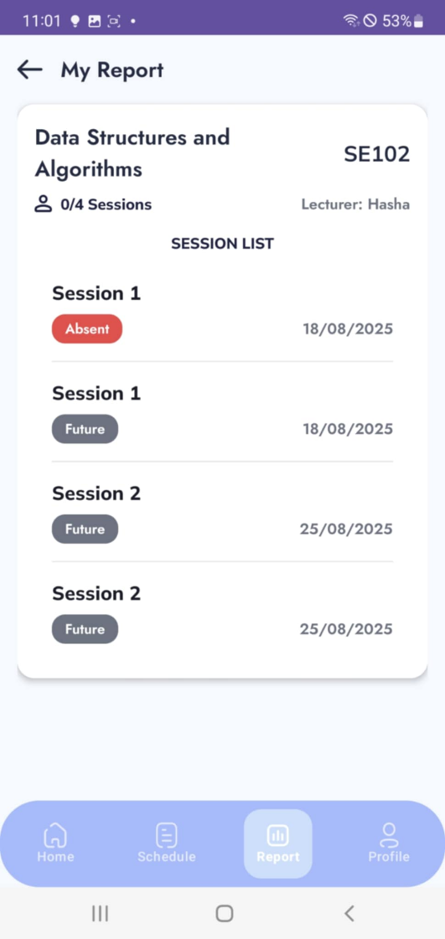
Figure 68: View Lecturer Calendar Layout
No | Field Name | Field Type | Description
1 | Title – My Report | Text Label | Screen title.
2 | Course Info | Text Label | Displays course name, code (e.g., SE102).
3 | Lecturer Info | Text Label | Displays lecturer’s name (e.g., Lecturer: Husha).
4 | Total Sessions | Text Label | Shows total number of sessions (e.g., 0/4 Sessions).
5 | Session List | List Item | Displays each session with status (Absent/Future/Present), session number, and date.
6 | Bottom Tab – Home | Navigation Tab | Shortcut to Home screen.
7 | Bottom Tab – Schedule | Navigation Tab | Shortcut to Schedule screen.
8 | Bottom Tab – Report | Navigation Tab | Active tab, showing current Report screen.
9 | Bottom Tab – Profile | Navigation Tab | Shortcut to Profile screen.
Table 139: View Personal Attendance Report Field Table
b. Use Case Specifications
ID and Name | UC – 14: View Personal Attendance Report
Created By | Dungktn | Date Created |  |  | 28/06/2025
Primary Actor | Student | Secondary Actors |  |  | System
Trigger | Student selects the “Attendance” or “Report” section in the app.
Description | Allow students to view their attendance summary, including attendance percentage by subject and semester, status breakdown, and warnings if thresholds are breached.
Preconditions | PRE-1. Students are signed in.  PRE-2. Attendance data has been recorded and synced.
Postconditions | POST-1. The report is displayed with up-to-date attendance metrics.
Normal Flows | Step |  | By | Step Details
Normal Flows | 1 |  | Student | Opens “Attendance Report” section from navigation or profile.
Normal Flows | 2 |  | System | Retrieves attendance records across subjects for current semester.
Normal Flows | 3 |  | System | Populates calendar with scheduled sessions, color-coded by status (upcoming, completed, canceled). Displays:  – % attendance per subject  – Total attended / total sessions  – Warning icon if attendance is below threshold
Normal Flows | 4 |  | Student | Taps on a subject to view session-level details (linked to UC-22).
Alternative Flows | Alt Step |  | Condition | Description
Alternative Flows | A1 |  | No attendance data available | System shows: “No attendance data available yet.”
Exceptions | - E1: If data retrieval fails, show: “Unable to load report. Please try again later.”
Frequency of Use | Medium
Business Rules | BR-01, BR-02, BR-14, BR-15
Other Information | - Low attendance warnings may be triggered based on thresholds set by Admin (UC-36).  - Session-level view includes history of attended, missed, and excused sessions.
Assumptions | - Backend attendance data is continuously updated from sessions.  - System stores attendance by student-subject-semester.
Table 140: View Personal Attendance Report Specification

3.2.2.18 Join Attendance Session
a. Screen Layouts
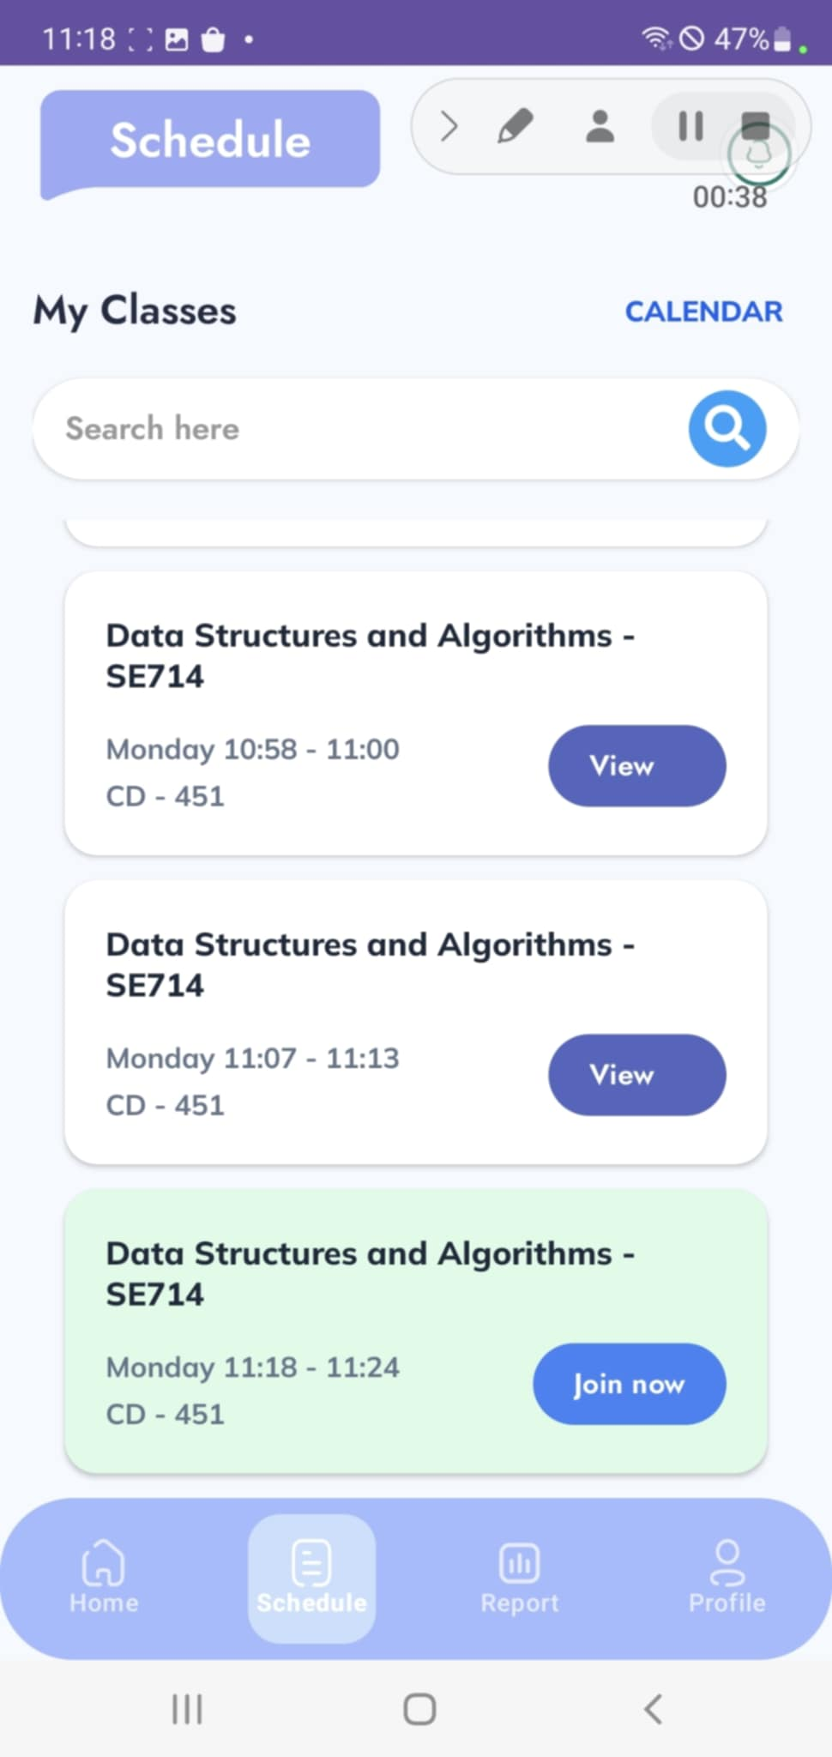
Figure 69: View Personal Attendance Report Layout
No | Field Name | Field Type | Description
1 | Title – Schedule | Text Label | Screen title.
2 | Calendar Switch | Text Link/Button | Allows switching to calendar view.
3 | Search Bar | Search Field | Search for a class by name/code.
4 | Class List | Card Widget | Displays session details (course name, code, time, room). Each card includes a button depending on the session status.
5 | View Button | Button | Available for upcoming or past sessions, used to view details.
6 | Join Now Button | Primary Button | Active for sessions currently ongoing, allowing the student to join attendance.
7 | Bottom Tab – Home | Navigation Tab | Shortcut to Home screen.
8 | Bottom Tab – Schedule | Navigation Tab | Active tab, showing current Schedule screen.
9 | Bottom Tab – Report | Navigation Tab | Shortcut to Report screen.
10 | Bottom Tab – Profile | Navigation Tab | Shortcut to Profile screen.
Table 141: Join Attendance Session Field Table
b. Use Case Specifications
ID and Name | UC – 16: Join Attendance Session
Created By | Dungktn | Date Created |  |  | 28/06/2025
Primary Actor | Student | Secondary Actors |  |  | System
Trigger | Student taps “Join Session” when class begins and signal is detected.
Description | Allow students to join an ongoing attendance session via Bluetooth signal detection. System confirms the student’s presence and records the attempt.
Preconditions | PRE-1. Students are signed in.  PRE-2. A valid attendance session is active.  PRE-3. Student’s device is registered and Bluetooth is enabled.
Postconditions | POST-1. Attendance join request is submitted and pending FaceID if required.
Normal Flows | Step |  | By | Step Details
Normal Flows | 1 |  | Student | Taps “Join Attendance” on the active class session.
Normal Flows | 2 |  | System | Scans for lecturer’s signal (broadcasted via Bluetooth).
Normal Flows | 3 |  | System | Confirms signal received and device is valid.
Normal Flows | 4 |  | System | Logs the student’s presence.
Normal Flows | 5 |  | System | Prompts for FaceID verification (UC-23) if configured.
Alternative Flows | Alt Step |  | Condition | Description
Alternative Flows | A1 |  | No signal detected | System shows: “No session signal detected nearby.”
Alternative Flows | A2 |  | Session not started yet | System shows: “Attendance session has not started.”
Exceptions | - E1: If Bluetooth is turned off, system shows: “Please enable Bluetooth to join session.”  - E2: If device is not registered, show: “Your device is not registered for attendance.”
Frequency of Use | High
Business Rules | BR-01, BR-02, BR-03, BR-05, BR-04 (if FaceID is required)
Other Information | - This flow may be triggered manually or as part of automatic detection.  - May include a countdown timer if joining is only available for limited time.
Assumptions | - Bluetooth signal broadcast is stable and in-range.  - Admin or lecturer has started the session using UC-35.
Table 142: Join Attendance Session Specification

3.2.2.19 View Session Detail
a. Screen Layouts
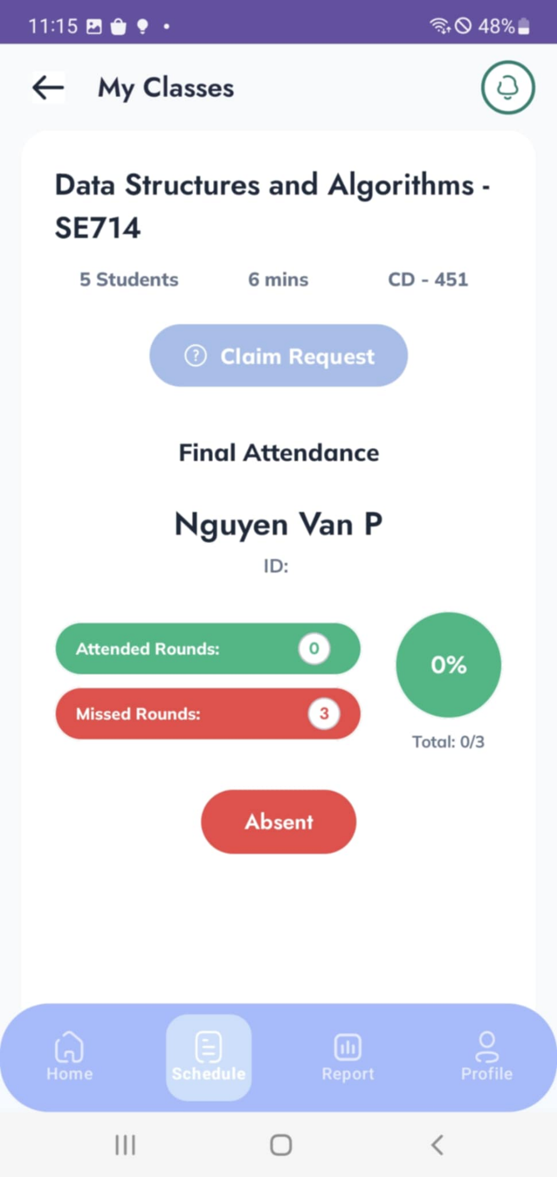
Figure 70: View Session Detail Layout
No | Field Name | Field Type | Description
S | Title – My Classes | Text Label | Screen title.
2 | Course Info | Text Label | Shows subject name, code, number of students, duration, and room (e.g., Data Structures and Algorithms – SE714).
3 | Claim Request | Button | Allows student to raise a request if attendance is incorrect.
4 | Student Info | Text Label | Displays student’s name and ID (e.g., Nguyen Van P).
5 | Attendance Stats | Text Labels | Shows attended rounds, missed rounds, percentage, and total sessions.
6 | Attendance Status | Status Label | Displays the attendance status (e.g., Absent).
7 | Bottom Tab – Home | Navigation Tab | Shortcut to Home screen.
8 | Bottom Tab – Schedule | Navigation Tab | Active tab, showing current Schedule/Session Detail screen.
9 | Bottom Tab – Report | Navigation Tab | Shortcut to Report screen.
10 | Bottom Tab – Profile | Navigation Tab | Shortcut to Profile screen.
Table 143: View Session Detail Field Table
b. Use Case Specifications
ID and Name | UC – 17: View Session Detail
Created By | Dungktn | Date Created |  |  | 28/06/2025
Primary Actor | Student | Secondary Actors |  |  | System
Trigger | Student taps on a specific session from the schedule or attendance history.
Description | Allows students to view detailed information about a specific class session, including time, subject, location, attendance result, and session history.
Preconditions | PRE-1. Students are signed in.  PRE-2. The selected session has occurred or is active.
Postconditions | POST-1. Session detail is retrieved and displayed.
Normal Flows | Step |  | By | Step Details
Normal Flows | 1 |  | Student | Selects a session from schedule or attendance report.
Normal Flows | 2 |  | System | Loads session information from server.
Normal Flows | 3 |  | System | Displays:  – Subject, room, date/time  – Attendance status (Present/Absent)  – Join timestamp or verification log  – Link to submit complaint (UC-19) if absent
Alternative Flows | Alt Step |  | Condition | Description
Alternative Flows | A1 |  | Session not linked to student | System shows: “Session not found or not assigned to you.”
Exceptions | - E1: If data retrieval fails, system shows: “Unable to load session details. Try again later.”
Frequency of Use | Medium
Business Rules | BR-01, BR-02, BR-15
Other Information | - Useful for tracking attendance evidence.  - Complaint access is only enabled if status is Absent and session is eligible (UC-19).
Assumptions | - Attendance status is already processed and stored.  - Session information is synced from admin-managed schedule (UC-39/40).
Table 144: View Session Detail Specification

3.2.2.20 Verify Face ID Request
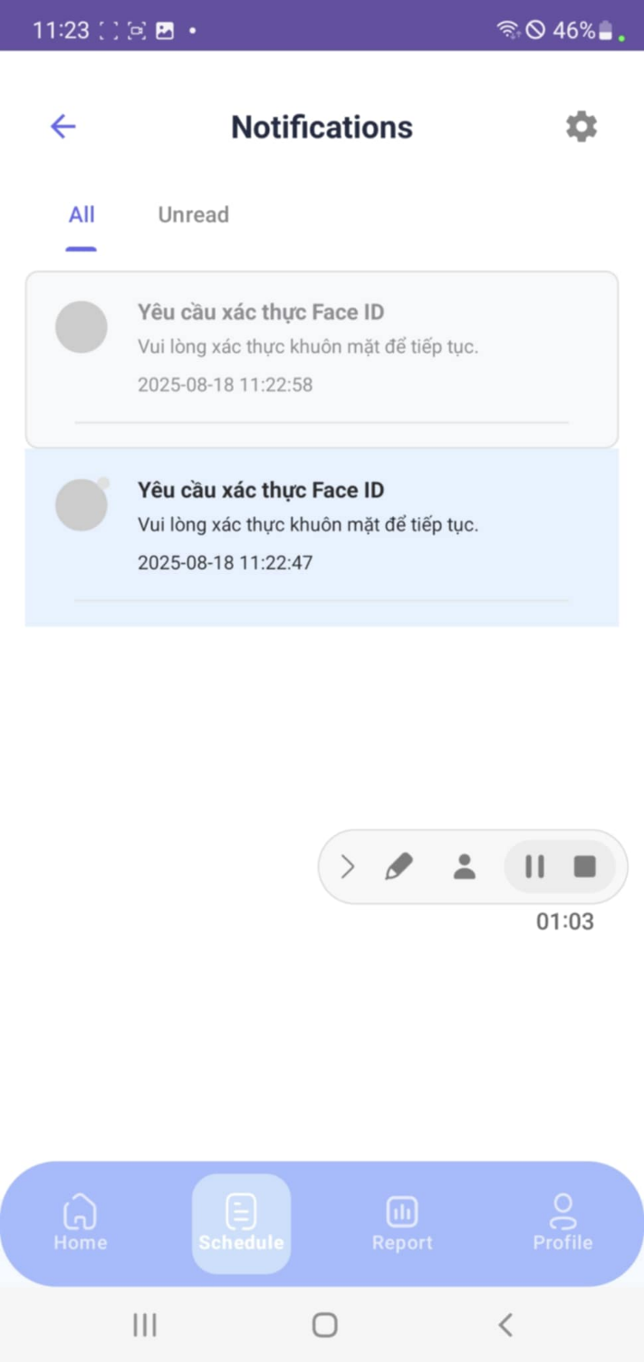
Figure 71: Notification Layout
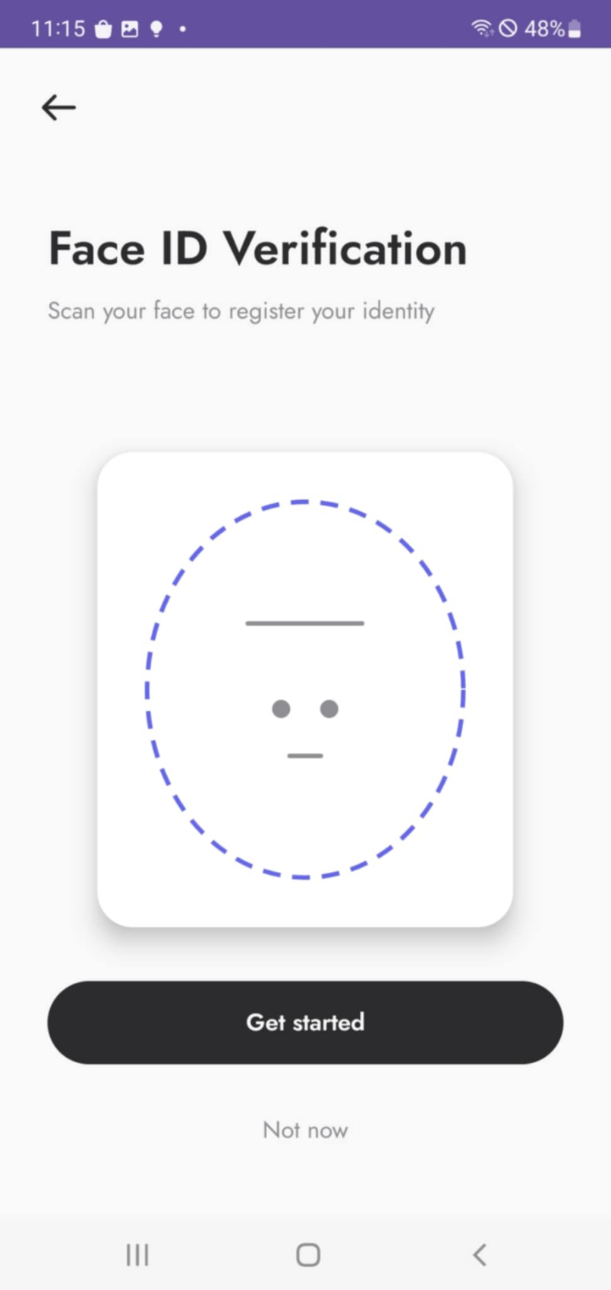
Figure 72: Verify Face ID Request Layout
a. Screen Layouts
No | Field Name | Field Type | Description
1 | Title – Notifications | Text Label | Screen title showing notification list.
2 | Notification Tabs | Tab Control | Tabs for All and Unread notifications.
3 | Notification Item | List Item | Displays notification message (e.g., “Yêu cầu xác thực Face ID”) with timestamp.
4 | Settings Icon | Icon Button | Opens notification settings.
5 | Face ID Verification Title | Text Label | Title: “Face ID Verification”.
6 | Instruction Text | Text Label | Helper text: “Scan your face to register your identity.”
7 | Face Frame/Illustration | Graphic/Widget | Guide for face alignment during scanning.
8 | Get Started | Primary Button | Starts the Face ID verification process.
9 | Not now | Text Link | Skips the Face ID verification process.
10 | Bottom Tab – Home | Navigation Tab | Shortcut to Home screen.
11 | Bottom Tab – Schedule | Navigation Tab | Shortcut to Schedule screen.
12 | Bottom Tab – Report | Navigation Tab | Shortcut to Report screen.
13 | Bottom Tab – Profile | Navigation Tab | Shortcut to Profile screen.
Table 145: Verify Face ID Request Field Table
b. Use Case Specifications
ID and Name | UC – 18: Verify Face ID Request
Created By | Dungktn | Date Created |  |  | 28/06/2025
Primary Actor | Student | Secondary Actors |  |  | Lecturer, System
Trigger | The system sends FaceID verification requests during a class session.
Description | Allow students to verify their identity via FaceID when requested by the lecturer, typically used during or after a session to confirm actual presence.
Preconditions | PRE-1. Students are signed in.  PRE-2. Attendance session is active.  PRE-3. Student has registered FaceID.
Postconditions | POST-1. FaceID verification is processed and result is stored.
Normal Flows | Step |  | By | Step Details
Normal Flows | 1 |  | System | Sends verification request to student’s device.
Normal Flows | 2 |  | Student | Receives prompt and confirms FaceID scan.
Normal Flows | 3 |  | System | Launches front-facing camera and performs scan.
Normal Flows | 4 |  | System | Verifies scan result against registered data.
Normal Flows | 5 |  | System | Sends results (Success/Fail) to Lecturer.
Alternative Flows | Alt Step |  | Condition | Description
Alternative Flows | A1 |  | Student declines request | System logs: “FaceID verification skipped by student.”
Exceptions | - E1: If scan fails, system shows: “FaceID not recognized. Try again.”  - E2: If camera permission is not granted, system prompts for access.
Frequency of Use | Medium
Business Rules | BR-01, BR-02, BR-04, BR-06
Other Information | - Optional but strongly recommended for identity integrity.  - Verification may be used as audit evidence in disputes.
Assumptions | - The device supports a camera and has network access.  - Lecturers actively triggers the FaceID request from their session interface.
Table 146: Verify Face ID Request Specification

3.2.2.21 View Lecturer Session Detail
a. Screen Layouts
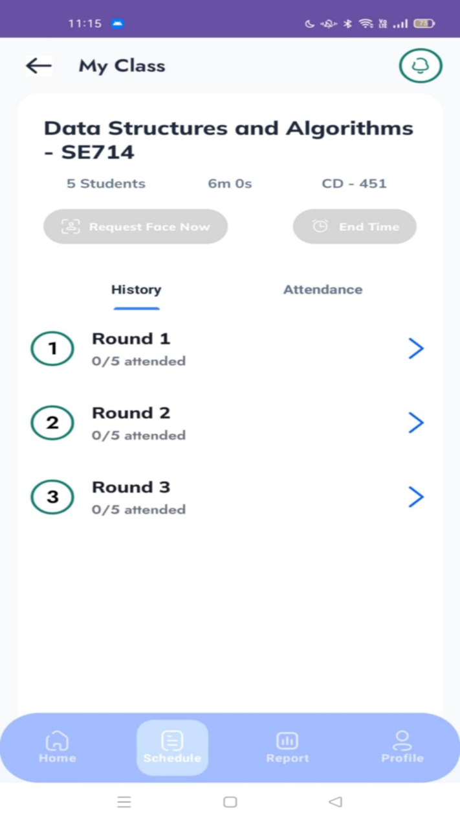
Figure 73: View Lecturer Session Detail Layout
No | Field Name | Field Type | Description
1 | Title – My Class | Text Label | Screen title.
2 | Course Info | Text Label | Displays subject name, code, number of students, duration, and room (e.g., Data Structures and Algorithms – SE714).
3 | Request Face Now | Button | Allows lecturer to trigger a Face ID attendance request.
4 | End Time | Button | Allows lecturer to end the attendance session.
5 | Tab – History | Tab Option | Shows session history with list of rounds.
6 | Tab – Attendance | Tab Option | Displays attendance details of students.
7 | Round List | List Item | Each round shows round number and attendance count (e.g., 0/5 attended).
8 | Bottom Tab – Home | Navigation Tab | Shortcut to Home screen.
9 | Bottom Tab – Schedule | Navigation Tab | Active tab, showing current Schedule/Session Detail screen.
10 | Bottom Tab – Report | Navigation Tab | Shortcut to Report screen.
11 | Bottom Tab – Profile | Navigation Tab | Shortcut to Profile screen.
Table 147: View Lecturer Session Detail Field Table
b. Use Case Specifications
ID and Name | UC – 22: View Lecturer Session Detail
Created By | Dungktn | Date Created |  |  | 28/06/2025
Primary Actor | Lecturer | Secondary Actors |  |  | System
Trigger | The lecturer selects a specific session from the schedule or calendar.
Description | Allow lecturers to view detailed information for a class session, including subject, room, time, student list, attendance history, and final statistics.
Preconditions | PRE-1. Lecturer is signed in.  PRE-2. Session is assigned to the lecturer.
Postconditions | POST-1. Session details are displayed and accessible for further actions.
Normal Flows | Step |  | By | Step Details
Normal Flows | 1 |  | Lecturer | Opens session from schedule/calendar.
Normal Flows | 2 |  | System | Loads session data: class name, date, time, and location.
Normal Flows | 3 |  | System | Displays:  - Student list  - Attendance status (Present, Absent, Excused)  - Duration  - Final status (Completed/In Progress)
Normal Flows | 4 |  | Lecturer | May navigate additional actions (UC-35 Start Session, UC-33 Manual Edit).
Alternative Flows | Alt Step |  | Condition | Description
Alternative Flows | A1 |  | Session has not yet started | System shows upcoming session details only (no attendance yet).
Exceptions | - E1: If session data fails to load, system shows: “Unable to retrieve session details.”
Frequency of Use | High
Business Rules | BR-01, BR-02, BR-07, BR-15
Other Information | - Supports access to edit, verify FaceID, or respond to complaints.  - Session details may include performance graphs and summary stats.
Assumptions | - Attendance session is synced in real-time with system.  - Lecturer has appropriate permissions to view and manage session data.
Table 148: View Lecturer Session Detail Specification

3.2.2.22 View Class Attendance Report
a. Screen Layouts
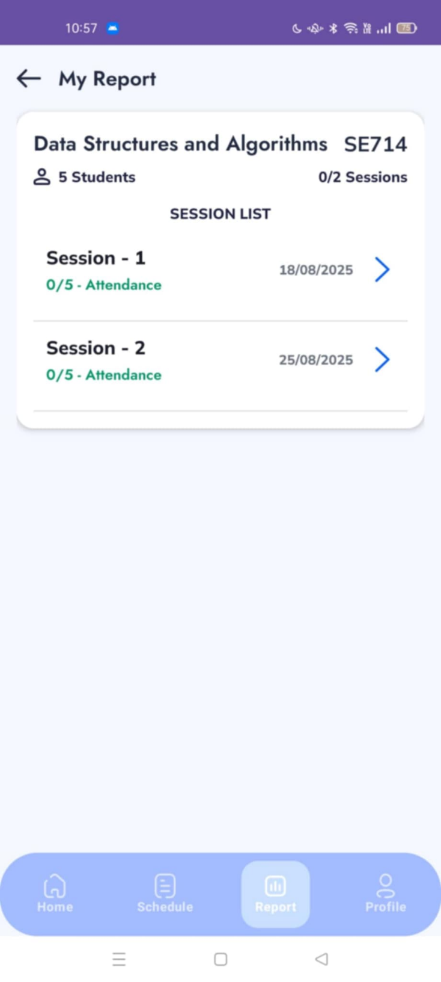
Figure 74: View Class Attendance Report Layout
No | Field Name | Field Type | Description
1 | Title – My Report | Text Label | Screen title.
2 | Course Info | Text Label | Shows subject name, code, and student count (e.g., Data Structures and Algorithms – SE714, 5 Students).
3 | Total Sessions | Text Label | Displays the total number of sessions (e.g., 0/2 Sessions).
4 | Session List | List Item | Displays each session with attendance count and date.
5 | Session Detail Link | Button/Icon | Each session entry includes a link (arrow) to open detailed attendance for that session.
6 | Bottom Tab – Home | Navigation Tab | Shortcut to Home screen.
7 | Bottom Tab – Schedule | Navigation Tab | Shortcut to Schedule screen.
8 | Bottom Tab – Report | Navigation Tab | Active tab, showing current Report screen.
9 | Bottom Tab – Profile | Navigation Tab | Shortcut to Profile screen.
Table 149: View Class Attendance Report Field Table
b. Use Case Specifications
ID and Name | UC – 23: View Class Attendance Report
Created By | Dungktn | Date Created |  |  | 28/06/2025
Primary Actor | Lecturer | Secondary Actors |  |  | System
Trigger | The lecturer opens an attendance report section and selects a class.
Description | Enables lecturers to view aggregated attendance statistics for a specific class, including student participation rates, attendance breakdowns, and performance warnings.
Preconditions | PRE-1. Lecturer is signed in.  PRE-2. The lecturer is assigned to the selected class.
Postconditions | POST-1. The system displays attendance statistics for the class.
Normal Flows | Step |  | By | Step Details
Normal Flows | 1 |  | Lecturer | Navigates to “Reports” section in the app.
Normal Flows | 2 |  | System | Displays list of assigned classes.
Normal Flows | 3 |  | Lecturer | Selects a class to view attendance statistics.
Normal Flows | 4 |  | System | Shows:  – List of students  – Attendance % per student  – Number of sessions attended, missed, excused  – Alerts for low attendance
Alternative Flows | Alt Step |  | Condition | Description
Alternative Flows | A1 |  | No attendance data available | System shows: “No attendance data available for this class.”
Exceptions | - E1: If report data fails to load, show: “Unable to load report. Please try again later.”
Frequency of Use | Medium
Business Rules | BR-01, BR-02, BR-14, BR-15
Other Information | - May include class-wide attendance trends and semester summaries.
Assumptions | - Attendance data has been consistently recorded and updated from sessions.  - System supports real-time reporting and alert thresholds.
Table 150: View Class Attendance Report Specification

3.2.2.23 View Session Attendance Report
a. Screen Layouts
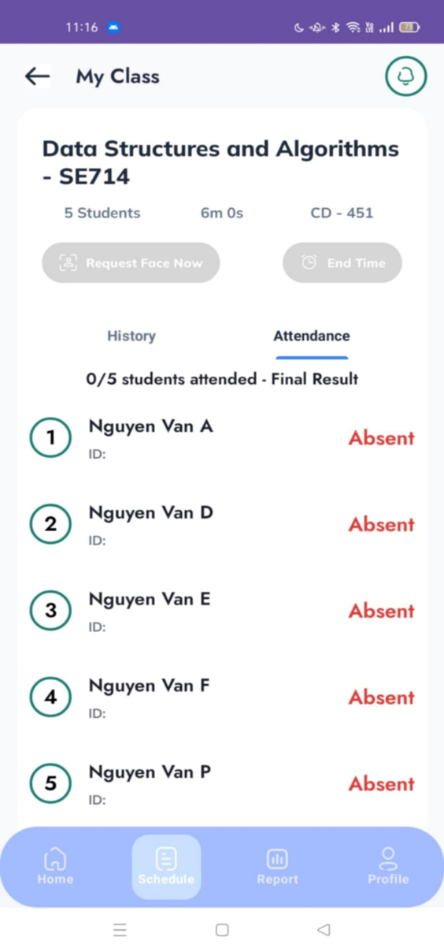
Figure 75: View Session Attendance Report Layout
No | Field Name | Field Type | Description
1 | Title – My Class | Text Label | Screen title.
2 | Course Info | Text Label | Shows subject name, number of students, duration, and room (e.g., Data Structures and Algorithms – SE714, 5 Students, 6 mins, CD-451).
3 | Request Face Now | Button (disabled) | Option to trigger Face ID request (inactive when viewing past session).
4 | End Time | Button (disabled) | Option to end attendance session (inactive when viewing past session).
5 | Tab – History | Tab Option | Switch to view attendance history.
6 | Tab – Attendance | Tab Option | Active tab, showing student attendance results.
7 | Attendance List | List Item | Displays list of students with ID, attendance status (e.g., Absent).
8 | Bottom Tab – Home | Navigation Tab | Shortcut to Home screen.
9 | Bottom Tab – Schedule | Navigation Tab | Shortcut to Schedule screen.
Table 151: View Session Attendance Report Field Tale
b. Use Case Specifications
ID and Name | UC – 24: View Session Attendance Report
Created By | Dungktn | Date Created |  |  | 28/06/2025
Primary Actor | Lecturer | Secondary Actors |  |  | System
Trigger | The lecturer opens a specific class session report to review attendance.
Description | Enables lecturers to view attendance statistics for a specific class session, including individual student records, attendance statuses, and timestamps.
Preconditions | PRE-1. Lectures are signed in.  PRE-2. Lecturer is assigned to the session.  PRE-3. The session has been completed, and attendance has been recorded.
Postconditions | POST-1. The system displays full session attendance details.
Normal Flows | Step |  | By | Step Details
Normal Flows | 1 |  | Lecturer | Navigates to a completed session via calendar or class detail.
Normal Flows | 2 |  | System | Retrieves attendance record for the selected session.
Normal Flows | 3 |  | System | Displays:  – List of enrolled students  – Status (Present, Absent, Excused)  – Time joined  – Method (Auto, Manual, FaceID)
Normal Flows | 4 |  | Lecturer | May optionally access complaint or FaceID verification history.
Alternative Flows | Alt Step |  | Condition | Description
Alternative Flows | A1 |  | No attendance recorded | System shows: “Attendance has not been taken for this session.”
Exceptions | - E1: If session data retrieval fails, show: “Unable to load session report. Try again later.”
Frequency of Use | Medium
Business Rules | BR-01, BR-02, BR-07, BR-15
Other Information | - May include breakdown of attendance method (Auto vs Manual).  - Used to support complaint resolution and audit trails.
Assumptions | - Session is finalized and synced.  - Only the assigned lecturer has access.
Table 152: View Session Attendance Report Specification

3.2.2.24 Broadcast and Scan Signal
ID and Name | UC – 25: Broadcast and Scan Signal
Created By | Dungktn | Date Created |  |  | 28/06/2025
Primary Actor | Lecturer, Student | Secondary Actors |  |  | System
Trigger | At the beginning of the session, the lecturer initiates a signal; students scan for it.
Description | The lecturer broadcasts a Bluetooth signal to initiate the attendance session. Students scan for the signal to register their presence in real time.
Preconditions | PRE-1. Both lecturers and students are signed in.  PRE-2. Devices have Bluetooth enabled and are within range.  PRE-3. Lecturer has started the session (UC-35).
Postconditions | POST-1. Students who detect the signal are marked as present (pending verification if needed).
Normal Flows | Step |  | By | Step Details
Normal Flows | 1 |  | Lecturer | Opens the session and taps “Start Broadcast.”
Normal Flows | 2 |  | System | Broadcasts Bluetooth signal unique to session ID.
Normal Flows | 3 |  | Student | Opens session and taps “Scan Signal.”
Normal Flows | 4 |  | System | Detects broadcast and validates signal.
Normal Flows | 5 |  | System | Marks student as joined (subject to FaceID check in UC-23).
Alternative Flows | Alt Step |  | Condition | Description
Alternative Flows | A1 |  | Student device fails to detect signal | System shows: “No signal detected. Move closer or try again.”
Exceptions | - E1: If Bluetooth is turned off on either device, system shows appropriate prompt.  - E2: If session hasn’t started, system alerts: “Attendance session not available yet.”
Frequency of Use | High
Business Rules | BR-01, BR-02, BR-03, BR-05, BR-07
Other Information | - Signal is time-limited and rotates per session to prevent misuse.  - Accuracy depends on Bluetooth hardware and proximity (typically <10m).
Assumptions | - Mobile devices are paired with correct student accounts.  - Lecturers start the session from their own device using UC-35.
Table 153: Broadcast and Scan Signal Specification

3.2.2.25 Create Face ID Request
a. Screen Layouts
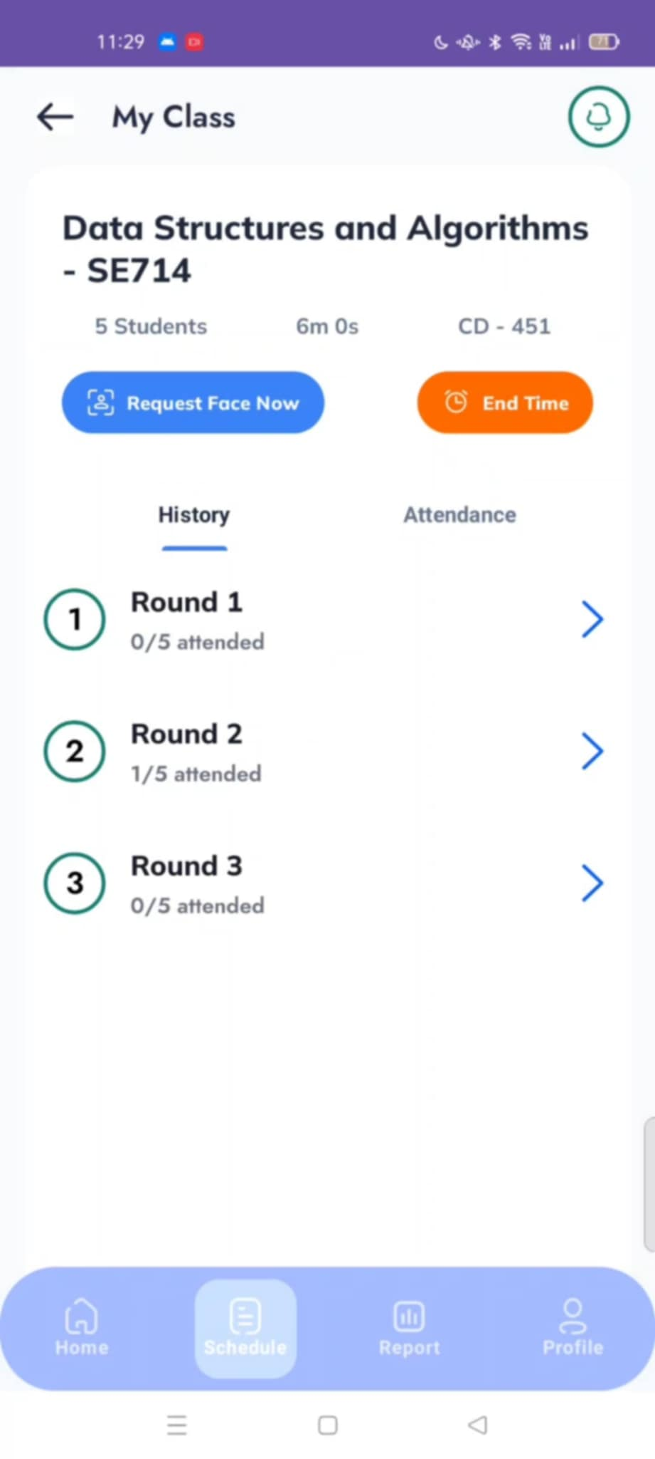
Figure 76: Schedule Layout
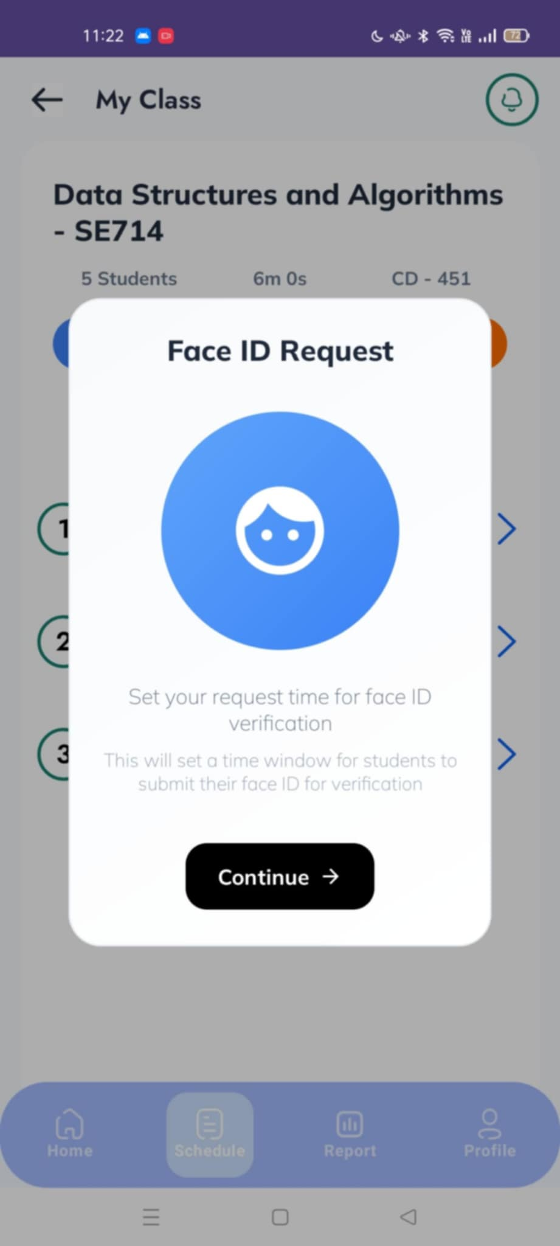
Figure 77: Create Face ID Request
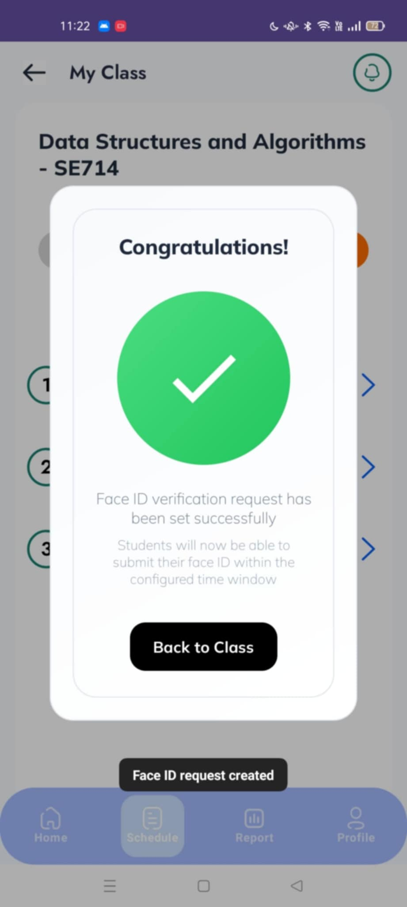
Figure 78: Create Face ID Request Successfully layout
No | Field Name | Field Type | Description
1 | Title – My Class | Text Label | Screen title.
2 | Course Info | Text Label | Displays course name, student count, session duration, and room (e.g., Data Structures and Algorithms – SE714).
3 | Request Face Now | Primary Button | Allows lecturer to initiate a Face ID verification request.
4 | End Time | Secondary Button | Ends the ongoing attendance session.
5 | Tab – History | Tab Option | Shows list of rounds with attendance counts.
6 | Tab – Attendance | Tab Option | Shows student attendance details.
7 | Round List | List Item | Displays attendance per round (e.g., 0/5 attended).
8 | Face ID Request Popup – Title | Text Label | Title of popup (e.g., “Face ID Request”).
9 | Face ID Request Popup – Instruction | Text Label | Explains the time window setup for Face ID submission.
10 | Face ID Request Popup – Continue | Button | Confirms request initiation and proceeds.
11 | Success Popup – Message | Text Label | Confirmation that Face ID request has been set successfully.
12 | Success Popup – Back to Class | Button | Returns lecturer to the session detail screen.
13 | Bottom Tab – Home | Navigation Tab | Shortcut to Home screen.
14 | Bottom Tab – Schedule | Navigation Tab | Active tab, showing current Schedule/Class screen.
15 | Bottom Tab – Report | Navigation Tab | Shortcut to Report screen.
16 | Bottom Tab – Profile | Navigation Tab | Shortcut to Profile screen.
Table 154: Create Face ID Request Field Table
b. Use Case Specifications
ID and Name | UC – 26: Create Face ID Request
Created By | Dungktn | Date Created |  |  | 28/06/2025
Primary Actor | Lecturer | Secondary Actors |  |  | Student, System
Trigger | Lecturer chooses to initiate a FaceID verification during an attendance session.
Description | Allows the lecturer to send a FaceID verification request to one or more students during a session to verify actual presence and detect proxy attendance.
Preconditions | PRE-1. Lecturer is signed in.  PRE-2. Attendance session is active.  PRE-3. Students have registered FaceID and are marked “joined.”
Postconditions | POST-1. Students receive verification requests and must respond immediately.
Normal Flows | Step |  | By | Step Details
Normal Flows | 1 |  | Lecturer | From the session detailed screen, selects one or more students to verify.
Normal Flows | 2 |  | System | Sends FaceID requests to select student devices.
Normal Flows | 3 |  | Student | Receives request and performs FaceID scan (handled in UC-23).
Normal Flows | 4 |  | System | Processes scan and updates result in lecturer’s session dashboard.
Alternative Flows | Alt Step |  | Condition | Description
Alternative Flows | A1 |  | Students already verified in session | System blocks duplicate FaceID request for that student.
Exceptions | - E1: If FaceID request fails to send, system shows: “Unable to send request. Try again.”  - E2: If student device is offline, system flags: “Device unreachable.”
Frequency of Use | Medium
Business Rules | BR-01, BR-02, BR-04, BR-06
Other Information | - Used to prevent impersonation and enforce attendance integrity.  - History of FaceID requests can be accessed in session detail for audits.
Assumptions | - Students must respond in real time; late responses are logged.  - Each request is traceable and timestamped.
Table 155: Create Face ID Request Specification

3.2.2.26 Automotive Attendance
ID and Name | UC – 27: Automotive Attendance
Created By | Dungktn | Date Created |  |  | 28/06/2025
Primary Actor | Lecturer | Secondary Actors |  |  | Student, System
Trigger | Lecturer starts a session and chooses automatic attendance mode.
Description | Enables lecturers to conduct attendance automatically using Bluetooth signal detection. Students in proximity with registered devices are marked present automatically without manual intervention.
Preconditions | PRE-1. Lecturers are signed in.  PRE-2. Attendance session has started (UC-35).  PRE-3. Students' devices are registered and have Bluetooth enabled.
Postconditions | POST-1. Attendance list is generated automatically.
Normal Flows | Step |  | By | Step Details
Normal Flows | 1 |  | Lecturer | Starts class session and selects “Automatic Attendance.”
Normal Flows | 2 |  | System | Begins scanning for nearby student devices broadcasting signals.
Normal Flows | 3 |  | System | Matches signal to student registry and confirms device validity.
Normal Flows | 4 |  | System | Marks students as present automatically and logs time.
Normal Flows | 5 |  | Lecturer | Reviews auto-generated list and proceeds with optional FaceID verification (UC-31).
Alternative Flows | Alt Step |  | Condition | Description
Alternative Flows | A1 |  | No signals detected | System alerts: “No student devices detected nearby.”
Exceptions | - E1: If the system fails to match device, it is excluded and may require manual review.  - E2: If student device is not broadcasting or out of range, student is not marked present.
Frequency of Use | High
Business Rules | BR-01, BR-02, BR-03, BR-05, BR-07
Other Information | - The automatic method is time-bound (e.g., 10-minute window).  - Attendance data is synced for reporting (UC-29, UC-28).  - May be combined with FaceID requests for added validation.
Assumptions | - Bluetooth signals are unique per student and registered.  - All data is logged for transparency and audit trails.
Table 156: Automotive Attendance Specification

3.2.2.27 Manual Attendance
a. Screen Layouts
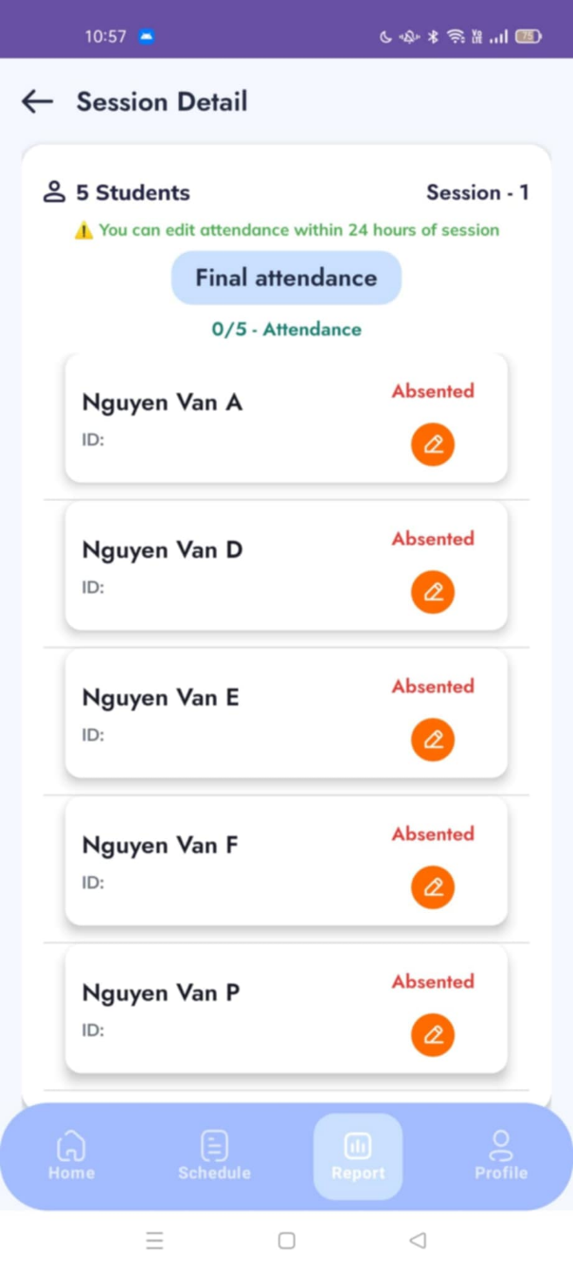
Figure 79: Manual Attendance layout
No | Field Name | Field Type | Description
1 | Title – Session Detail | Text Label | Screen title.
2 | Session Info | Text Label | Displays number of students and session number (e.g., 5 Students – Session 1).
3 | Edit Notice | Text Label | Warning message that attendance can be edited within 24 hours of the session.
4 | Final Attendance | Button/Label | Section header for final attendance results (e.g., 0/5 Attendance).
5 | Student List | List Item | Displays student name, ID, and attendance status.
6 | Attendance Status | Status Label | Indicates attendance status (e.g., Absented).
7 | Manual Edit Icon | Action Icon | Allows lecturer to manually edit or override attendance status.
8 | Bottom Tab – Home | Navigation Tab | Shortcut to Home screen.
9 | Bottom Tab – Schedule | Navigation Tab | Shortcut to Schedule screen.
10 | Bottom Tab – Report | Navigation Tab | Active tab, showing current Report/Session screen.
11 | Bottom Tab – Profile | Navigation Tab | Shortcut to Profile screen.
Table 157: Manual Attendance Field Table
b. Use Case Specifications
ID and Name | UC – 28: Manual Attendance
Created By | Dungktn | Date Created |  |  | 28/06/2025
Primary Actor | Lecturer | Secondary Actors |  |  | System
Trigger | The lecturer chooses to manually adjust attendance during or after a session.
Description | Enables lecturers to manually mark, adjust, or correct attendance records for students in special situations, such as technical issues, late arrivals, or verification failures.
Preconditions | PRE-1. Lecturer is signed in.  PRE-2. Session is active or has ended within the allowed adjustment window.  PRE-3. Lecturer has proper authorization to edit attendance.
Postconditions | POST-1. Adjusted attendance is saved and reflected in session records.
Normal Flows | Step |  | By | Step Details
Normal Flows | 1 |  | Lecturer | Opens session detail and selects “Manual Attendance.”
Normal Flows | 2 |  | System | Displays full student list with current attendance status.
Normal Flows | 3 |  | Lecturer | Edits statuses (e.g., Absent → Present, adds Excused) and optionally adds notes.
Normal Flows | 4 |  | System | Validates and saves updated attendance records.
Normal Flows | 5 |  | System | Logs the changes with timestamp and editor identity for audit.
Alternative Flows | Alt Step |  | Condition | Description
Alternative Flows | A1 |  | Session outside editable window | System shows: “Manual editing not allowed after 24 hours.”
Exceptions | - E1: If save fails, system shows: “Update failed. Please try again or contact admin.”  - E2: If lecturer lacks permission, system blocks edit and displays: “Access denied.”
Frequency of Use | Medium
Business Rules | BR-01, BR-02, BR-08, BR-11, BR-15
Other Information | - Notes on edits help in resolving attendance complaints (UC-34).  - Manual edits are visible in session history with reason tags.
Assumptions | - Session is editable within 24 hours of end time (BR-08).  - Lecturer decisions override automatic detection when justified.
Table 158: Manual Attendance Specification

3.2.2.28 Start Attendance Session
a. Screen Layouts
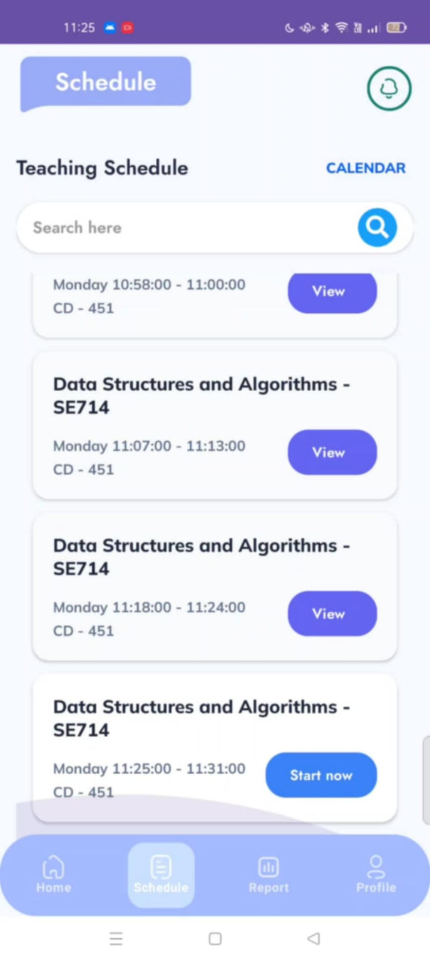
Figure 80: Start Attendance Session layout
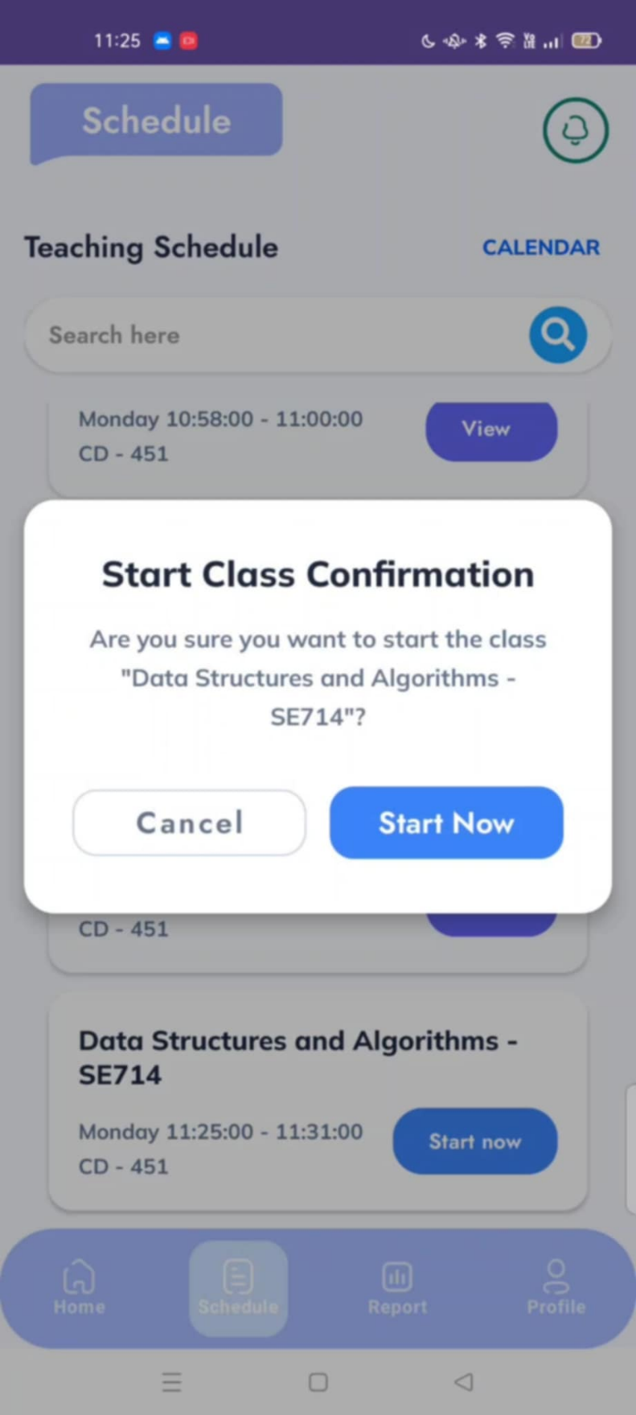
Figure 81: Confirm start layout
No | Field Name | Field Type | Description
1 | Header Title | Label/Text | Displays the title “Schedule”.
2 | Calendar Button | Icon/Button | Shortcut to switch to calendar view.
3 | Search Bar | Textbox + Icon | Input field to search class sessions with a search icon.
4 | Class Card | Container | Each scheduled class displayed as a card.
5 | Subject Name | Label/Text | Shows subject name (e.g., Data Structures and Algorithms – SE714).
6 | Class Time | Label/Text | Displays session start and end time.
7 | Classroom Code | Label/Text | Displays classroom code (e.g., CD – 451).
8 | Action Button | Button | “View” for normal sessions, “Start Now” for starting attendance.
9 | Bottom Navigation | Navigation Bar | Contains 4 buttons: Home, Schedule, Report, Profile.
Table 159: Start Attendance Session Field Table
b. Use Case Specifications
ID and Name | UC – 29: Start Attendance Session
Created By | Dungktn | Date Created |  |  | 28/06/2025
Primary Actor | Lecturer | Secondary Actors |  |  | System
Trigger | The lecturer selects a scheduled class and initiates the attendance session.
Description | Allow lecturers to start a new attendance session manually or automatically, enabling students to join and register attendance within a valid time window.
Preconditions | PRE-1. Lecturer is signed in.  PRE-2. The selected session is scheduled and assigned to the lecturer.  PRE-3. The current time is within allowed timeframe.
Postconditions | POST-1. Attendance session is active and accepting student joins.
Normal Flows | Step |  | By | Step Details
Normal Flows | 1 |  | Lecturer | Opens upcoming session from schedule/calendar.
Normal Flows | 2 |  | Lecturer | Selects “Start Session” and chooses mode: Automatic or Manual.
Normal Flows | 3 |  | System | Activates session and begins tracking attendance inputs.
Normal Flows | 4 |  | System | Broadcasts signal (if applicable) and opens join window.
Normal Flows | 5 |  | System | Displays real-time student join status to lecturer.
Alternative Flows | Alt Step |  | Condition | Description
Alternative Flows | A1 |  | Session has already started | System shows: “Session already active or completed.”
Exceptions | - E1: If network fails, system shows: “Unable to start session. Check connection.”  - E2: If schedule mismatch occurs, system alerts: “Session not found or not assigned.”
Frequency of Use | High
Business Rules | BR-01, BR-02, BR-05, BR-07, BR-17
Other Information | - Session duration and end rules are defined in admin configuration (UC-42).  - Signal may be auto disabled after a timeout.
Assumptions | - Lecturer starts session only once.  - Students will use UC-21 to join after session is active.
Table 160: Start Attendance Session Specification

3.2.2.29 Backfill Data
ID and Name | UC – 15: Backfill Data
Created By | Dungktn | Date Created |  |  | 28/06/2025
Primary Actor | System | Secondary Actors |  |  | Student, Lecturer
Trigger | Device reconnects to the internet after being offline.
Description | Automatically detects and synchronizes attendance data that was captured and stored locally on a mobile device while it was offline. Ensures that no attendance records are lost due to temporary connectivity issues.
Preconditions | PRE-1. The device has stored offline data locally.  PRE-2. Internet connection is re-established.
Postconditions | POST-1. The report is displayed with up-to-date attendance metrics.
Normal Flows | Step |  | By | Step Details
Normal Flows | 1 |  | System | Detects that device has reconnected to the internet.
Normal Flows | 2 |  | System | Scans local storage for pending attendance data.
Normal Flows | 3 |  | System | Verifies data integrity and timestamps.
Normal Flows | 4 |  | System | Uploads valid records to central server.
Normal Flows | 5 |  | System | Marks records as synced and clears local cache.
Alternative Flows | Alt Step |  | Condition | Description
Alternative Flows | A1 |  | No data found locally | System skips sync process.
Exceptions | - E1: If upload fails due to server error, data is queued for retry.
Frequency of Use | Automatic
Business Rules | BR-01, BR-02, BR-13, BR-15, BR-19
Other Information | - Retry queue supports exponential backoff strategy.  - All operations are transparent to the user; no manual action is required.
Assumptions | - Device storage is secure and accessible.  - Local records include all necessary metadata for validation.
Table 161: Backfill Data Specification

3.2.2.30 Process Attendance Data
ID and Name | UC – 76: Process Attendance Data
Created By | Dungktn | Date Created |  |  | 28/06/2025
Primary Actor | System | Secondary Actors |  |  | Student, Lecturer
Trigger | Students join sessions or attendance records are submitted from mobile devices.
Description | The system receives raw attendance data (e.g., Bluetooth signal, join timestamps, FaceID results), validates it against session configuration and business rules, and stores final attendance records in the database.
Preconditions | PRE-1. Attendance session is active or recently ended.  PRE-2. Devices are authorized and synced.
Postconditions | POST-1. Validated attendance is stored in the central database.
Normal Flows | Step |  | By | Step Details
Normal Flows | 1 |  | System | Receives raw attendance signals or records from devices.
Normal Flows | 2 |  | System | Validates device identity, signal time, and session matching.
Normal Flows | 3 |  | System | Applies FaceID verification (if required).
Normal Flows | 4 |  | System | Checks business rules (e.g., time window, session overlap).
Normal Flows | 5 |  | System | Stores finalized attendance record with status (Present, Absent, Excused).
Alternative Flows | Alt Step |  | Condition | Description
Alternative Flows | A1 |  | Data duplicates or already processed | System ignores and logs for review.
Exceptions | - E1: If data is incomplete or invalid, system logs it and excludes from attendance.  - E2: If session not found, system discards record and alerts admin.
Frequency of Use | High
Business Rules | BR-01, BR-02, BR-03, BR-04, BR-05, BR-06, BR-07, BR-15, BR-19
Other Information | - Every record includes timestamp, device ID, and verification status.  - All processing is automated, no human intervention required.
Assumptions | - Network and synchronization with mobile app are stable.  - All students use registered devices and follow session rules.
Table 162: Process Attendance Data Specification

3.2.2.31 Store Local Attendance Data
ID and Name | UC – 77: Store Local Attendance Data
Created By | Dungktn | Date Created |  |  | 28/06/2025
Primary Actor | System | Secondary Actors |  |  | Student, Lecturer
Trigger | Students join an attendance session while the mobile device is offline.
Description | When a student joins an attendance session without internet connectivity, the mobile app stores the attendance record locally on the device. This data will be automatically synchronized when a connection is restored (UC-20).
Preconditions | PRE-1. Students join sessions offline.  PRE-2. Session and student data is caught locally.
Postconditions | POST-1. Attendance data is stored in encrypted local storage.
Normal Flows | Step |  | By | Step Details
Normal Flows | 1 |  | Student | Opens the app and joins attendance session (offline).
Normal Flows | 2 |  | System | Records session ID, student ID, timestamp, and verification result (if any).
Normal Flows | 3 |  | System | Store the record securely in local storage.
Normal Flows | 4 |  | System | Flags the record for sync once connectivity is restored (see UC-20).
Alternative Flows | Alt Step |  | Condition | Description
Alternative Flows | A1 |  | Student declines request | System logs: “FaceID verification skipped by student.”
Exceptions | - E1: If local write fails, system logs error and alerts user to retry later.
Frequency of Use | Medium
Business Rules | BR-01, BR-02, BR-03, BR-13, BR-15, BR-19
Other Information | - Data includes checksum to prevent tampering.  - Sync process is handled by UC-20 (Backfill Data).  - Offline records are not shown to lecturers until synced.
Assumptions | - App has local storage permission and enough space.  - Student device maintains accurate time for timestamping.
Table 163: Store Local Attendance Data Specification

4. Non-Functional Requirements
No | Category | Requirement
AAS Web System
01 | Performance | The web system must respond to user actions within 1 second for 95% of requests.
02 | Scalability | The system must support at least 10,000 concurrent users during peak load.
03 | Availability | The system must maintain 99.9% uptime monthly, excluding scheduled maintenance.
04 | Reliability | Attendance records and configuration settings must not be lost even in the event of server failure.
05 | Security | All access must be protected via HTTPS, and only authenticated users can access the system.
06 | Maintainability | The codebase must be modular and follow clean architecture to enable updates without downtime.
07 | Usability | Admin dashboard must be accessible with clear labels, icons, and support for basic accessibility.
08 | Data Integrity | Any change to schedules, devices, or user data must be logged with timestamps and actors.
09 | Compliance | The system must comply with institutional data retention policies (e.g., keeping logs for 6 months).
10 | Backup & Recovery | Daily backups must be stored and recoverable within 4 hours of data loss incident.
AAS Mobile System
01 | Performance | App must respond within 1.5 seconds for 95% of user interactions (e.g., tap, navigation).
02 | Offline Capability | Apps must support offline attendance and syncing when connection is restored (see UC-20, UC-46).
03 | Battery Efficiency | Bluetooth broadcasting and scanning must minimize battery drain during sessions.
04 | Security | Apps must enforce biometric or passcode login where applicable (e.g., FaceID, fingerprint).
05 | Platform Support | The app must run smoothly on Android 10+ and iOS 13+ with backward compatibility.
06 | Data Integrity | Local data must be encrypted and tamper-proof while awaiting sync.
07 | Usability | Interface must be designed for quick one-hand use and be intuitive for non-technical users.
08 | Notification System | Students and lecturers must receive timely push notifications for attendance and complaints.
09 | Accessibility | Apps must be used by individuals with color blindness and provide screen reader support.
10 | Recovery | In case of app crash, data must persist and automatically resume the previous state on restart.
Table 164: Non-Functional Requirements Table

